**Hand-out 1**

**Structure of DNA**

**Introducing DNA: Key Points**

**DNA Structure**

* Write notes and draw labelled diagrams to explain what a **nucleotide** is. Indicate the 3 prime and 5 prime carbons:

**Base Pair rule**

* Use notes, diagrams and memory aids to explain the base-pair rule.

**Sugar-Phosphate Backbone**

* Draw a strand of DNA nucleotides and colour code them. Add labels and notes to explain how the sugar-phoshate backbone is formed.



**DNA: Double Helix**

* Write notes to explain how the **double helix forms** and why it is described as being **anti-parallel.**
* Next complete the diagram by adding the bases and completing the labels:

Notes:

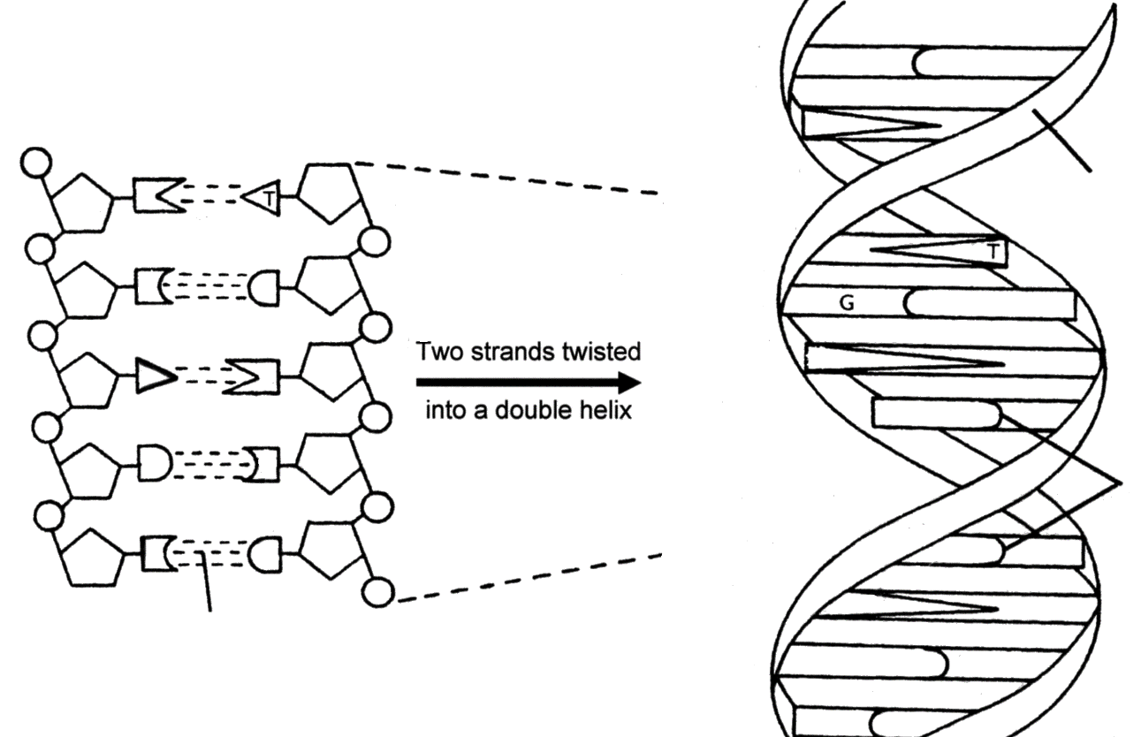

* *Complete this simplified diagram of two complementary DNA strands, by writing the initial letter of each missing base:*

**3’**

**A G T T C A**

**T C A G A A**

* What do the thick horizontal lines in the diagram above represent? **Add a label to indicate this**.

**Organisation of DNA in Eukaryotes**

Label the diagram and write notes to explain how **DNA is packaged into chromosomes** in eukaryotic cells.

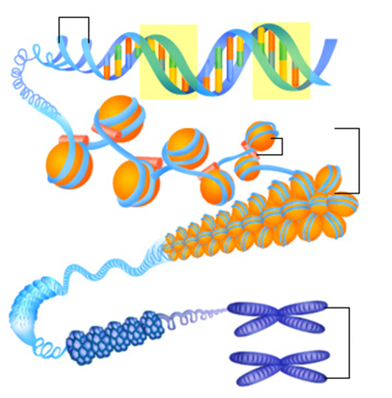

Notes:

**Circular Chromosomes in Eukaryotes**

Label the diagram below to show the three places that DNA is found within eukaryotic cells. Write notes explain the difference between the organisation on DNA in each organelle.

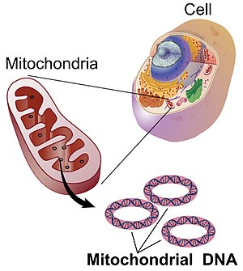

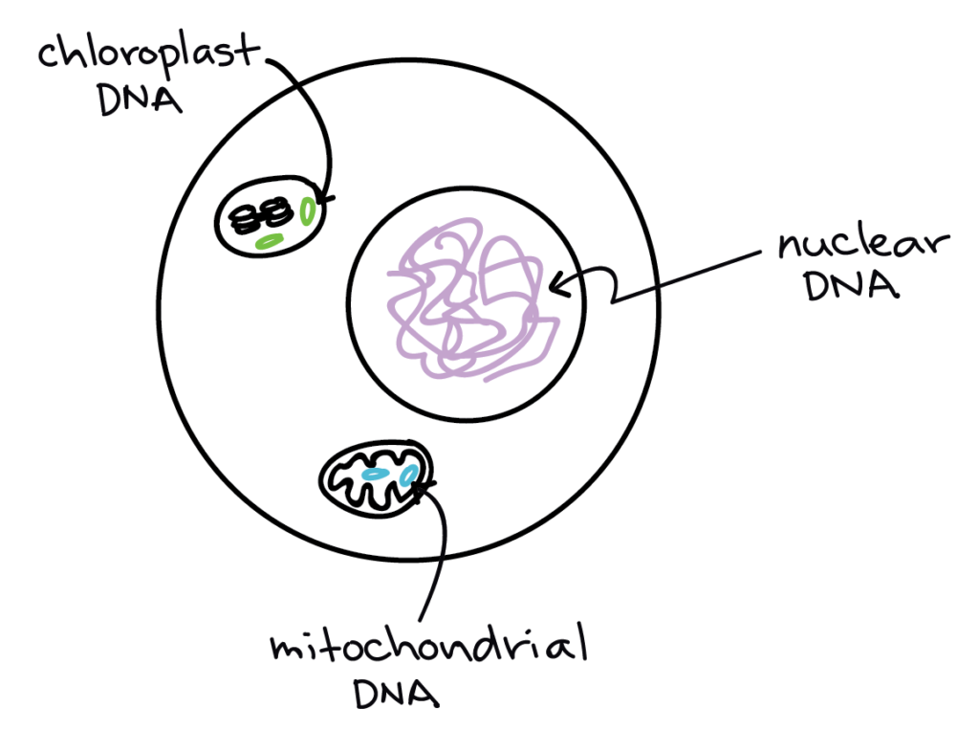

Notes

**Organisation of DNA in Yeast Cells**

Use the diagram below to write notes on the organisation of DNA in a yeast cell.

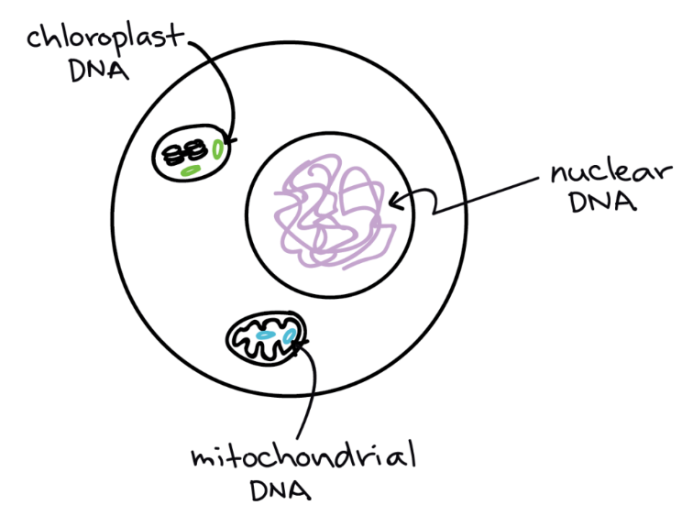



**Notes:**

**Organisation of DNA in Prokaryotes**

Label the diagram and write notes on the organisation of DNA in prokaryotes.

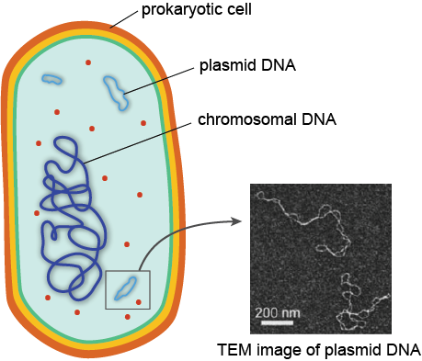

**Notes**

**Organisation of DNA Summary**

Complete the table below to summarise the organisation of DNA in different cell types.

|  |  |  |  |
| --- | --- | --- | --- |
| Cell type | Linear Chromosomes | Circular Chromosomes | Plasmids |
| Eukaryotes – animal |  |  |  |
| Eukaryotes - plant |  |  |  |
| Yeast cells |  |  |  |
| prokaryotes |  |  |  |