St Ambrose High Parent Council
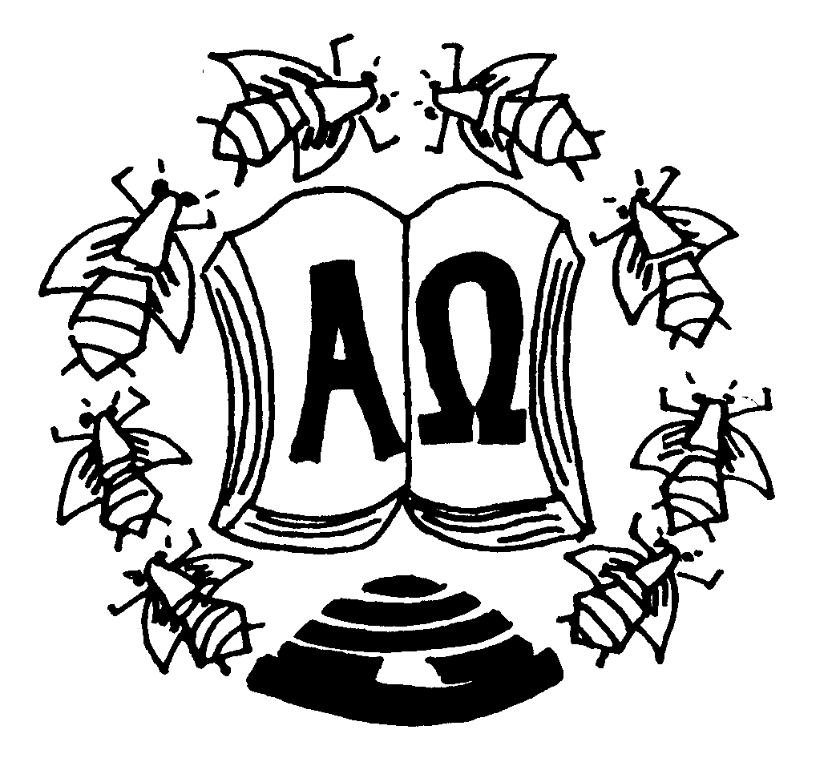

Agenda of meeting Monday 3rd December 2018

AGENDA

- Prayer

- Apologies

- Correspondence

- Previous minutes address

- Campus

- NLC Review

- Report from HT - St Ambrose - Shines

- A.O.C.B

- Date of next meeting

