Parent Evening Booking System - Help Sheet
- Log in by typing the following address DIRECTLY into your website browser’s address bar (please do not google it) –
https://parents-booking.co.uk/stambrosehigh
- The following screen will appear. Fill in the blank boxes to log in -
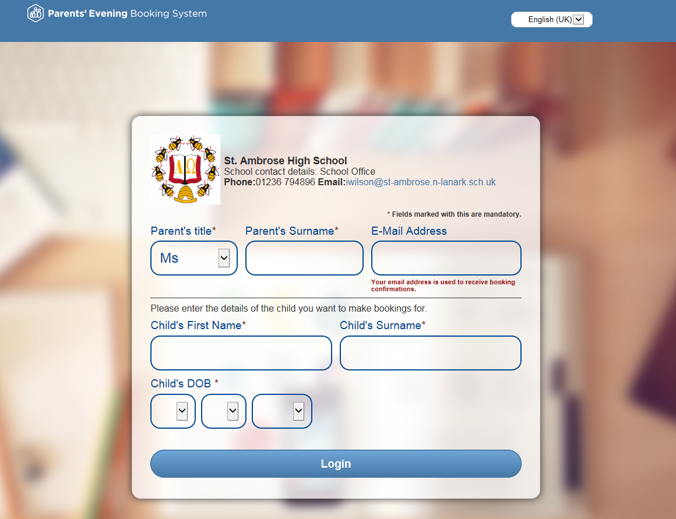

- The system will ask you to either make individual bookings or to use the Automated Booking Wizard. We recommend using the Wizard as it will work out the best fit of appointment times for you.
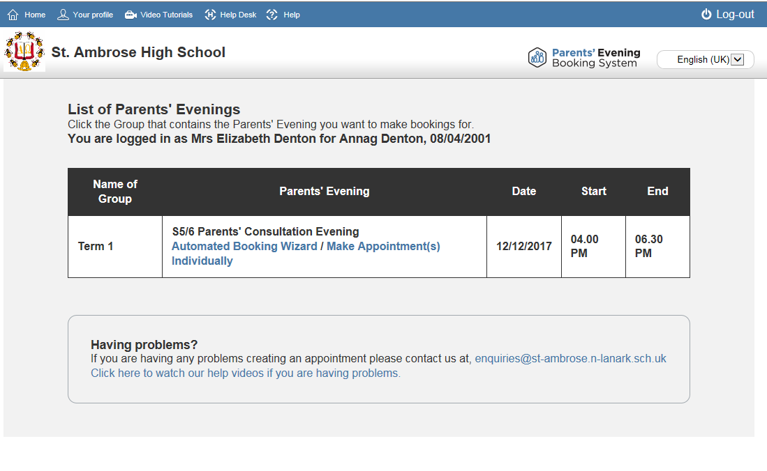
There are VIDEO TUTORIALS available to view when you are logged in or on the school website

The Wizard will try to get the tightest group of appointments for you, even if you are making appointments towards the end of the booking window

- The booking system will then allow you to book appointments for the teachers you wish to meet. The quickest way to do this is to click the ‘Select All Teachers’ button and then remove any subjects/teachers you do not wish an appointment with. If you have two children in the same year group, both names will show up to allow you to make separate appointments.

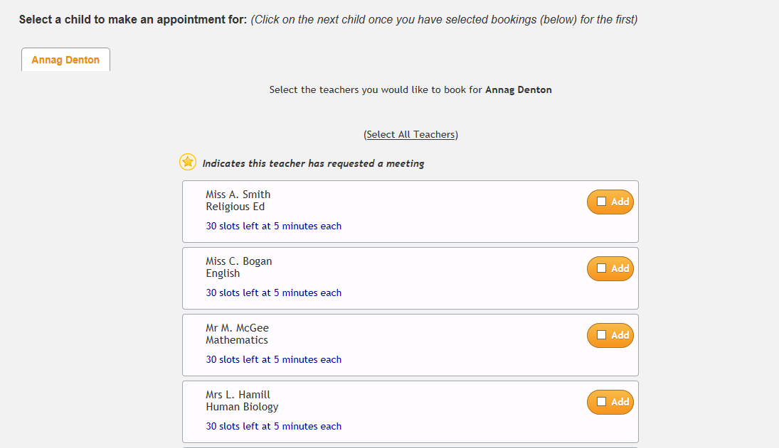
If a teacher has specifically requested a meeting then you will see this indicated by a yellow star

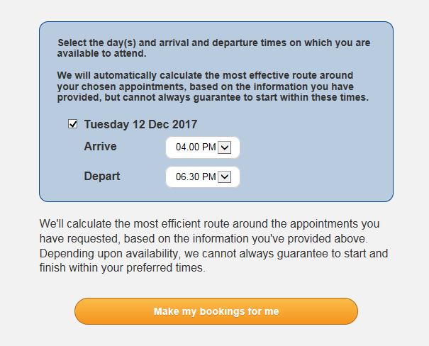
- You will then be asked when you
are available for your appointments.
Simply use the drop down menu to
select the earliest and latest times you
can attend.

Then click ‘make my bookings
for me’ button and the Wizard will do
all the hard work for you.

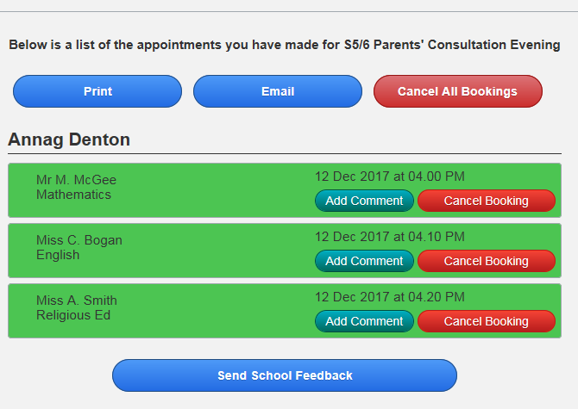
- The booking system will provide you with
your list of appointments which you can
either print out, email or refer to on your phone.
You can continue to add, cancel or amend
bookings right up until booking closes.

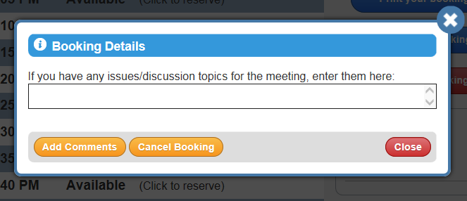

If you want to discuss a particular issue with any teacher then you can add a comment in advance of the meeting.

Please do not hesitate to contact the school office by telephone (01236 794896) or by email (enquiries@st-ambrose.n-lanark.sch.uk) if you require further support.

