Digital Homework Guide

Homework will be issued through our school app and on Microsoft Teams.
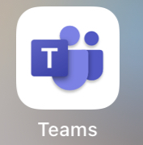
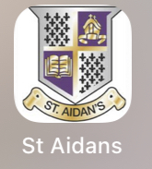

- You can download our school app from the app store by typing in “St Aidan’s Wishaw”.

- Microsoft teams also works best by downloading the app. It can be downloaded on phones, tablets and desktop computers.

- Homework will be issued digitally by the class teacher through the school app and each class’ Microsoft Teams page. No homework should be returned to school. Homework should be digitally handed in using Microsoft Teams.

The School App

- Each class teacher will post the homework for the week on the school app under their class heading.

- If you scroll along the categories at the top, you will see your child’s class and by clicking on it, you will be able to see any class announcements and homework.

- The school app is only used for issuing homework and homework cannot be handed in via this way.

Microsoft Teams
You can use the Microsoft Teams app on a desktop computer or on a phone/tablet.

Using a phone/tablet

- Download the app from the app store. Once it is downloaded, open the app and it will ask for your child’s glow email address.
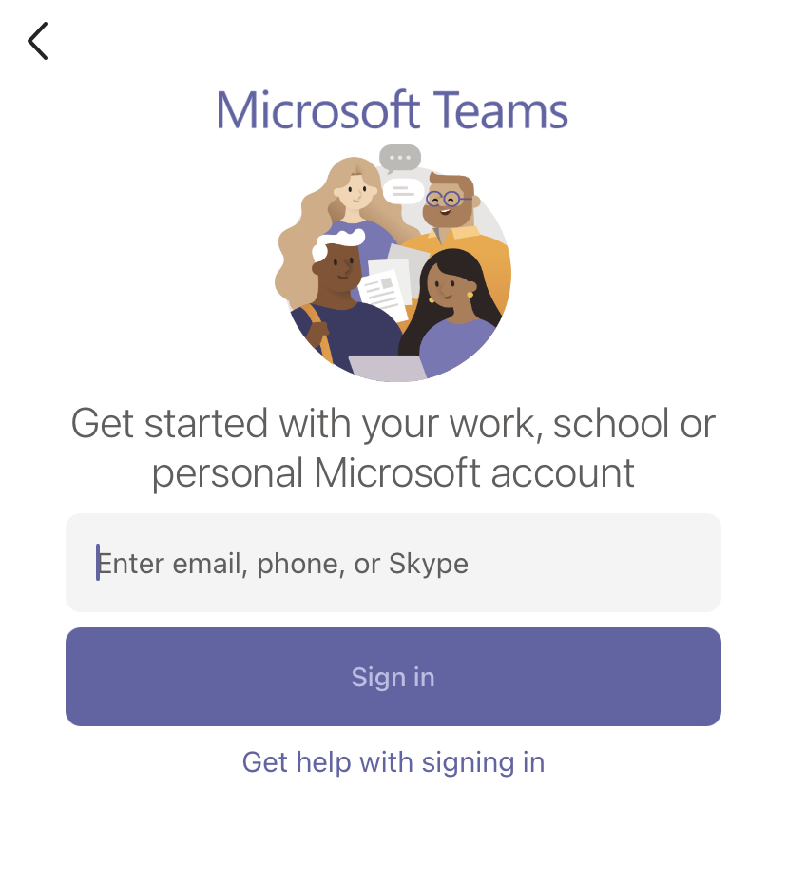

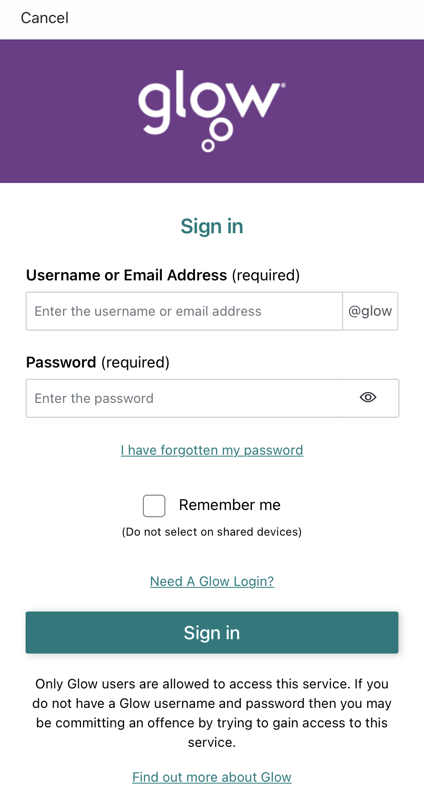
- Once you click “sign in”, it will then take you to a glow page where it will ask you to enter your child’s glow email address and password.

- You should be signed in and you should be able to see your child’s teams page.
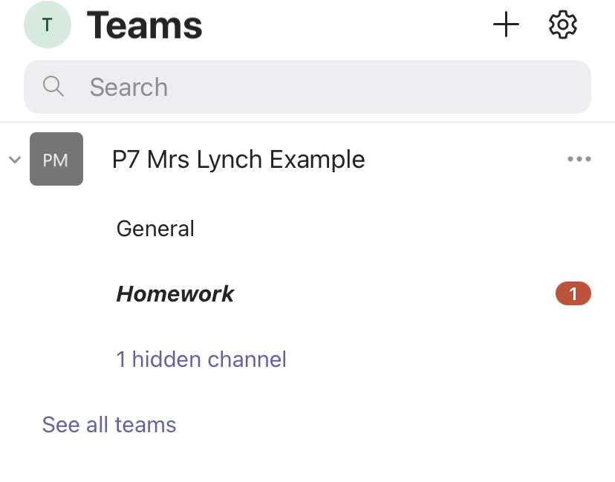

- Click on the “homework” channel in order to see your child’s homework for the week.
- To see the homework. Click on “view assignment” (circled in red in the picture below).
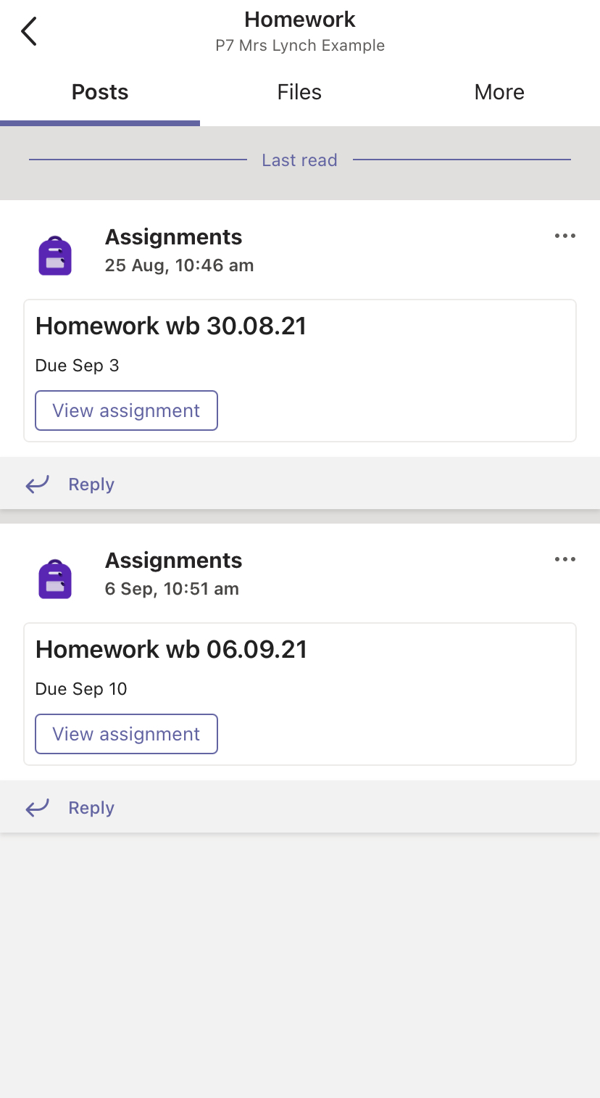
- If the homework requires any online resources, they will be uploaded to the files section (circled in green in the picture below).

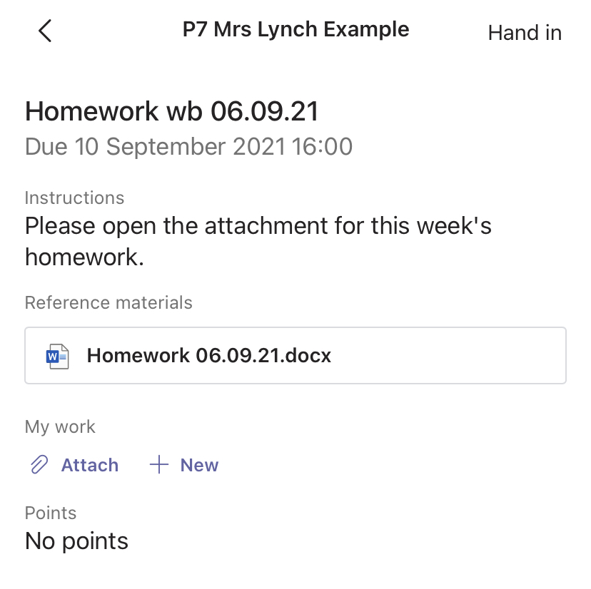
- It will then open up the “assignment” (homework) and it will look like the picture below. Click on the attachment – under the heading ‘reference materials’ (circled in red) and this will open up the homework tasks.

Handing in homework via Microsoft Teams.

- We ask that homework is not returned to school physically but handed in through the teams app.

- As a lot of the homework is active, particularly in the infants, taking a picture of the completed task or your child doing the task can be handed in as homework i.e. reading their book, writing their common words/spelling words or completing their sums etc.

- Class teachers can see who has completed sumdog/studyladder tasks so there is no need to upload a picture of those completed tasks to Microsoft Teams.

- To hand in homework:
  - Click on “attach” (circled in red) and then you can choose to upload a picture from your tablet/phone (circled in green) or take a photo of the completed task/your child doing their task (circled in blue).
  - You can upload multiple documents/photos and you can do this as you go throughout the week (the attachments that you upload will save automatically).
  - Please do not click “hand in” (circled in orange) until you have attached all homework for that week. If you do this and then have something else to attach, just click “undo hand in” and attach your other picture(s).
