**St.Aidan’s Primary School, Language and Communication Support Centre & Nursery Class**

**School Improvement Plan**

**2018/2019**

PARENTS AS PARTNERS IN LEARNING

DEVELOPING HOME SCHOOL PARTNERSHIP

**SCHOOL IMPROVEMENT PLAN 2018/2019**

**CHILD FRIENDLY VERSION**

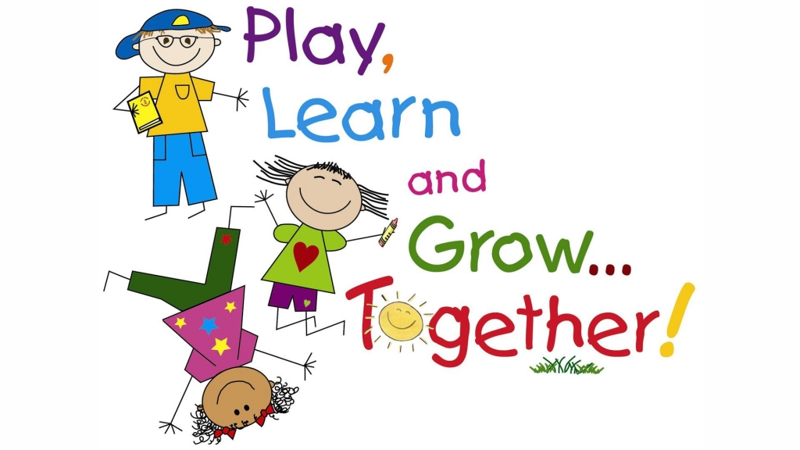

**We are going to continue to improve our Numeracy and Mathematics through interventions such as Number Talks, SEAL, 5 min numeracy Box and sumdog. We will plan an exciting Numeracy week and take our learning outdoors.**

**We are going to keep encouraging growth mindset, resilience and perseverance through our Nurture Support, Tree of Knowledge, Communication Friendly School Award, Drawing and Talking and Emotion Works Programme**.

**Teachers are going to keep learning from each other to ensure the best results in or school. This year we will be looking at phonological awareness, Big Writing and interventions such as Language Land, Book Bug, Sunnybank, Rainbow Reading, Read, Write and Inc. and Colourful Semantics to help us with our literacy. We will benefit from having a new and improved library area in school.**



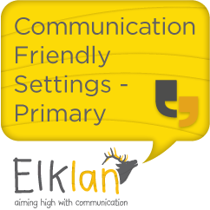

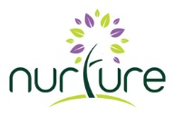

**We are going to keep encouraging everyone to be involved in making decisions about learning. We will understand how the benchmarks can show us progress and next steps. This will then be shared at home through our Tracking Reports**.

**WHAT ARE WE DOING TO IMPROVE OUR SCHOOL THIS YEAR**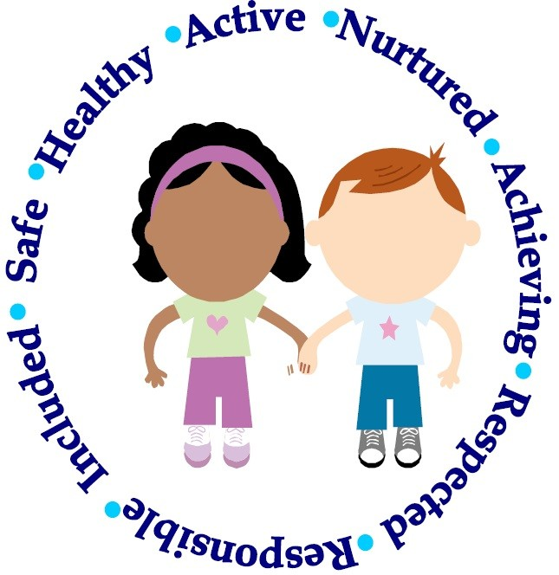

**We want to make our school a fair place and give everyone the same start by offering a Breakfast Club and Soft Start Play zone. Teachers will be trained in Makaton and we will offer Lunch Time and After School clubs to all children**



**We are going to make sure everyone has a voice and can take responsibility in school through participating in committees, playground buddies, pupil council, Pope Francis Faith Award and through our intergenerational project with Alzheimer Scotland**.



**Staff will make sure we are safe, staff will nurture us, and staff will listen to us. We will also learn more about our school core values**.

**We will improve our Health and Wellbeing through interventions such as the Daily Mile, Outdoor Learning, Forest Schools/ kindergarden. We will also begin to improve our playground.**