Primary 2/3 Homework Grid November 2020
Common Words and Phonemes  New learning is given in the grid below. Please do at least one active task and a written task weekly for the common words and phonemes given.  Phonemes Common Words  Dolphins Stage 2 Starting Stage 3 mb ue aw oi green people which another what bring long said three again these people too school some never  Sea Horses Stage 1 Starting Stage 2 oy oa ay ea our down off him all came here her before day away always today  Star Fish Stage 1 All initial sounds go got get with a focus on if for on g,l,f,o,b,u be but you  Active Ideas  Hit the target- Write your common words on small cards and lay them on the floor. Use a soft ball/wooden spoon etc. to hit the target. As you hit the target read the word aloud. An adult could also ask you to find the word and you splat it with your spoon.  Make It – Use pasta pieces to make your words.  Make It- Make your words using stones or pebbles.  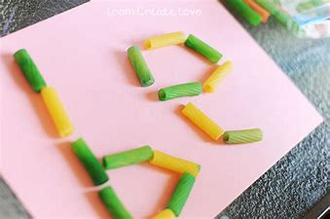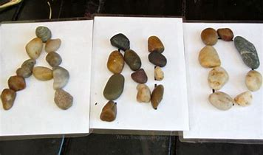  Written Ideas  Use Look, Say, Cover, Write, Check to spell words three times.  Can you write an interesting sentence using all of your spelling words?  Rainbow Write your words using rainbow colours.  BIG small spelling words eg. BECAUSE because  Numeracy and Maths  Use the 100 splat square to help with your counting patterns. Can you count in odds and evens? Steps of 2s, 5s and 10s Forwards by counting on and Backwards by counting back?  Try www.ictgames.com Whack a Mole and Play your Cards Right.  Money  You could set up your own shop at home and make price labels for the items you are selling. Check the coins your customers are giving you and work out change needed.  Lay out a selection of coins and add amounts up.  Can you find different ways to make 10p,20p, 50p and a £1?  Log in to your SumDog games. | Reading  Please log in to www.oxfordowl.co.uk and type the username stmarysp23 class login KATIEMORAG. If you go to My Class Login to enter the details given. Some examples of book titles are given below. You could also try the online activities shown at the top of the toolbar on each text.  Dolphins-Gold The Destroyer, East of the Sun The Champions Cup, False Alarms  Sea Horses-Green What’s That Noise? Rowing Boats Please Do Not Sneeze The Magic Paintbrush  Star Fish- Pink Big Feet, Can You See Me? Family Poems  Health and Well Being/ IDL TOPIC/ Religious Education  Go to www.sidandshanarri.co.uk and click on the Achieving Part of the Well Being Wheel and listen to the short clip. Can you think of something you have achieved recently at home and in school? Talk about your achievements and you could even make your own badge or certificate of achievement.  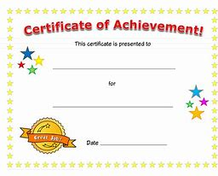  For our Victorian topic you could find out a few facts about school in Victorian times. You could write or draw about your findings.  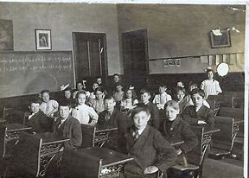  During the month of November we remember all those who have gone to Heaven. You could make a cross and write the names of all the people/pets you are praying for. Decorate it nicely and say the special remembrance prayer. We are very lucky to have so many special people watching over us and keeping us all safe.  