Primary 2/3 Homework Grid October 2020
Common Words and Phonemes  The children now have a red homework jotter containing a common word list and a phoneme list for their stage. Assessments took place during the month of September and we now have three working groups. New learning is given in the grid below. Please do at least one active task and a written task weekly for the common words and phonemes given.  Phonemes Common Words  Dolphins Stage 2 ss ll ff kn four miss never these well will fell call three room long tree under were thing know  Sea Horses Stage 1 ee oo ck ai had see has play no look make like made said big could  Star Fish Stage 1 Initial sounds a at the I in it an is and a,t,s,i,p,n,  Active Ideas  Lego Words- Can you make your common words using lego pieces?  Type It- Type your common words onto a screen, I pad, phone.  Make It- Make your words using pencils/crayons or pipe cleaners.  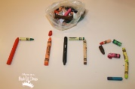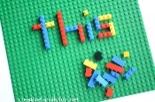  Written Ideas  Use Look, Say, Cover, Write, Check to spell words three times.  Rainbow Write your words using rainbow colours.  Pyramid spelling for example spell said s  sa  sai  said  Numeracy and Maths  Keep learning your numbers to 100 and beyond. Can you read and write them? Can you order them going from smallest to largest and largest to smallest?  Topmarks.co.uk Coconut Ordering and Caterpillar Ordering are good games to revise ordering and sequencing numbers.  Hit the Button is also good go over number bonds and doubles and halves in a fun way.  Measure  Collect five things from your house and order them from the smallest to the tallest? Shortest to the longest?  Using paper clips can you measure how many paper clips long your pen/ pencil is? Try to find some more objects to measure using your paper clips or your hand span. 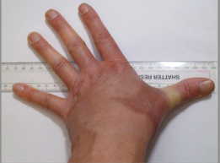  Log in to your SumDog games. | Reading  Please log in to www.oxfordowl.co.uk and type the username stmarysp23 class login KATIEMORAG. If you go to My Class Login to enter the details given. Some examples of book titles are given below. You could also try the online activities shown at the top of the toolbar on each text.  Dolphins Escape of the Giant Chicken Dinosaur Safari, Finn MacCool Mini Marvels  Sea Horses The Play Park, Zak and Zee, Painting the Loft, No Tricks Gran  Star Fish A Home For Ted, Tiger’s Family Big, Bad Bug The Dragon Balloon  It was good to hear that pupils are reading the Katie Morag texts at home and catching up with the CBBC episodes. The children have been so enthusiastic about our class topic.  Health and Well Being and Religious Education  Can you make an Autumn poster at home? You might want to draw and write about the signs of Autumn we are now seeing all around us. You could go on an Autumn walk and enjoy crunching in the piles of leaves all around you. Think about what you can see, hear, smell and touch.  Show that you are becoming responsible by making your bed in the morning and tidying away your toys. You have no idea how much this will help your parents and carers out. Make them smile by showing how grown up you are getting.  We have been learning lots about Katie Morag and Scotland. With an adult you could try to make a Scottish recipe or taste some Scottish foods. When you are at the shops look for foods with the Scottish flag. You could try tasting some porridge or oatcakes.  Remember to pray for those you love and care for. Say The Lord’s Prayer- The Our Father and also the Glory Be.

