# Easter Activities

St Mary’s Bulletin

|  |  |  |
| --- | --- | --- |
| March 2017 |  |  |

# Parent Council

• • •

We had a terrific turn out at our last meeting. Thanks to all who attended, great to see some new faces. Our next meeting will take place on Monday 27th March at 6.30pm, any parent wishing to joins us can. Our AGM will be held in school on Monday 24th April at 6.30pm. This is open to everyone and we would be delighted to see as many of you as possible. Many Thanks

Huge Thanks for the tremendous support.

We still have a Movie Morning / No Homework Week and Easter Disco.



On the last day, 31st March, we will announce the winners. All money raised will go towards SCIAF Big Wee Box Appeal.

**School Closes at 2.30pm on Friday 31st March**

# Reconciliation

P3 Children

The Primary 3 children will receive the Sacrament of Reconciliation on Tuesday 21st March at 7.30pm – Sacred Heart Parish. May God Bless them at this special time.

# School Disco

Thursday 30th March

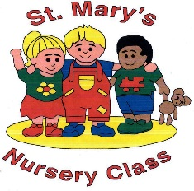P1-3 6.15pm – 7.15pm

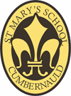P4-7 7.30pm – 8.45pm

Cost £2.50 includes

Drink/Snack/Sweet

# Sumdog

Letter with log in details is being sent home. Please keep it safe. Well done to our winners of the SumDog competition. Evidence suggests playing improves performance greatly and the children love it.

# Daffodil Tea / Fairtrade Coffee Morning

Why not come along and join us on Friday 24th March at 10.30am for some entertainment from the Nursery and School children, along with a cup of tea/coffee, Flowers and cakes will be on sale. Everyone Welcome