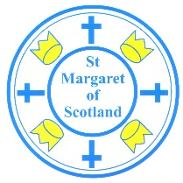

St Margaret of Scotland Primary, Language Communication Support Centre & Nursery

November 2025
School Telephone Number – 01236 632102



NEWSLETTER


Dear Parent or Carer,
We hope that you are all looking forward to Christmas this year. Please find out below what is happening in November and December in St Margaret of Scotland Primary.
Patronal Feast Day and St Margaret of Scotland 25th Birthday Celebrations
We are all looking forward to celebrating our Patronal Feast and our 25th Birthday of the opening of St Margaret of Scotland Primary, LCSC & Nursery Class. Please send any of your old picture to enquiries-at-st-margaret-scotland@northlan.org.uk
We will have various events throughout the week beginning 10th November 25.
- Our Talent show split will take place on Monday 10th (P1-P3) & Wednesday 12th (p4-P7) November (pupils only).
- Street Party Afternoon on Thurs 13th (pupils only). Pupils can bring an extra snack (remembering we are a nut free school).
- SMOS Feast Day Mass at 10.00am followed by Coffee Morning for parents, family and invited guests on Friday 14th with & movie/popcorn afternoon for all the children in their classes.

Our parent council are going to try and find the “time capsule” that we believe was buried in the garden and add items to be found in the next 25 years!

Christmas Enterprise

Our pupil Christmas Enterprise will take place on Thursday 4th December 2025 from 3.00 – 5.30pm Please come along and support your child and their class as we have lots of enterprising Christmas gifts you can buy.
Please note this date in your diary and spread the word.

SMOS Parent Council Christmas Fayre
The parent council will be holding their Annual Christmas Faye in the school on Saturday 6th December from 11.00-13.00.
💫 Colour Raffle Donations
Each class will be allocated a colour, and we’re asking for donations to help create our fabulous hampers! A letter has been issued by Mrs Dempsey on behalf of the PC.
Think of anything you’d love to receive yourself — such as:
✨ Toiletries & pamper sets
✨ Non-perishable treats (crisps, sweets, chocolates)
✨ Smelly sets, candles, or small gifts
🎁 Raffle Prizes
If you’d prefer, you can also donate a larger prize — bottles of alcohol, vouchers, or gift sets are all hugely appreciated!
Every single item donated helps us raise money for the fun events and experiences we put on for our children throughout the year. 💖
🙋‍♀️ Volunteers Needed
We’re also looking for friendly helpers to run the game stalls and lend a hand during the fayre. It’s a brilliant way to get involved and be part of the festive fun!
Let’s come together as a wonderful SMOS community and make this year’s Christmas Fayre one to remember! 🎅🎁🎄


Christmas Lunch

The children will have their Christmas lunch in school on Thursday 11th December 2025. A letter has been issued to you.

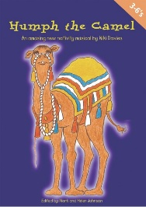
“Humph The Camel” Performance
The P1 – P3 children have been rehearsing for the school nativity “Humph the Camel”.
This event will take place on Tuesday 2nd December @ 1.45pm and Wednesday 3rd December @ 1.45pm
Tickets are available for sale at £2 per ticket (max 2 tickets per family).

Christmas Class Parties 5th – 15th December
Our Christmas parties will take place as follows:
Fridy 5th December All P7’s Monday 8th December All P6’s
Tuesday 9th December All P5’s Wednesday 10th December All P4’s
Thursday 11th December All P3’s Friday 12th December All All P2’s
Monday 15th December All P1’s

On the day of the party your child can bring a change of clothes in their schoolbag.


M & M Productions “Cinderella”
There will be an in-house showing of the Pantomime “Snow White” for our children on Tuesday 16th December 2025.
This event will be funded by the school so there will be no cost to parents/carers.

Communication

The school will be moving away from the X platform for sharing pictures of learner. This will move to SWAY. A separate letter has been issued containing guidance for parents. Please contact the school office if you need any other information.

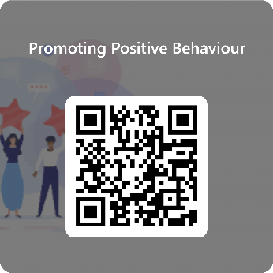
Promoting Positive Behaviour
We are seeking parental views on our school policy in promoting positive behaviour. Please scan the QR code.

Head Lice
Once a week – take a peak!
Be extra vigilant and check your child’s hair regularly.

Dogs in the School Yard
Please be reminded that dogs are not allowed in school grounds. They must be on a lead at all times and remain outside the school gates. If you require to enter the grounds the dog must be carried by an adult.


Breakfast Club
A reminder that our breakfast club provision remains an option from 8.20am. This is a free provision for P1 – P5 and if you would like P6 or P7 to attend please contact the school for further discussion. Achieve More coaches offer some morning physical activity at the club too.



Dates to Remember

Tuesday 2nd & Wednesday 3rd December Humph the Camel Performance
Thursday 4th December School Christmas Enterprise
Saturday 6th December Parent Council Christmas Fayre
Friday 5th – Monday 15th Class Parties
Tuesday 16th December Pantomime
Thursday 18th December School closes at 2.30pm
Monday 5th January 2026 Pupils Return to School

Wishing all of our SMOS community a peaceful and happy Christmas.
With kind regards and best wishes.

S Duffy (Mr)
Acting Head Teacher

