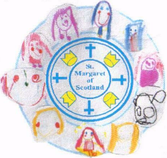

St Margaret of Scotland
Primary, LCSC and Nursery Class

Learning, Teaching and Assessment Policy

June 2021

Rationale

In St Margaret of Scotland Primary, we are committed to ensuring we provide the highest possible learning experiences for all of our children. We offer an inclusive environment where all learner’s needs are met. This ensures that we deliver the best possible life chances for all of our children.

Our learning and teaching is underpinned by the following documentation:
- Curriculum for Excellence Experiences and Outcomes and Benchmarks
- National Improvement Framework and Improvement Plan, 2021
- Building the Curriculum 1-5
- How Good is Our School 4
- Moderation Cycle
- ‘Making every lesson great’- North Lanarkshire Council
We are committed to providing:
- Excellence through raising attainment: ensuring that every child achieves the highest standards in literacy and numeracy, set out within Curriculum for Excellence levels, and the right range of skills, qualifications and achievements to allow them to succeed; and
- Achieving equity: ensuring that every child has the same opportunity to succeed, with a particular focus on closing the poverty-related attainment gap.
National Improvement Framework
The National Improvement Framework and Improvement Plan helps us deliver the twin aims of excellence and equity; galvanizing efforts and aligning our collective improvement activities across all partners in the education system to address our key priorities.
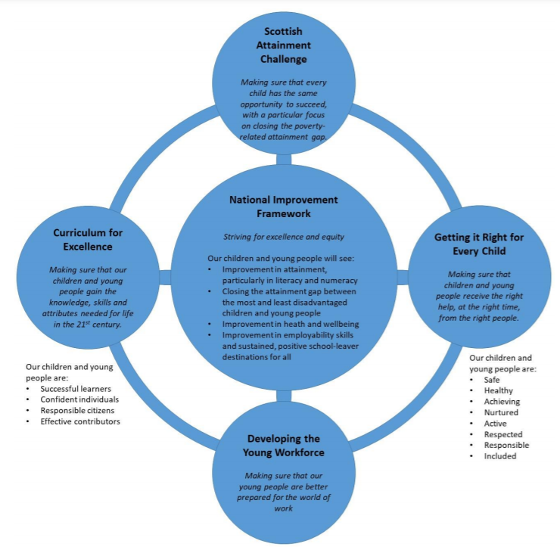

Aims

Our aims are to:
- Provide high quality learning experiences and opportunities for all learners. Ensuring that we provide additional support and interventions for those pupils who require this as well as challenging our more able learners.
- Assess, monitor and track our pupils’ progress to ensure they are successfully progressing through CfE levels.
- Work as a team to identify and meet our School Improvement Priorities in order to continually improve and develop our school in line with the National Improvement Framework values and priorities.
- Provide a range of CLPL opportunities for our staff members in order to allow them to continually develop and improve their practice.
- Promote Parent Partnerships in order to support our parents/carers in developing the skills and confidence to engage in, and encourage, their children’s learning in school and in everyday life.

“Schools need to ensure that information about children’s attainment and achievement is robust and used effectively to make improvement to children’s learning”.​ Quality and Improvement in Scottish Education 2012-2016

“Both staff and learners should foster a sense of achievement by sharing challenging and realistic expectations. Sharing success criteria along with learning intentions allows learners to see what success looks like”. Building the Curriculum 5

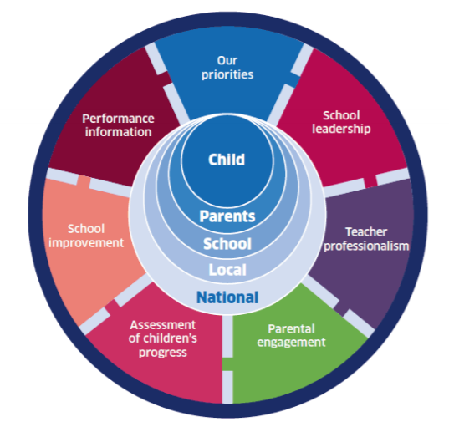

Key elements of effective Learning and Teaching

Every lesson should include the following key elements to help ensure high quality learning and teaching.

- Clear Learning Intentions and Success Criteria for every lesson.
Learning Intentions:
- We use the phrase W.A.L.T (We are learning to) when sharing and discussing the learning intentions with our children.
- Our Learning intentions are shared orally and displayed in a child-friendly legible/pictorial manner.
- All pupils should be able to say, ‘At the end of this lesson, I will know/be able to/understand...’
- Where appropriate, the children will write the W.A.L.T in their jotters.
- When marking, the focus for feedback must relate specifically to the W.A.L.T/W.I.L.F.
- W.A.L.T Communication Friendly poster is displayed in every classroom.
Success Criteria:
- We use the phrase W.I.L.F (What I’m looking For) when creating, sharing and discussing the Success Criteria with our children.
- All pupils will participate in creating a clear and specific W.I.L.F showing what success will look like and how they will achieve the W.A.L.T. This will be in partnership with the teacher.
- W.I.L.F is displayed legibly/pictorially for the children to follow during the lesson and is regularly discussed with and by the learners during the lesson. The children’s work is regularly used to illustrate success in action.
- Children use the criteria to self-assess their own and/or partner’s work.
- W.I.L.F Communication friendly poster is displayed in every classroom.

- Clear Differentiation to Enable ALL Pupils to Access learning

- All children are challenged appropriately.
- Planning shows clear differentiation.
- W.A.L.T. may be the same for all children. However, W.I.L.F., tasks, resources and level of input may differ from child to child.

- All Children are actively engaged in their Learning

- All children should be actively engaged in their learning. Staff should take into consideration, each child’s concentration span.
- Opportunities to Think/Pair/Share and discussion with a ‘shoulder partner’ are regular features in lessons. Children are trained to engage appropriately and effectively.
- Whiteboards are used for short bursts of show me activities to develop understanding and to ensure children are engaged during the lesson.
- Visual aids, artefacts, clips, games etc. are all used creatively in order to enhance learning.

- All Children receive Feedback which is regular and clear and enhances learning

- AifL strategies are embedded in everyday practice and are used to inform learning and teaching.
- All children are clear about how they need to improve.
- Marking is directly linked to the learning intention/success criteria and identifies next steps.
- A mixture of written and oral teacher feedback is provided during and after each lesson.
- Pupils are trained to identify and provide feedback on their own and peer’s learning. They can identify key strengths and next steps linked with the W.A.L.T and W.I.L.F.
- Children are given appropriate time to reflect upon and to address feedback given.

- Learning is enhanced through the use of ICT

- ICT is used to enhance learning wherever possible.
- Each class has their own set of iPads and interactive smartboard for daily use.
- Laptops are available for each class to use each week to support learning across the curriculum.

- Learning is enhanced though Co-operative Learning

- Co-operative learning refers to a set of instructional methods in which children work in small, mixed-ability learning teams and is a key feature of classroom practice in St Margaret of Scotland Primary. The children in each team are responsible not only for learning the material themselves but also for helping their team. Co-operative learning is used across the curriculum
- Positive teamwork behaviours are explicitly taught and reinforced, before co-operative learning is implemented

- Learning is supported through the effective use of Additional Adults

- Additional adults are given clear direction on how the class teacher wishes them to support children’s learning. They are clear about who they are supporting and why.
- Additional adults spend a significant amount of their allocated classroom time supporting children with their learning rather than doing administrative tasks.

- Children can only learn when there are High Standards of Behaviour

- Promoting positive behaviour plays a significant role in St Margaret of Scotland Primary. Strategies that we use for promoting positive behaviour can be found in our school’s Positive Behaviour Policy.
Structuring an Effective Lesson

Lessons generally follow a basic structure which comprises four ‘phases,’ as follows:

Phase 1: Overview
Phase 2: Receiving new information
Phase 3: Processing the information
Phase 4: Review

Teachers may move through the phases more than once during a lesson. In other words, there can be several direct teaching inputs and several mini plenaries during the one lesson. Good teachers weave instruction and review throughout the lesson. It is essential to remember that teaching and learning is not the same thing; encountering information is not the same as understanding it. At the heart of any really successful school is teaching which leads to learning.

- Structuring an Effective Lesson: Phase 1 – OVERVIEW

Although this is relatively short in duration, it includes a number of features.

Creating an appropriate working atmosphere

- A classroom environment should be created that maximises opportunities to learn. Displays and keywords are changed regularly and aid learning. The environment should be free from clutter and arranged to aid independent learning.
- Resources should be prepared and accessible in advance of lessons.
- Greeting the class with a smile and building a positive, supportive relationship with every pupil is key.

Linking the lesson to prior learning/knowledge – exemplars

- ‘Think about the three most important things you learnt in the last lesson – now tell your partner.’
- ‘In two minutes, I’m going to ask you what you learnt in the last lesson. You may talk to your shoulder partner if your wish.’
- ‘Today’s lesson is about the water cycle. Work with your shoulder partner and jot down what you already know on your whiteboard.’

Providing an Overview

- One way teachers can help children see the ‘big picture’ is by building up a ‘topic map’ which the children can add their own questions and answers as a unit of work progresses.

Sharing W.A.L.T./W.I.L.F. with children

- ‘By the end of today’s lesson you will all know/be able to/understand…’
- Ensure W.A.L.T. and W.I.L.F. are specific and child friendly language is used.

Triggering thinking

Consider beginning a lesson by saying:
- ‘Today when I’m reading, I want you to listen out for some really powerful adjectives that you can use in your writing later on.’
- ‘For homework tonight, I am going to be asking you to write down the functions of the different parts of a plant – you will find out what these are in today’s lesson.’

- Structuring an Effective Lesson: Phase 2 –Receiving New Information

Providing pupils with new information and skills. This is the teaching phase. New information can be delivered in numerous ways:

- Exposition
- Audio-visual aids (e.g. video clip etc.)
- Diagrams and pictures
- ICT programmes/Internet
- Books
- Practical demonstration
- Teacher/peer modelling

The quality of the input during this phase will have a huge impact upon the extent to which pupils understand information. While high-quality exposition does not necessarily guarantee understanding, it does make it significantly more likely.

Periods of exposition are short
Children, no matter their age, have a limited concentration span. In general terms, significantly more learning will take place when new information is transferred and explained in three bursts of ten minutes rather than one thirty minute session.

More than one ‘beginning’ is created

Children tend to remember more from the beginning of an experience. When exposition is chunked, a number of ‘beginnings’ are created in the lesson. Teachers should make these new starts obvious using phrases such as, ‘Now we are moving onto…’ or ‘The next activity we are going to be doing is…’ or ‘I’d like you to move back to the carpet for the next part of the lesson.’

Teaching input needs to be regularly punctuated with effective questions

- Effective Questioning is a vital component in every lesson. Our staff use Blooms Taxonomy in order to ask questions that will develop our learners’ higher order thinking skills.
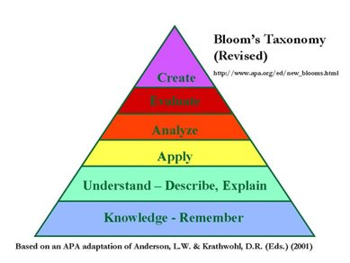
- Posing an open question at the start of an explanation will prime the brain to notice detail and begin to form an answer.
- Asking an open question at the end of input takes the learning into Phase Three and is designed to develop and to assess deeper learning.
- Teachers should not be frightened to ask closed questions during teaching input. Closed questions keep children alert and provide instant feedback as to whether they have heard correctly and have understood.

Teaching input needs to be punctuated with activity

Teachers should punctuate the input of new information (Phase Two) with activities designed to help children make sense of it (Phase Three). This kind of integrated, alternating patter of, ‘Phase Two, Phase Three, Phase two, Phase Three’ can often be more effective than an extended period of explanation. For example, if a teacher is modelling how to write complex sentences, s/he might pause and ask the children to work with a partner to write one sentence on a whiteboard before continuing with further instruction.

New information is presented in different ways

The fact that different individuals prefer to receive information in different ways requires that information is transmitted in more than one way during Phase Two.

A verbal explanation may well be clear, concise and of high quality. However, two thirds of the class may be working outside their preferred learning style and struggle to grasp what is being said.
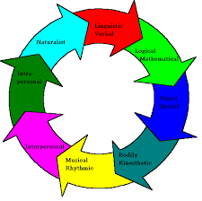
Teachers should aim to make learning multi-sensory so that children have opportunities to learn from seeing, hearing and doing. Howard Gardner’s theory of Multiple Intelligences can be a helpful way for teachers to ensure that a wide variety of learning approaches are used in the classroom.
say

make
do

write

- Structuring an Effective Lesson: Phase Three - Processing the Information

The emphasis in Phase Three is on:

- Developing understanding
- Demonstrating understanding
- Assessing understanding
Active Learning
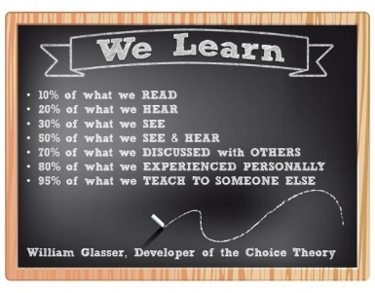
For children to learn something well, they need to experience the information or concept in a variety of ways: hearing it, seeing it, discussing it with others, asking questions about it. Most importantly, children need to ‘do it,’ working things out for themselves, exploring new things through a range of examples and applying knowledge and skills in new and unfamiliar contexts.

Of course, the teacher has a vital role to play in active learning – supporting children and extending learning through skilful intervention. All areas of the curriculum at all stages can be enriched and developed through an active approach.

Quality Teacher/Pupil Interactions

- Using effective questioning, especially carefully formulated open questions.
- Providing ‘thinking time.’ (Children need time to think-through their answers before replying.)
- Giving children the opportunity to explore and to articulate their thinking in pairs and groups.
- Ensuring that children fully understand the question by asking them to repeat it or to re-phrase it.
- Extending and deepening understanding by asking follow-up questions, for example, ‘What made you think that?’
- Asking children to identify three possible answers and then to select the best one (so that they don’t always give the first answer that pops into their heads.)
- Scaffolding thinking and answering e.g. ‘In two minutes I am going to ask you…but before I do, I’d like you to think/talk about… Now I’d like you to think about…Now you can answer my original question.’

- Structuring an Effective Lesson: Phase Four – Review
The emphasis on this phase is:
- Reviewing what has been learned
- Reflecting on how and why it has been learned

The W.A.L.T. is central to all four phases of the lesson.

When teachers summarise what has been learned, the effect on children’s memories is relatively significant. However, when children themselves identify what they have learned as the lesson draws to a close, their memories will be given a significant boost.
Teachers must always refer back to the W.A.L.T. and W.I.L.F. encouraging the children to reflect on what they have learned and what has helped them to learn. Use prompts such as:

- What did you do today that you found most helpful when you were learning?
- What did you do today that you found less helpful?
- If you had to do the task again, how would you do it?
- If you had to give one piece of advice to someone tacking the same task tomorrow, what would it be?
- Remember all phases are connected through good, specific W.A.L.T. and W.I.L.F. criteria.

Assessment

Assessment is an integral and ongoing part of Learning and Teaching in St Margaret of Scotland Primary.

“Assessment in the context of education involves deciding, collecting and making judgements about evidence relating to the goals of the learning being assessed.” Harlen, 2006

Assessment is built in – not a bolt on at the end of a lesson.
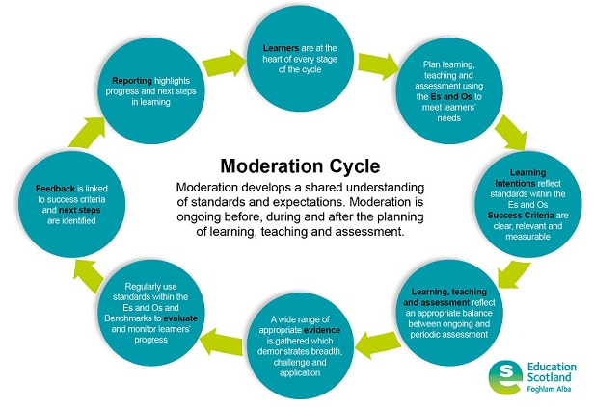
This means we identify:
- What we want children to learn (outcome).
- How they’re expected to learn it (experience).
- How they’re able to demonstrate their learning.
- If the nature of the response (evidence) involves additional learning. We design tasks which take account of this.

Formative Assessment

- Assessment is said to be formative when the teacher and the learner adjust teaching and learning in the light of feedback. It focusses more on what HAS been learned and what needs to happen next - ‘within their extended grasp’.
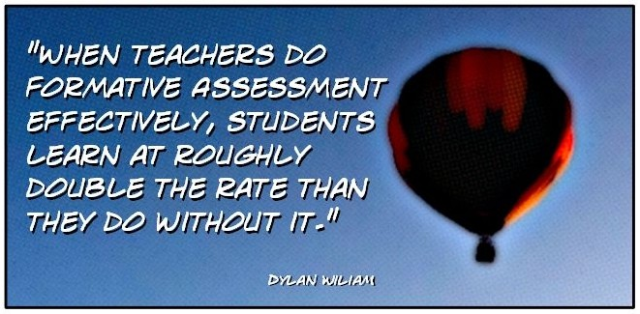
- Should move learning forward.
- Should be ongoing and continuous.
- We use a range of formative assessment strategies across our school.

Summative Assessment
- Assessment is summative when it is used simply to evaluate the extent to which progress has been made or standards met – a snapshot in time.
- We have an Assessment Calendar which each stage follows throughout the year. Our pupils take part in a variety of summative assessments in order for us to gather evidence and data to demonstrate that our pupils are successfully progressing through CfE levels. Please see our Assessment Calendar in the Appendix.
- We have Learning Log jotters. Our pupils complete all learning activities in these jotters on certain weeks throughout the year. These snapshot learning jotters are again used as evidence on our pupils’ learning and progression. They are shared with our parents/carers at certain points throughout the year.

Teacher Professional Judgement

Teacher Professional Judgement plays a huge role in St Margaret of Scotland Primary. Here is some information on why this is significant:

- Formal tests can’t easily assess learning considered important for life in the 21st Century​.
- Some learning can only be assessed by observing how pupils respond to tasks set.
- Teaching staff and EY practitioners are best-placed to devise meaningful tasks and assess learning which can’t be easily ‘measured’.

“Teachers’ professional judgement about the progress children and young people are making and the point at which they should progress from one level to another will be important features of learning and teaching approaches.” BtC 3: a framework for learning and teaching, 2008: p26

In St Margaret of Scotland Primary, our staff work collegiately to assess and moderate our pupils’ learning through completing High Quality Assessments each term. Our staff gather SAY, MAKE, WRITE AND DO evidence and work with their stage partners in order to moderate the High Quality Assessment Pieces. This ensures that we have consistency in standards and our staff have a clear understanding on Achievement of a Level.
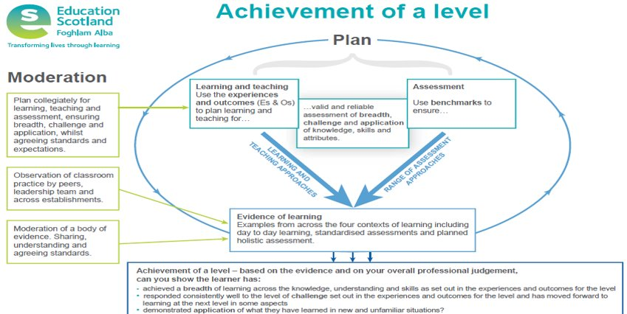
Teachers’ Professional Judgement for each pupil is recorded and tracked at three points throughout the year. (October, January and April). Our staff members track children using the following criteria: Purple – Requires challenge, Green – on track, Yellow – inconsistent and Red – not on track.

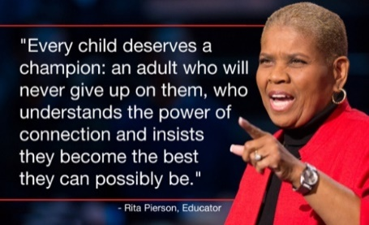
Conclusion

This policy is intended to identify the learning, teaching and assessment procedures that we follow in St Margaret of Scotland Primary in order to meet the needs of all of our learners. We are a “School of Quality” and strive to Get it right for every pupil!

Evaluation and Monitoring

This policy will be reviewed in June 2022.

APPENDIX 1
Assessment Calendar
2021- 2022
* = new pupils / those of unknown ability / less able pupils
** = pupils of average ability
*** = more able children / pupils working at a fast pace
**** = deadline for completion of reading assessments
 | Aug. | Sept. | Oct. | Nov. | Dec. | Jan. | Feb. | Mar. | Apr. | May | June
Planned Learning Conversation with Stage Partner(s) | $$√$$ |  | $$√$$ |  |  | $$√$$ |  |  | $$√$$
Update Seemis using teachers’ professional judgement (Tracking CfE Levels - linked to Benchmarks) |  |  | $$√$$ |  |  | $$√$$ |  |  | $$√$$
Moderation: High Quality Assessment | $$√$$ |  | $$√$$ |  |  | $$√$$ |  |  | $$√$$
SNSA P2 – P7 |  |  |  |  |  |  |  |  |  | $$√$$
Literacy Environment  (Guide for setting up the classroom) | $$√$$
CEM P1 | $√$ |  |  |  |  |  |  |  |  | $$√$$
SWST P2 – P7 |  | $$√$$ |  |  |  |  |  |  |  | $$√$$
Unassisted Writing -  Criterion Scale Assessment |  | $$√$$ |  |  |  | $$√$$ |  |  |  | $$√$$
 | Aug. | Sept. | Oct. | Nov | Dec. | Jan. | Feb. | Mar. | Apr. | May | June
Benchmarking for all pupils reading PM books P2/P3 and Rapid Readers P4 to P7 |  |  | $$√$$ |  |  |  |  | $$√$$ |  |  | ****
Running Records for pupils on P3, P4/5 or P6/7 novels |  |  | $$√$$
Benchmarking P1 |  |  |  | $$√$$  *** |  |  | $$√$$  ** |  |  | $$√$$  * | ****
NLC Active Literacy P1 – P7  (ongoing throughout the year) |  | $$√$$ | $$√$$ | $$√$$ | $$√$$ | $$√$$ | $$√$$ | $$√$$ | $$√$$ | $$√$$
IDL Cloud P4 - P7 |  | $$√$$ |  |  |  | $$√$$ |  |  |  |  | $$√$$
Teach Your Monster to Read  P1 – P3 |  | $$√$$ |  |  |  | $$√$$ |  |  |  |  | $$√$$
YARC P7 (for selected pupils only) |  |  |  |  |  |  |  |  |  | $$√$$
MALT P1 – P7 | $$√$$ |  |  |  |  |  |  |  |  |  | $$√$$
MALT for children on Catch Up Numeracy | $$√$$ |  |  | $$√$$ |  |  |  |  |  |  | $$√$$
Maths – Linked to SEAL/Developing Number Knowledge P1 – P7  (ongoing throughout the year) |  | $$√$$ | $$√$$ | $$√$$ | $$√$$ | $$√$$ | $$√$$ | $$√$$ | $$√$$ | $$√$$
 | Aug. | Sept. | Oct. | Nov | Dec. | Jan. | Feb. | Mar. | Apr. | May | June
NLC – Stress and Anxiety | √
HWB - SDQ |  |  |  |  |  |  |  | $$√$$
HWB – My Star Profile for Kidzone |  | $$√$$ |  |  |  |  |  |  |  | $$√$$
HWB- Kidzone – Boxhall Profile | √
Assessment Class Checkpoint - preschool |  |  |  |  |  |  |  |  |  | $$√$$
Assessment Class  Language Communication Grid |  | $$√$$ |  |  |  | $$√$$ |  |  |  | $$√$$
Nursery Tracking and Monitoring Grid for Literacy |  | $$√$$ |  |  |  | $$√$$ |  |  |  | $$√$$
Nursery Tracking and Monitoring Grid for Numeracy |  | $$√$$ |  |  |  | $$√$$ |  |  |  | $$√$$
Nursery Tracking and Monitoring Grid for HWB |  | $$√$$ |  |  |  | $$√$$ |  |  |  | $$√$$

APPENDIX 2

High Quality Assessment Template

Class: | Teacher: | Term:
Experiences and Outcomes | Periodic Assessment/Context/Learning Experiences | Learning Outcomes/Success Criteria – demonstration of learning (“I can…” as defined by the success criteria agreed)
Benchmarks – to be filled in after periodic assessment evidence gathered | Pupil Voice – to be filled in after periodic assessment evidence has been gathered. This evidence can be gathered and then annotated using stickers, post its etc. What has the pupil learned? How did the pupil learn? What skills were developed? | Evidence of Learning – (Say, Write, Make, Do). Consider the range of assessment evidence that will be gathered to meet the intended outcome (breadth, challenge and application)

APPENDIX 3

Moderation Template with Reflective Questions

Regional Improvement Collaborative: West Partnership
Facilitator Moderation Template (FMT)

This template should be completed by a facilitator/member of the group to provide the practitioner with constructive and supportive feedback that represents the views of the group. Please ensure your comments are legible and supportive.
Facilitator
Curriculum Area(s) | Languages | Maths |  |  | Sciences |  |  | Social Studies |  |  | Exp. Arts | Technologies |  |  | RME |  | HWB
Aspect | Literacy |  |  |  |  |  | Numeracy |  |  |  |  |  |  | Health & Wellbeing
Level | Early |  |  | First |  |  |  |  | Second |  |  |  | Third |  |  | Fourth
HOTS | Remembering |  | Understanding |  |  | Applying |  |  |  | Analysing |  |  | Evaluating |  | Creating
Evidence Code

Moderation of planning- Planning for assessment
Planning | Is there coherence amongst the Es and Os selected? How can you evidence this?  Is key learning identified?  Is there coherence amongst the Es and Os selected?  Do the Es and Os that have been selected link together well?  Are the Es and Os meaningful and relevant to the children?  Does the evidence relate to the Es and Os identified?
Is the Learning Intention clear, concise and does the Success Criteria clearly state what the learner should know, understand and be able to do by the end of the learning experience? (Can you clearly identify the Higher Order Thinking Skills)

Does the Learning Intention clearly link with the selected Es and Os?
Is it clear to see the intended learning?
Does the language within the Learning Intention clearly link with the verbs within the selected Es and Os?
Is the Learning Intention concise and devoid of any unnecessary context?

Are the Success Criteria clear, relevant and measurable?
Do the Success Criteria outline what the learner needs to do to achieve the learning?
Are they written in pupil friendly language?
Is there evidence to suggest the learner was involved in creating the Success Criteria?
Do the Success Criteria include the development of skills, knowledge and/or attributes?
Do the Success Criteria link with the Learning Intention? And in turn the benchmarks?

Assessment | How have the Benchmarks been used to support the creation of the success criteria? What evidence is there to support this?  Have the appropriate benchmarks been selected that link with what is being assessed?  Does the evidence clearly support the benchmarks selected?  Is the language/skills/knowledge within the benchmarks evident in the success criteria?
Is this plan for a child or group or YP at the beginning, middle or at the end of a level? (This should cover areas such as pace and challenge, breadth and application and achievement through a level)

How is this evidenced? Is it clear where they are in their learning journey? In what way? Or why is it not?

Is the planned learning experiences/ context focussed and does it facilitate the key learning from the identified Es and Os?

Does this give an overview of the learning experiences clearly linked to the Es and Os?
Do the learning experiences meet the needs of the learner? Challenge or support?
Are the learning experiences engaging and enjoyable? Allow for personalisation and choice?
Are they coherent and relevant?
Is there a depth of to the learning experience? Progression with the learning? And breadth of learning experiences?

Do the learning experiences show high quality teaching and learning practices?

Is there a triangulation between the planning, the teaching and learning experiences, the assessment? E.g/ Are the Es and Os planned in the teacher’s forward plan/termly plan/weekly plan? Is this what the children have been learning about for a duration of the term? Can the children discuss and talk about their learning which clearly links to the Es and Os planned and the learning experiences delivered? Is the assessment process/Periodic Assessment clearly linked in and delivered timely? (Not just an add on)

Moderation of learning. Progress towards achievement of a level.

Learning Experiences and Planned Assessment
Reflect upon the planned learning experiences/context? Is there a range of evidence? Reflect on the range/quality of assessment evidence gathered to meet the success criteria considering breadth, challenge and application of learning. In what way do they demonstrate the design principles?

Do the learning experiences link with the planned Es and Os? With a breadth of learning?
Is there range of learning experiences planned with a range of evidence?
Including what the learner can say, make, write and do?
Do the learning experiences and the evidence reflect skills, knowledge and understanding and attributes?
Does the learning experience and learning evidence reflect the targeted learning (not the activity)?
Are a range of assessment approaches planned and used? Including peer and self assessment, questioning, formative approaches?
Does the learning experiences and evidence cover the four contexts for learning? Curriculum areas and subjects, interdisciplinary learning, opportunities for personal achievement and ethos and life of the school.
Are there opportunities for breadth, challenge and application?

Breadth
Progression in areas of their learning
- Growing confidence and competence of skills in familiar contexts
- Broadening their use of language in a range of familiar contexts
- Broadening amount of detail in explanations, descriptions etc that are provided written and oral
- Making connections within their learning including across curricular areas

Challenge
- Developing skills, attributes and capabilities in more challenging
- Developing aspects of Higher Order Thinking Skills- analysing, evaluating, creating
- Learning in a more complex contexts/situations
- Demonstrating increasing responsibility and independence in their learning
- Developing ability to evaluate their own and others learning
- Responding accurately and confidently in more challenging and unfamiliar contexts
- Responding to and producing increasingly complex pieces of work,
- Developing more complex texts, presentations, models etc with greater length, vocabulary, structure and ideas and concepts

Application
- Learning, including, knowledge, skills and attributes are used in new and unfamiliar contexts
- The learning is transferrable into new contexts and across subject areas
- Make strong connections between learning across learning and subject areas
- Finding, selecting, sorting, classifying and linking information from a variety of sources
- Using information for a variety of purposes
- Exploring new ideas and concepts
- Making informed decisions based on knowledge and information received from different reliable sources
- Justifying and explaining their ideas, their thinking and their judgements
- Independence within their learning, what and how they learn
- Complex texts, presentations, models etc with greater length, vocabulary, structure and ideas and concepts in different ways and different contexts
- Evaluating own and others learning, identifying next steps and how to achieve them
- Sharing learning in a variety of different ways, for a variety of different purposes and audiences
- Use of HOTS consistently within their learning

Challenge and enjoyment, breadth, progression, depth,, personalisation and choice, coherence and relevance

Feedback and annotations of learner’s evidence
Is the feedback linked to the success criteria and are the learner’s strengths and next steps identified? What is the progress towards achievement of a level?

Is the feedback focussed on the agreed set of Success Criteria?
Is the feedback age and stage appropriate? Child friendly language?
Are the strengths clear to the learner?
Are the next steps clear to the learner? Is it clear how the learner can improve and meet the next steps?
Is the feedback linked to the Success Criteria/Learning Intentions/Benchmarks?
Is there a range of teacher, peer and self assessment?
Is the feedback acknowledged by the learner?
Can you see within the evidence that the feedback has been acted upon?

Pupil Voice – Where is there evidence of the learner’s involvement in the assessment process? What further suggestions could you offer to extend and support this young person?

Is there evidence of dialogue with the learner about their learning?
Have pupils had the opportunity to reflect on their learning? Including the strengths and areas for improvement?
Is there evidence to show that the learner has had choices within their learning?
Can you see where the children have made choices? Info shared? Created new texts of their own choice?
Have they participated in peer and/or self assessment?
Is there evidence of the pupils discussing their learning with others- what they are doing, how they are doing it?
Have they had the opportunity to share their learning?
Is there evidence of learners answering HOTS questions? Discussing questions? Asking HOTS questions? Explain their answers?

Can you identify where this child/young person is on their journey towards achievement of a level. Are they;
- On track and may require challenge
- On track to achieve
- At risk of underachieving
- Not on track and underachieving. Requires additional support.

Is the assessment valid? Is it well planned and well evidenced?
Has the learner achieved the Success Criteria?
What have they achieved and how well have they achieved it? Is this evidenced?
Can this evidence and assessment been seen as part of the bigger picture for this child’s learning journey?

Any other comments

APPENDIX 4

Leuven Scale of active engagement in learning
Leuven scale of active engagement in learning  Professor Ferre Laevers:  Leuven University, Belgium | - Extremely Low – the child shows hardly any activity | No concentration; staring; daydreaming; an absent, passive attitude  No goal-orientated activity; aimless actions; not producing anything;  No signs of exploration and interest; not taking anything in; no mental activity
 | - Low: the child shows some degree of activity which is often interrupted | Limited concentration; looks away during the activity; fiddles; dreams  Action only leads to limited results
 | - Moderate: the child is busy the whole time, but without real concentration | Routine actions, attention is superficial; is not absorbed in the activity and activities are short-lived; limited motivation, no real dedication, does not feel challenged; the child does not gain deep-level experiences; he/she does not use capabilities to full extent; the activity does not address the child’s imagination
 | - High: there are clear signs of involvement but these are not always present to their full extent | The child is engaged in the activity without interruption; most of the time there is real concentration but during some brief moments the attention is more superficial; the child feels challenged, there is a certain degree of motivation; the child’s capabilities and his/her imagination to a certain extent are addressed in the activity
 | - Extremely High: during the observation of learning the child is continually engaged in the activity and completely absorbed in it | Is absolutely focussed, concentrated without interruption; is highly motivated, fells strongly appealed by the activity; even strong stimuli cannot distract him/her; is alert, has attention for details shows precision;  mental activity and experience are intense; the child constantly addresses all of his/her capabilities; imagination and mental capacity are in top gear; obviously enjoys being engrossed in the activity

