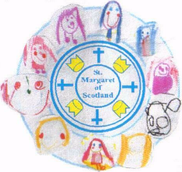

St Margaret of Scotland
Primary, LCSC and Nursery Class

Digital Technologies Policy

March 2021

Rationale

In St Margaret of Scotland Primary we are committed to delivering excellence and equity by improving education and delivering the best possible life chances for all of our children. Our overarching vision is in line with the National Improvement Framework, Scottish Education Delivery Plan, North Lanarkshire’s Digital Solutions to Enhance Learning and Teaching Guide and North Lanarkshire’s Digital Learning and Teaching Guidance, Version 8.
This is accomplished by:

- Excellence through raising attainment: ensuring that every child achieves the highest standards in literacy and numeracy, set out within Curriculum for Excellence levels, and the right range of skills, qualifications and achievements to allow them to succeed; and
- Achieving equity: ensuring that every child has the same opportunity to succeed, with a particular focus on closing the poverty-related attainment gap.

Digital technology can enrich education across all areas of Curriculum for Excellence. When this is used effectively and appropriately, digital technology can enhance learning and teaching, equip our children and young people with vital digital skills and crucially, it can lead to improved educational outcomes.

The digital technologies sector is the fastest growing sector in Scotland. 100,000 people are employed in this area with approximately 13,000 new jobs each year. In order to successfully prepare our pupils for learning, life and work, we need to ensure that our children experience a curriculum rich in digital technologies and digital approaches to learning and teaching.

“Digital literacy encompasses the capabilities required for living, learning and working in a digital society. It includes the skills, knowledge, capabilities and attributes around the use of digital technology which enable individuals to develop to their full potential in relation to learning, life and work.” Education Scotland (2015)

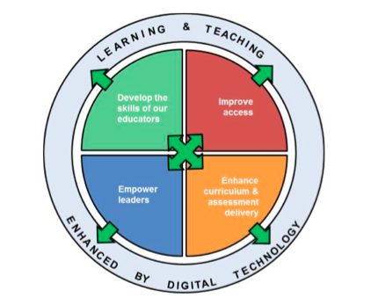
Aims
Our aims are to:
- Increase our stakeholders understanding of digital learning and digital literacy.
- Develop the skills and confidence of staff in the appropriate and effective use of digital technology, to support and enhance learning and teaching.
- Provide an inclusive and progressive digital curriculum for all learners to ensure the correct skills are developed across all stages.
- Ensure that digital technology is central in all areas of the curriculum.

Digital Learning and Digital Literacy
It is vital that digital technology finds a place in all curricular areas so that our learners are able to fully benefit from an education enhanced by digital technology. We want to ensure our learners experience a wide range of opportunities to develop their digital skills by using a range of digital tools and applications.
“Digital skills should be embedded in the curriculum and developing a digital literacy for all has to be integral throughout Curriculum for Excellence” (Digital Solutions to the Productivity Puzzle (2016) Scottish Council for Development Industry)
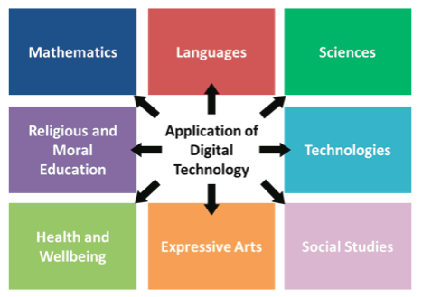

Learning and Teaching
In St Margaret of Scotland Primary our teachers plan and assess learning in accordance with the experiences and outcomes from Curriculum for Excellence and the progression pathways.
- We have a Digital Leader who is responsible for developing digital learning within our school. She has access to Digital training and advice.
- We have a new digital learning progressive planner that we are going to follow in order to ensure the correct knowledge and skills are being developed across each stage within our school.
- Each class have their own Teams page. This was used daily during remote learning and will continue to be used to encourage a blended learning approach and for weekly homework.
- Our Staff make regular use of the online platform created by the West Partnership Regional Improvement Collaborative. The West OS tile in Glow has a bank of recorded learning content.
- E-Sgoil and Education Scotland websites are also used to support digital learning within and outwith the classroom.
Digital technologies are used by teachers to present work, support and enhance learning and teaching, and to consolidate and assess knowledge and skills of all pupils, with appropriate support and differentiation built in. Pupils’ learning is supported across a range of digital platforms.
Each class have their own set of iPads and headphones. They also have access to a set of laptops each week. This provides a range of opportunities to develop our pupils’ digital skills and to ensure digital technology is used to enhance learning and teaching across the curriculum. Digital technology is also used across the school to support the education and inclusion of learners with additional support needs.
We will continue to add to our technology resources each year, to increase access and to regularly develop digital learning and digital literacy as the curriculum develops and as new digital platforms are introduced.
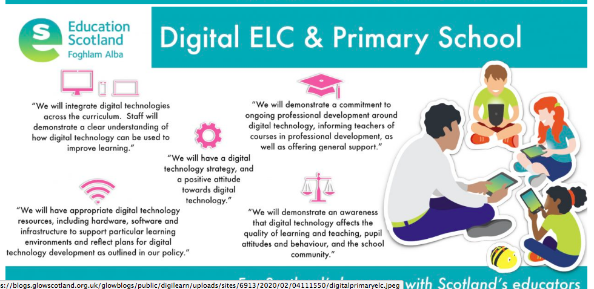

Nursery
Our Nursery make great use of Microsoft Teams where they upload resources regularly for the children to access. They use Sway online profiles to support learning at early level. In addition to this, the staff are now using the app ‘2 simple - build a profile’ in order to monitor and track progress and learning. They make great use of their Nursery Twitter page, where they communicate regularly with parents and carers.
Accessibility Tools
Microsoft Teams have a number of accessibility tools that provide equity of access for ASN pupils. These tools include:
- Immersive Reader – This allows text to be read aloud and can be used to zoom in on text. You can also set a background colour, font and size for pupils with visual or specific literacy difficulties.
- Live Captions – This feature is particularly useful for pupils with hearing difficulties.
- Translator – This tool allows text to be translated into a choice of multiple languages and allows EAL pupils equity of access.
- Shortcut Keys – This tool is particularly useful for pupils that have difficulty using a mouse.
Our staff are aware of the different accessibility tools available and their benefits. We have a folder with more detail regarding digital support available for ASN pupils in our school Teams page.

Staff Development
All members of teaching and support staff are given regular opportunities to continually develop and enhance their digital knowledge and skills. They are encouraged to make use of the varied and numerous CLPL opportunities available, such as those offered by Virtual School, Learning HUB, Education Scotland, West Partnership. In addition to this, we have whole school training events, and share good practice within our school.
Our Digital Leader regularly updates staff in this area in order to continually develop our staff’s digital knowledge and skills. We have a digital folder in our staff teams page where digital resources are shared regularly.

Parents and Carers
We are committed to enhancing our communication with parents / carers and partner agencies through the use of Digital Technologies.
We communicate daily via our School Twitter page and Groupcall. Miss Love and Mrs McGregor are responsible for overseeing this page daily. In addition to this, each staff member has their own class Twitter page where they regularly share photos and information linked to their class’ learning and teaching. We ensure that we follow all Twitter information outlined in the Digital Learning and Teaching Guidance. In addition to this, our LCSC staff communicate daily with our parents and carers via the See Saw app.
We have a school website which is updated regularly with our class, staff, curriculum and parent council information along with our school policies.
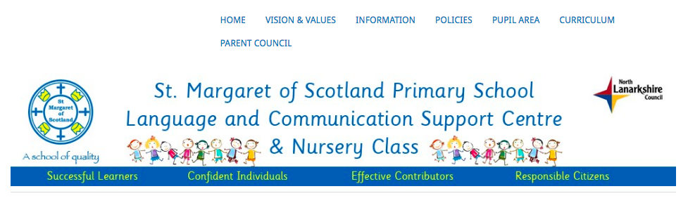

Online Safety
Safety online is an essential part of digital learning. Pupils need to learn how to keep themselves and others safe. Online safety will remain a priority throughout the school. Pupils will be made aware of issues related to online safety, sharing personal information, cyber bullying and the safe use of social media.
We follow the guidance outline in the National Action Plan on Internet Safety for Children and Young People, 2017. We are committed to the following aims:
1. Giving everybody the skills, knowledge and understanding to help children and young people stay safe online: we will help parents, carers and people who work with children and families to understand how to help children stay safe online and how to deal with problems if they occur.
2. Inspiring safe and responsible use and behaviour: we will make it clear that individuals, including children, need to take responsibility for their own online behaviour.
3. Creating a safer online environment: we will work together to make sure that children are less likely to come across or get access to things that are not suitable for them.
Online safety is a key feature in the school digital technology progression pathway, with guidance and resources for teaching internet safety at each stage throughout the school.
Teachers discuss and remind pupils about online safety during all digital learning opportunities.

Acceptable Use Agreement
All pupils and parents/carers must abide by NLC Acceptable Use Agreement of digital technology at all times. Any breech of this should be reported immediately to the head teacher who will decide on the appropriate action to be taken.

Homework
From August 2020, the platform used for the setting, delivery and feedback of homework for the majority of pupils is via Microsoft TEAMs.
Homework is shared every Monday via their Class TEAMs page and our staff are mindful of:
- Pupils having guidance on how to access/share learning via the appropriate digital platform. (How to/help videos should be shared with pupils requiring support).
- Pupils’ access to the appropriate technology (e.g. pupils will not be asked to print out work)
- Differentiation of task and/or outcome
- Protecting pupils’ privacy – Homework should be shared directly with class teacher in order to receive private, detailed feedback. Only general feedback will be provided on the Class Chat.
Completed homework should be shared with the child’s class teacher in one of the following ways:
1. Uploaded to the child’s individual notebook.
2. Via the Assignments section in the child’s teams page.
3. Via sharepoint
4. Via Glow email.

COVID19 - Remote Learning
If a child is self-isolating or absent from school for a period of time, they will be able to access learning remotely until they are able to return to school. Guidance has been agreed among school staff on the form this should take e.g.
- Timing and method of delivery of teaching and learning remotely with regards format and posting of tasks/activities
- Differentiation
- Uploading of pupil work
- Feedback
- Monitoring and tracking of engagement
- Contact with parent/carer
- Reporting concerns
1. This will be monitored closely by SLT and reviewed in light of regular feedback from pupils, staff and parents/carers.
2. Digital technology in the form of school laptops/I pads will be loaned to pupils if required. NLC loan agreement MUST be completed for all equipment loaned.
3. In response to the global pandemic caused by COVID19, NLC has supported schools in their approaches to the teaching of digital technologies and specifically online learning through a variety of different means which are supportive to this policy.

Digital School
In planning for the future of digital learning and teaching within North Lanarkshire and to support the recovery of education following the COVID-19 emergency, Education and Families established a Digital School. This will focus development of 5 key areas:
- Digital divide experienced by young people – develop equity of access to technology and connectivity to engage in learning experiences from home.
- Communication to families – develop guidance and communications to support families to create a learning environment at home.
- CLPL – Further develop training programmes to enhance the skills knowledge and confidence of staff in delivering learning digitally.
- Curriculum – in line with North Lanarkshire’s curriculum review align current digital learning and activities to ensure a consistent and progressive curriculum.
- Digital Data – develop systems to track use of and engagement with digital learning experiences to inform school improvement and learner journeys
ALL staff have access to this resource including the VIRTUAL CLASSROOM.
For all aspects of guidance regarding digital technologies and online learning staff should refer to the latest version of NLC Digital Learning and Teaching Guidance.

Digital Divide
The Scottish Government awarded North Lanarkshire grant funding to support the work of addressing the digital divide for children and young people. This funding means that devices belonging to schools will not need to be deployed, unless in very exceptional circumstances which would be discussed with the school.
In St Margaret of Scotland Primary School, 33 devices have been delivered to our families in a phased approach.
The factors we had to consider were, children and young people:
- Having limited access to a device at home
- Being care experienced
- Being entitled to FSM
- Living in a low income family, who are entitled to clothing grant

Child Protection – Remote Learning
A child Protection and Wellbeing Leaflet has been created and shared to support staff when delivering digital Learning. All issues relating to online Child Protection (CP) will be dealt with in the same way as for face-to-face teaching. All welfare concerns should be communicated to our school’s Child Protection Officer (Miss Love) and should be added to the class Care and Welfare jotter.
Professional Conduct
Our staff have a commitment to the professional values of integrity, trust, respect and social justice. These should be demonstrated in online activity both at work and at home. Moreover, staff have a responsibility to be positive role models to learners; exercising sound judgement and due care at all times when online and setting an example of good digital habits. More information can be found here: GTCS Professional Guidance on the Use of Electronic Communication and Social Media

Evaluation and Monitoring
This policy will be reviewed in March 2022.

