

St Margaret of Scotland Primary, Language Communication Support Centre & Nursery

May 2017

School telephone number – 01236 632102

**NEWSLETTER**

Welcome to our May Newsletter!

We are now in our final term which is very busy.

**IMPORTANT INFORMATION**

**Feedback from Parents night 23rd March.**

Thank you for taking the time to complete our questionnaire. We were delighted with your feedback. 140 questionnaires were completed. Here are the results.

|  |  |  |  |  |  |  |
| --- | --- | --- | --- | --- | --- | --- |
|  | Strongly Agree | Agree | Neither Agree nor Disagree | Disagree | Strongly Disagree | N/A |
| My child enjoys coming to school | **91** | **37** | **8** | **4** | **0** | **0** |
| My child is safe at school | **101** | **29** | **6** | **3** | **1** | **0** |
| The school understands and responds to my child’s needs | **88** | **42** | **5** | **4** | **1** | **0** |
| My child is taught well at school | **105** | **33** | **0** | **2** | **0** | **0** |
| My child is making good progress | **92** | **42** | **4** | **2** | **0** | **0** |
| My child is encouraged to work hard and do their best | **102** | **35** | **1** | **2** | **0** | **0** |
| My child receives an appropriate amount of homework for his/her age | **72** | **51** | **10** | **3** | **1** | **3** |
| My child enjoys a stimulating range of after-school activities | **60** | **42** | **18** | **5** | **0** | **15** |
| The school communicates with me effectively about my child’s progress | **84** | **47** | **6** | **1** | **1** | **1** |
| The school communicates with me effectively about school events and activities | **86** | **40** | **10** | **3** | **1** | **0** |
| The school seeks my views and listens to my concerns | **73** | **47** | **16** | **3** | **1** | **0** |
| There is a good standard of behaviour at St. Margaret of Scotland | **75** | **49** | **11** | **4** | **1** | **0** |
| ‘Good to be Green’ encourages positive behaviour | **97** | **33** | **7** | **3** | **0** | **0** |
| The school is welcoming and there are opportunities to get involved | **88** | **41** | **9** | **1** | **1** | **0** |
| I think the school is well led and managed | **90** | **47** | **1** | **1** | **1** | **0** |
| My child is encouraged to lead a healthy lifestyle | **88** | **49** | **3** | **0** | **0** | **0** |
| My child gets on well with children from other backgrounds | **99** | **34** | **6** | **1** | **0** | **0** |
| My child is encouraged to positively contribute to the wider community | **88** | **44** | **8** | **0** | **0** | **0** |
| I would recommend St. Margaret of Scotland to another family | **102** | **29** | **7** | **1** | **1** | **0** |

**School Improvement Plan 2017-18**

We are working hard to identify our plan for next session. All staff (including support staff) are currently involved. I will be working with a focus group of children and parents over the next couple of weeks to finalise. If you would like to be involved please complete and return attached pro forma.

[](http://www.google.co.uk/url?sa=i&rct=j&q=&esrc=s&source=images&cd=&cad=rja&uact=8&ved=0ahUKEwj81ZbA5ufTAhWVHsAKHbamDn8QjRwIBw&url=http://www.northlanarkshire.gov.uk/index.aspx?articleid=33102&psig=AFQjCNFw84Rt8ndIzU1SOoyWRqNXVW3qXQ&ust=1494590729232534)It is very important that we work in partnership on our school improvement so please get involved if you can.

**Learning Festival**

We are delighted to announce that we won an award at this years’ North Lanarkshire Council’s Learning Festival.

The category was “Productive Partnerships – Purposeful Learning. We worked on an innovative P7 transition project which was really exciting. Our P7 have worked with the City of Glasgow College and will visit Sky Academy on May 17th. This was planned in partnership with the schools in the OLHS cluster – St Lucy’s, St Barbara’s, St Joseph’s, St Andrew’s and St Mary’s.

Staff from St Margaret of Scotland Primary visited the Learning Festival last week and attended seminars and professional training.

**Make, Move and Munch Club**

Well done to Billie-Anne Compston, P1, Sophie Hammerton, P2, Alex Leskiewicz, P2a, Rose Compston, P2, Toni-Marie Compston, P3, Katie Dunne, P4/5, Joshua Aitken P4/5, Jack Bain, P6 and their families for participating in the Make, Move and Munch Club. Over the past 8 weeks children and their parents/carers have made delicious, healthy meals and trialled different types of exercise. They have learned that becoming healthier can be fun, easy and achievable.

We hope to run this after school club again in September.

Thank you Miss McBain for organising and participating.



**Financial Education Week (18-21 April)**

Thank you to Miss Rooney for organising this. It was very successful and the children learned very important skills for life. We had very successful visits from the Credit Union and The Royal Bank of Scotland.



**Primary 1 Inductions**

Our Induction Programme for the new P1 children’s is well underway. The children have been spending time in the P1 classrooms, meeting their teachers and buddies.

**Pupil Council Conference**

[](https://www.google.co.uk/url?sa=i&rct=j&q=&esrc=s&source=images&cd=&ved=0ahUKEwjgluOTqMDMAhWIzRQKHQS6CeMQjRwIBw&url=https://twitter.com/btsnorthlan/status/715977072565428224&bvm=bv.121099550,d.d24&psig=AFQjCNFYlhkRdHgydnhsGHqEye24PqW0tg&ust=1462447641051070)Two of our P7 pupils attended the Annual Pupil Council Conference at the Village Community Centre, Cumbernauld. Thank you Aimee Lee Duncan and Leonie McDonald for representing us.

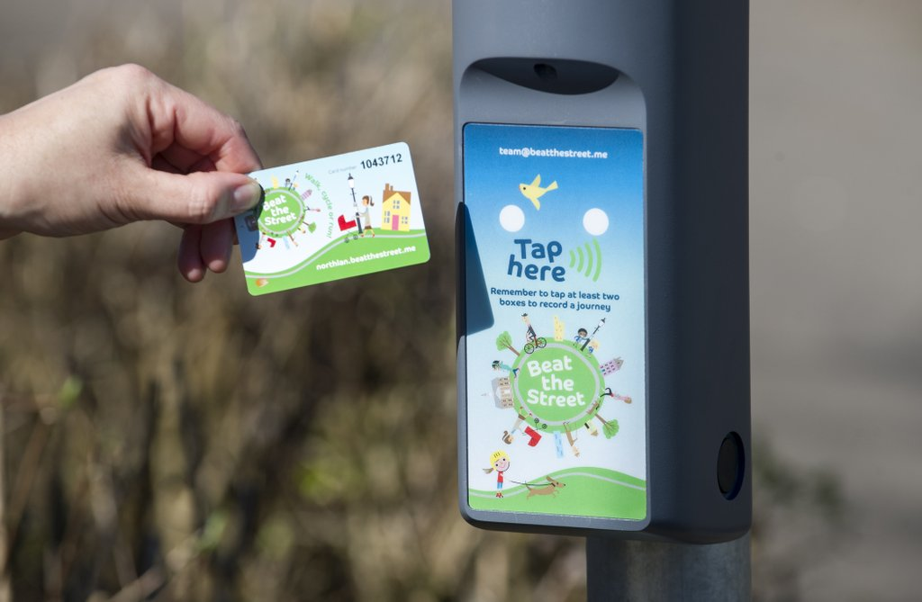

**Beat The Street – North Lanarkshire Council** 

****Please encourage your child to enjoy this this healthy initiative. Walk, run or cycle, tapping between Beat Boxes. If you have registered your card, you can win a prize! Follow @BTSNorthlan on twitter for more information.

**First Holy Communion**

A huge thank you to Miss Cosgrove, Miss Rooney and Mrs Jaap who prepared our children so spiritually for the Sacrament of First Holy Communion.

Thank you Fr McKay and Fr Campbell for the beautiful service on Sunday 7th at St Joseph’s Parish and Sunday 14th at Sacred Heart Parish.

The children are a credit to you all – very well done!

**Tesco Bags of Help Grant Scheme – Improving Our Outdoor Learning**

We are delighted that our application to the Tesco Bags of Help Grant Scheme has been successful and our project “Improving Our Outdoor Learning” will be put forward to a customer vote in Tesco stores during May and June.

Our project, alongside two other successful projects in our region will go forward to a vote in Cumbernauld, Craigmarloch, Kirkintilloch and Bishopbriggs Tesco stores. Customers will vote for their favourite project.

The project with the highest number of votes will receive £5,000, second place £2,000 and 3rd place £1,000.

We will know the result by the end of July 2017.

Please, please, please vote for St Margaret of Scotland and help us to improve our Outdoor Learning. Thank you.

**Summer Trips**

We are busy planning our summer trips at present.

P1 Caldergelen Country Park

P2/3 Transport Museum / Kelvingrove Park

P4, 5, 6 & 7 Science Centre

**Kilbowie**

****Primary 7 are eagerly awaiting their residential trip to Kilbowie… this takes place on Tuesday 30th May – Friday 2nd June.

**Please note the following…**

* *Once a week take a peek?*

Can I ask that you check your child’s hair and be extra vigilant when brushing, combing or washing your child’s hair.

* *Uniform*

[](https://www.google.co.uk/imgres?imgurl=http://www.schooljotter.com/imagefolders/bedale/Downloads_Page/uniform.JPG&imgrefurl=http://www.schooljotter.com/showpage.php?id=107687&docid=nuxBp6QIzV23HM&tbnid=7XZjjTWEpqoc1M:&w=461&h=439&safe=strict&bih=878&biw=1280&ved=0ahUKEwiA0p2_oNXOAhVCOBQKHaG8B5YQxiAIAg&iact=c&ictx=1)We are noticing that many children are coming to school without ties, PE kits, appropriate footwear…

Please help us be ensuring that your child comes to school in full uniform and is prepared for the day ahead.

* *Good to be Green*

[](https://www.google.co.uk/imgres?imgurl=http://www.primaryteaching.co.uk/prodimg/A159_1_Zoom.jpg&imgrefurl=http://www.primaryteaching.co.uk/allproducts/good-to-be-green&docid=52EoYVpxCKyc3M&tbnid=Ir7dcTIwYFGsrM:&w=600&h=600&safe=strict&bih=878&biw=1280&ved=0ahUKEwit6PWEoNXOAhULshQKHZTQDGQQxiAIAg&iact=c&ictx=1)Please sign and return to school on Monday mornings. It is very important that you know how your child is behaving at school. Please let us know if you have lost this card.



**Dates for you Diary**

|  |  |
| --- | --- |
| Wednesday 17th May | Primary 7 to visit Sky Academy |
| Wednesday 17th May | Mainstream Induction (3) LCSC Induction (1) |
| Tuesday 23rd May | Primary 3 Parent Assembly |
| Wednesday 24th May | LCSC Induction (2) |
| Tues 30th May – Fri 2nd June | Kilbowie |
| Tuesday 30th May | P2 & P3 Transport Museum and Kelvingrove Park |
| Wednesday 31st Mat | LCSC Induction (3) |
| Tuesday 6th June | P1/ P1/2Calderglen Park |
| Wednesday 7th June | P7 to OLHS |
| Wednesday 7th June | Assessment Class Inductions |
| Thursday 8th June | P7 to OLHS (School closed to all other pupils) |
| Monday 12th June | P4, P5, P6 & P7 to the Science Centre |
| Monday 12th June | Eco/Health Week |
| Tuesday 13th June | P7 to OLHS |
| Wednesday 14th June | Assessment Class Induction |
| Thursday 16th June | Sports Day (weather permitting) |
| Tuesday 20th June | P7 Prom |
| Thursday 22nd June | P7 Leaver’s Mass |
| Friday 23rd June | Nursery Graduation |
| Monday 26th June | Good to Be Green Disco |
| Tuesday 27th June | Children to new Classes |
| Wednesday 28th June | School Closes |

Thank you for your continued support and co-operation.

With kindest regards.

M Love (Miss)

Head Teacher

**School Improvement Plan 2017 – 2018**

I would like to be involved with the Focus Group

Name ___________________________________________________

Contact Telephone Number ___________________________________

(Please return to the school office by Monday 22nd May)