Accessing North Lanarkshire’s Virtual Classroom

- Log into your Glow account using the details they have been given in school.

- Click on the Virtual Classroom Tile
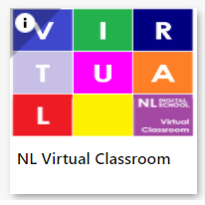

- Click on the appropriate colour of classroom. The table below is a guide to help you select the correct colour.

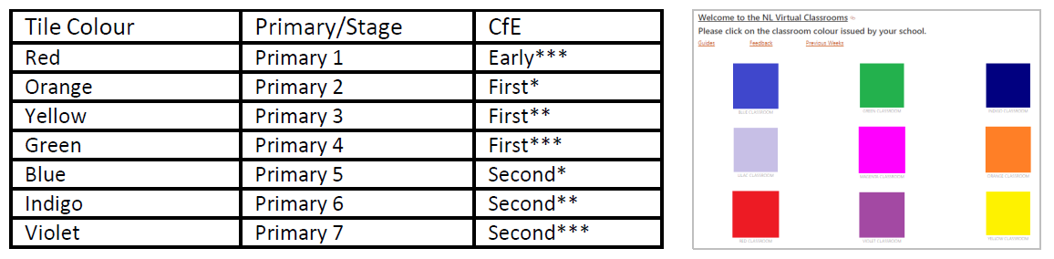

- The classroom will look like this. Click on the doorway to access the next page.

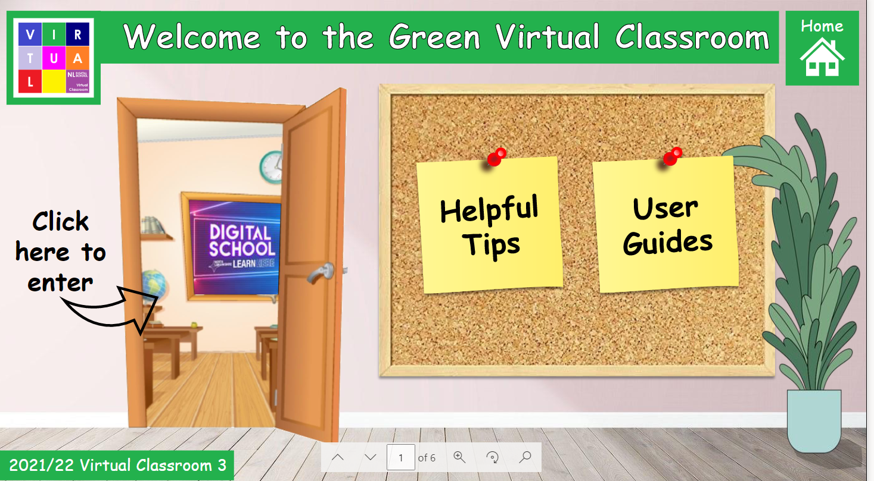

- You will then see the next screen. Choose the curricular area you want to work on.

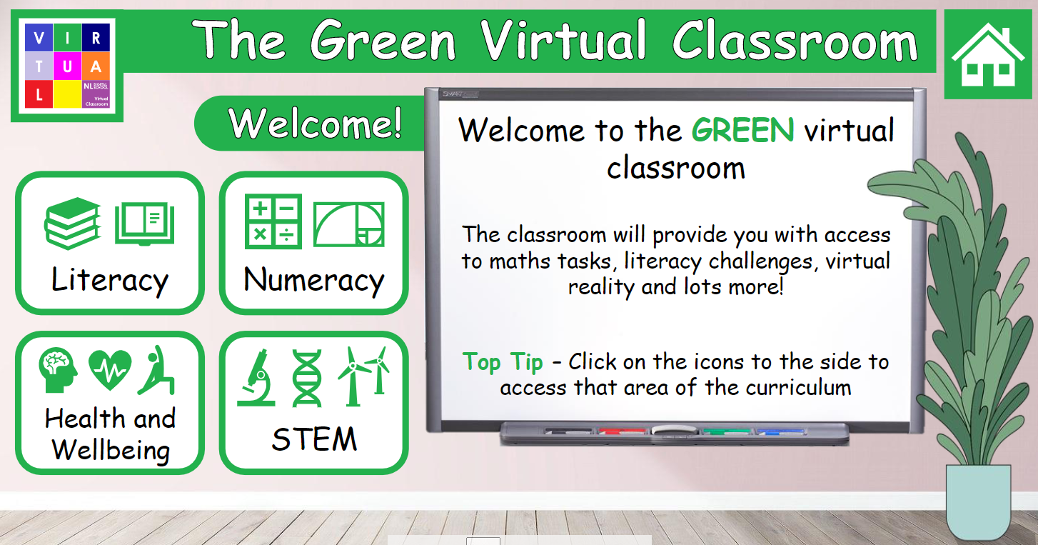

- Once you enter the curricular area you have chosen, there are a variety of pictures and tasks to click on. When you hover over an item/picture that has a task within it, it will change to a yellow colour. You can then select the task and complete it.

