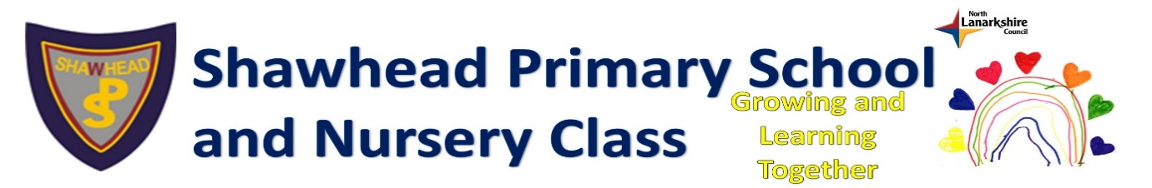

Play-Based Learning in Primary 1 and 2

Parental Information Leaflet

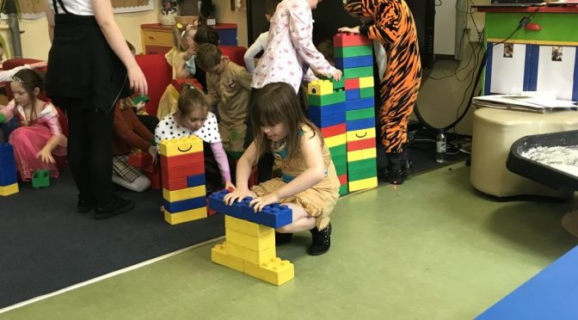

When your child joins Shawhead Primary, they will continue their learning journey through Early Level of Curriculum for Excellence, where we will build on the knowledge and skills they already have. We know that children thrive in a safe, nurturing environment and we will provide that by teaching through play-based learning. This leaflet will explain how this will look for your child and the benefits it will bring. If you have further questions, please don’t hesitate to contact Mrs Paterson on ht@shawhead.n-lanark.sch.uk or Mrs Barton on cbarton@shawhead.n-lanark.sch.uk.

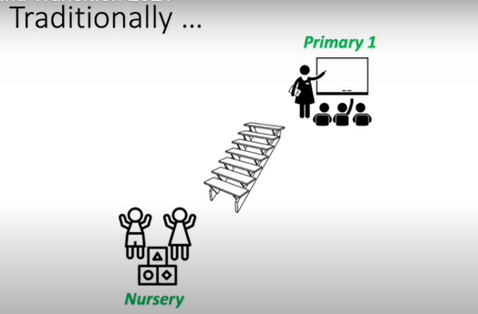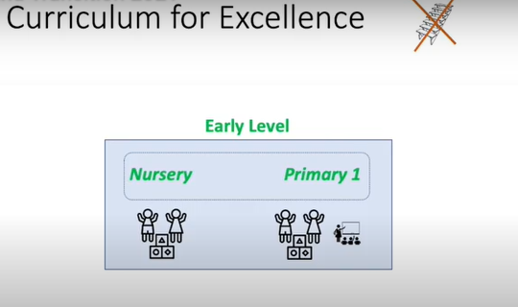

What is Play-based Learning?
The teacher sets the stage with engaging and fun activities. The child explores through play: observing, experiencing, wondering, exploring, and discovering. The teacher is nearby to observe, ask questions, make suggestions, or play along with the child. But the child decides which activities to do, which toys to play with, what to do with them, and for how long.

What is play?
Play can be defined as anything that has these characteristics:
- Child-Led. Freely chosen. The child is in control. He/she makes the plan.
- Creative. The child can adapt items, create something new or experience things in a new way.
- Spontaneous. It’s flexible and open-ended, and it changes and evolves as play time goes on.
- Fun. The player looks happy and engaged.

Does a child really learn by “just playing”?
We know the brain builds connections when it is exposed to novel experiences, and then allowed to repeat them again and again till it achieves mastery. This process builds two 2 forms of intelligence: memory – crystallized intelligence – the database of information that we access, and improvisation – fluid intelligence – what allows us to adapt that information to new situations. (Medina)
Direct instruction from a parent or teacher can be a great way of adding information to the database of crystallized intelligence. But, the best possible way for children to build fluid intelligence is by hands-on, engaged, self-guided improvisation… in other words, by playing.

Teacher’s Role
The adult plans an environment and schedule which promotes learning. Children learn best when they feel safe, so familiar routines, consistent rules, and respectful relationships are essential components. The adults offer meaningful experiences that are stimulating, invite exploration and engage kids. The teacher often has outcomes in mind: knowledge, skills, abilities and understandings children will acquire, but they have not determined an exact path the child must take to get that knowledge.

Benefits – children who learn by playing gain:
- Physical competence. Free play allows a child to practice emerging skills till they are mastered.
- Self-direction. The child gets to make decisions, make plans, and see them through.
- Creativity. Experiments show that children who are taught “the right way” to use a toy will use it in limited ways. Kids who are allowed to freely explore develop many more creative uses.
- Problem-solving. When a child creates her own plan for play, she doesn’t foresee challenges that will come up that an adult might see. This offers lots of chances for problem-solving.
- Language skills. Play requires asking and answering questions, giving commands and acting on them, and explaining your goals to the person you are playing with.
- Conflict resolution skills. There’s lots of negotiation that goes on in co-operative play.
- Emotional intelligence. Dramatic play helps children understand emotions, learn how to express emotions, and distinguish between real emotions and “pretend” emotions.
- Symbolic play. If a child can use a stick to simulate an ice cream cone, it helps her later understand that numbers on a page represent how many objects they have, and that letters represent sounds, and musical notes on a page indicate where to place her fingers.
- Better memory. Kids are motivated to remember things they need to know for a play scenario.
- Reduced stress. Play is fun. Children play when they feel safe. We are all more capable of learning new things when we are having fun and feeling safe.

How will the day look in Base 1?
The day will be broken into 3 learning blocks each day:
1 – Literacy
2 - Numeracy and
3 - all other curricular areas

During each day, the children will engage in 3 types of learning:
- Teacher-led instruction
This is a ‘traditional’ lesson. The children will be taught sounds, letters, reading, counting, etc. They will complete a task to demonstrate their understanding of the lesson.

- Teacher-led play
The teacher will create play-based activities that link to the traditional lessons. This will help reinforce the teaching and help the children understand and retain the information. An example of this may be an alphabet jigsaw, sorting items or ordering objects with numbers on them etc.

- Child-led play
A variety of resources and areas will be set up for the children to move freely around. These will include creative materials, building blocks and role-play equipment. This will have a similar look and feel to a nursery.
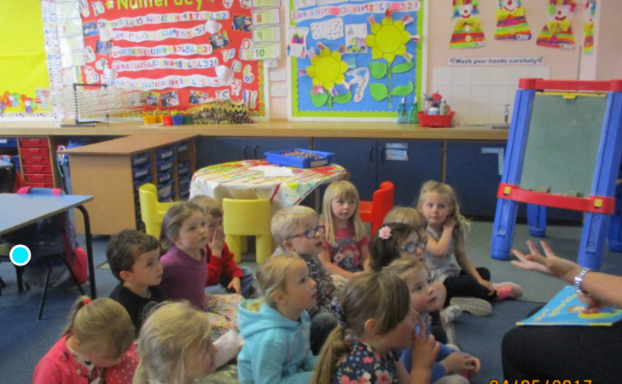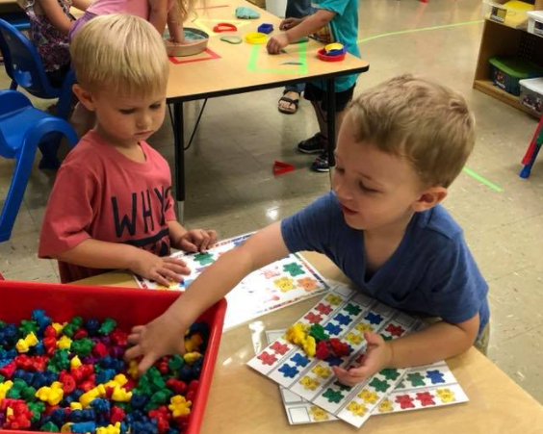
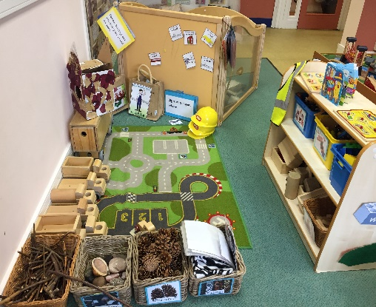

The teacher will get to know the children and will adapt the learning areas and time spent at each one to meet the needs of each child.

Outdoor Learning
All children benefit greatly from time outdoors. At Shawhead Primary we know that children who learn in the outdoors are engaged and enthusiastic. So we endeavour to take the children outdoors as regularly as we can, utilising the many areas of our playground, including the outdoor classroom, trim trail, bikes, scooters and tree area.

