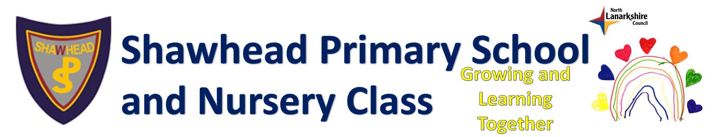
Remote and Live Learning Position Statement – January 2021
Aim  At Shawhead, we aim to provide a package of Remote Learning which provides a curriculum that reflects the in-school experience as much as is practical and possible.  We aim to offer differentiated, progressive learning which is responsive to learners’ needs within the confines of the national restrictions.  This includes promoting and developing skills that will increase children and young people’s capacity for independent learning as a key driver of the remote learning approach. | Definition of Remote Learning (Ed. Scot. 2021)  Remote learning is learning that is directed by practitioners and undertaken by children and young people who are not physically with the practitioner while instruction is taking place.  Remote learning involves a combination of ‘live’ interactions between teaches and learners, and also learning which takes place away from the direct presence of the class teacher.  Whilst not a substitute for classroom-based learning and teaching, effective remote learning can mitigate some of the adverse impacts of a reduction in face-to-face learning. | Audience  - Pupils  - Staff  - Parents/Carers  Links to Documents to Support:  - Education Scotland Guidance- Covid-19 Education Recovery Group (CERG)  - Shawhead Primary School and Nursery Class Guide to Remote Learning  - Updated NLC Digital Learning and Teaching Guidance Version 7
School Approach to Remote Learning  - We will use Glow, NLC Virtual Classroom and Microsoft Teams to set learning and learning activities for P1-7 and for the nursery children.  - We will plan quality-learning experiences for pupils, linked as much as possible to the curriculum that would be covered had the children been in school.  - We will ensure progression of learning as much as possible within the confines and restrictions of remote learning.  - We will offer a balance and range of ways for pupils to engage with learning activities including written, practical and online.  - We will use the features of Teams and NLC Virtual Classroom to organise, schedule and assign tasks as appropriate to the age and stage of learners.  - We will offer a mixture of weekly and daily activities as appropriate to the age and stage of learners. This will vary based on teacher knowledge of their learners and needs. |  | Core Resources  Glow  Teams  NLC Virtual Classroom
Quality Assurance
- SLT Sampling and monitoring Teams
- Staff pastoral support from HT
- SLT supporting a sampling daily live lessons
- Revised annual calendar of Self-Evaluation
School Approach to Live Lessons  - We will provide daily opportunities for pupils to have live ‘check-ins’ with their teachers for clarification of teaching pastoral contact via Teams meetings at 9.30am and 1.30pm aiming for 2 live lessons per day.  - We will use pre-recorded videos and audio clips to provide instructions, tutorials and teaching examples, both teacher-made and commercially available (within copyright)  - We will provide set times where class teachers will be ‘online’ to respond quickly to direct messages and questions from learners and parents.  - We will provide a weekly ‘Together Time’ on a Thursday to work on a whole school collaborative art project and provide an opportunity for the children to come together via Teams and in the school hall to connect and be together. |  | Associated UNRC Articles  3 Best interests of child  5 Parental Guidance  28 Rights to Education  29 Goals of Education  31 Leisure, Play and Culture
Supporting Engagement  - We will provide 2 daily live lessons to encourage participation and engagement from learners.  - We will monitor pupil engagement in Teams through Insights, completing of assigned tasks and submitting/ uploading of completed work.  - We will contact parents/ carers of pupils with no visible engagement to offer support and help remove any barriers to engagement. This includes (but is not limited to):  *IT support and technical advice, e.g. passwords, help sheets etc.  *advice and guidance on managing timescales, family commitments etc.  * supporting with poverty-related barriers, e.g. providing IT equipment, resources etc.  - We will support children accessing emergency childcare in line with NLC criteria to undertake their ‘Remote Learning’ whilst attending school.  - We will collect views of all stakeholders on Remote Learning through weekly pupil questionnaires, fortnightly parent questionnaires and discussions at Parent Council. |  | Associated HGIOS4 QIs  QI 1.2  QI 2.2  QI 2.3  QI 2.5  QI 3.2
Associated School Values
Safety (online)
Achieve
Working Together
Equality
Attitude
Develop Resilience

