Self-Isolation and Home Learning Guidance
for
Parents and Carers

Dear Parents and Carers,
We realise that home learning can be both daunting and stressful. At Shawhead Primary, we want to ensure our parents and carers feel informed and supported should their child/children need to learn from home. We have created this document to help you understand the platforms that we are using as a school to ensure that learning continues in the event of a self-isolation or period of lockdown.

Mrs Paterson
Head Teacher

Online Access
All children have received a letter home (shown below) with their usernames and passwords for the three platforms we use at Shawhead Primary – Glow, Rising Stars and Sumdog. The children have also been practising logging in and using these websites in school so that they are familiar with each site and how to navigate it. If you have any problems getting logged on at home, please contact Mrs Barton on cbarton@shawhead.n-lanark.sch.uk for support.

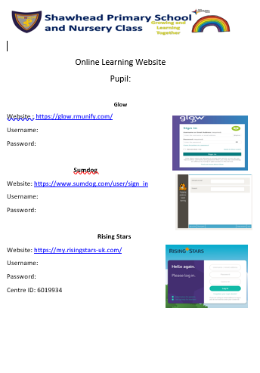

Hard Copies of Work
Although the school can provide hard copies of tasks and these can be collected from the school office at a pre-arranged time by a non-isolating adult, it is preferable that work is completed on-line as this minimises spreading Covid-19. Work completed at home on the hard copies should not be returned to the school. We thank you for your understanding with this.

Glow
https://sts.platform.rmunify.com/Account/SignIn/glow

This platform supports all curricular areas and allows communication between teachers and pupils.
Log into Glow at the start of the home learning period to access your 2-week learning grid (example shown below). In the Files section, there are folders for Literacy, Numeracy and IDL, Health and Wellbeing and Outdoor Learning. Files have been loaded into the folders so you can see the spelling words, text books, topic lessons etc that you work from.

Pupil Name | Literacy | Numeracy | IDL/Health and Wellbeing
Week 1 | Week 29 Stage 2 Phonics and Spelling  - Work on magnetic board  Common Words Spelling tasks –  Write sentences  Copy words x3  Rising Stars Reading and tasks | Teejay Booklet 1a –  Sumdog | Choose 3 Scotland IDL Tasks from grid
Week 2 | Week 30 Stage 2 Phonics and Spelling  - Work on magnetic board  Common words Spelling tasks -  Write sentences  Copy words | Teejay Booklet 1a –  Sumdog | Choose 3 Scotland IDL Tasks from Grid

Work that has been completed can then be uploaded to the Self-Isolation Uploaded Work Folder in the Files section (see picture below). This can be done by either doing the work on a Word document and attaching it, or taking a picture of work that has been written down and uploading it. Please clearly label the work with your child’s name and the date.

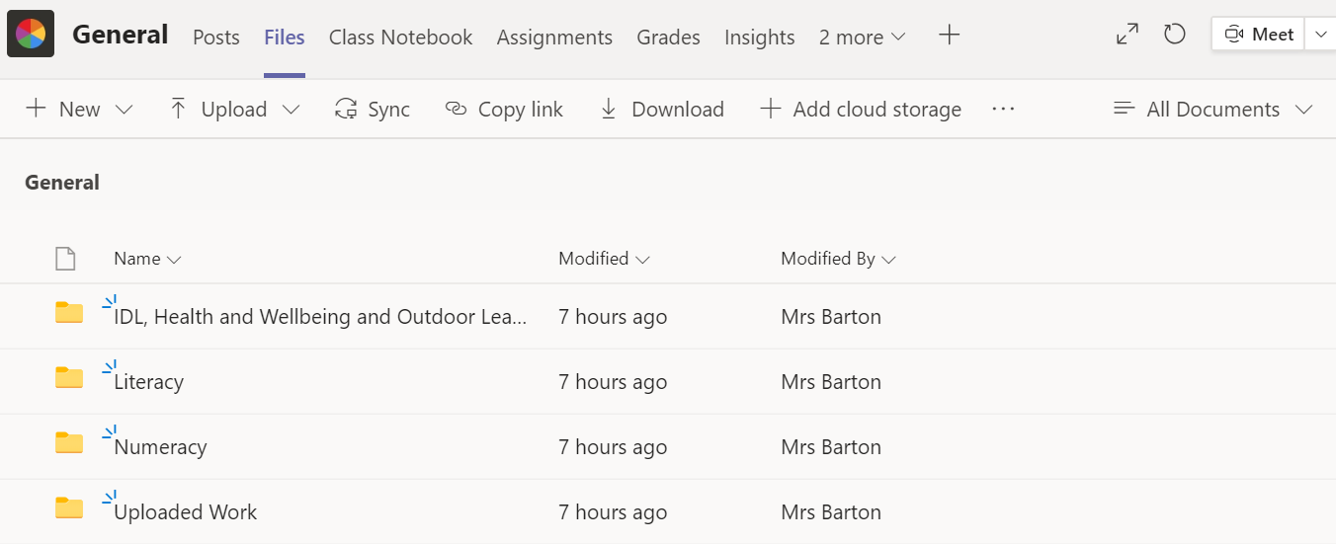

Rising Stars

https://my.risingstars-uk.com/

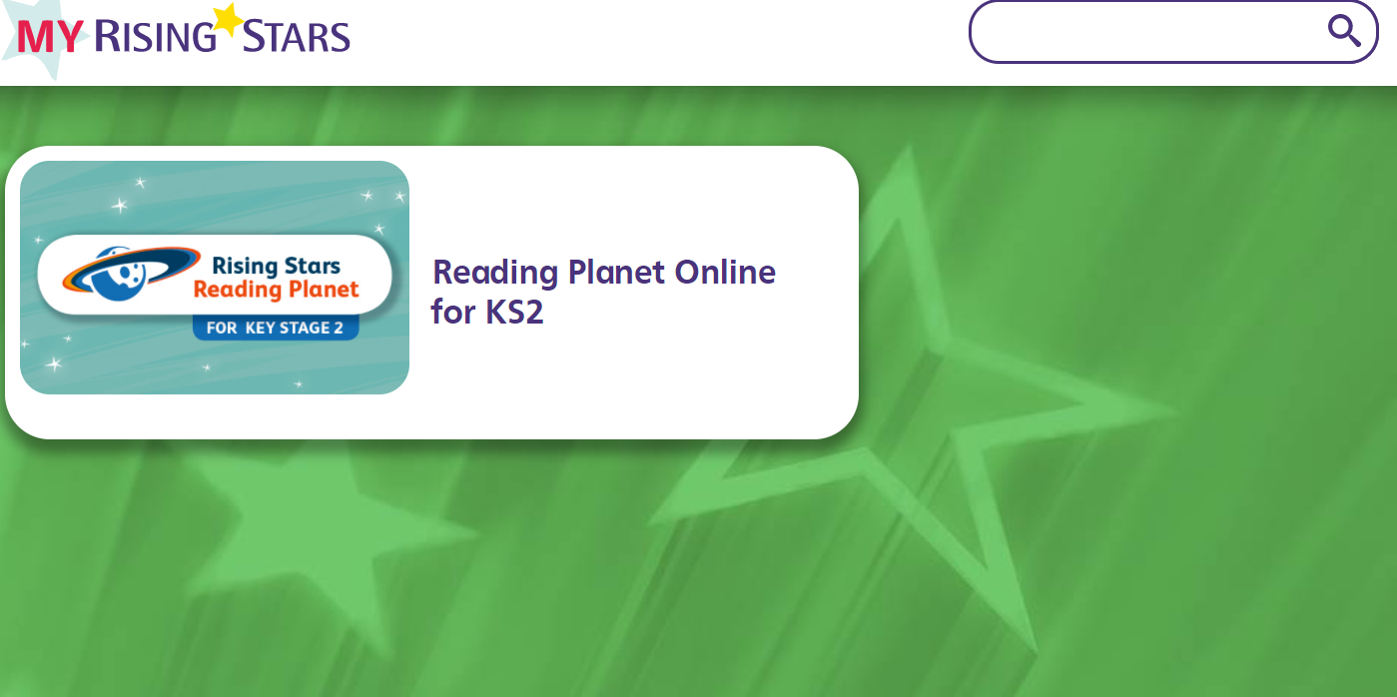
Rising Stars is an online reading resource that allows the class teachers to assign age and stage appropriate books to the children in their class.
During a period of home learning, please support your child to read the allocated books and complete the interactive quizzes. At the end of the book, answer the comprehension questions and submit answers on their Glow Team in the Uploaded Work Folder in the Files section.
Class teachers receive a weekly report showing the usage and results of the Rising Stars quizzes and questions, so you do not need to monitor the answers at home.

Sumdog
https://www.sumdog.com/

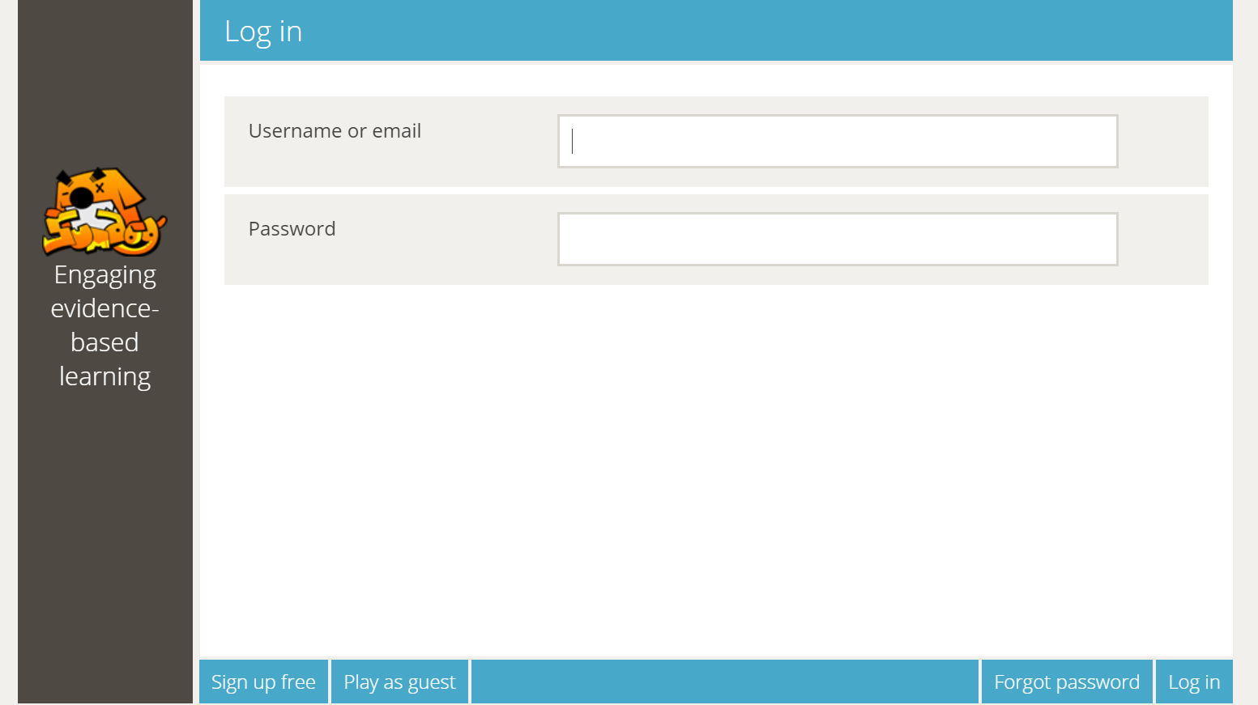

Sumdog is a numeracy website that tailors the questions to suit the learner’s needs. The children use it regularly in school and find the games both challenging and engaging. Children can log in and play the game for an unlimited amount of time.
In the same manner as Rising Stars, teachers receive weekly feedback regarding the online time and accuracy of answers so parents do not need to monitor the work.

