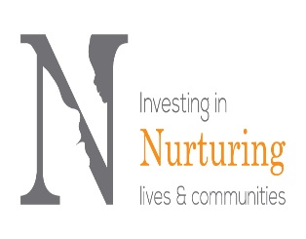 

Learning together at the Forest School.

Have you ever wondered what it would be like to participate in a Forest School session?

To find out the endless learning opportunities the Forest has to offer?

What risks there are for you and your child, if any?

What you would need to bring?

How you community assets can support your child’s learning?

Nicola would like to invite you to attend an informal parents information session on Thursday 9th March 2016 at 8.50 am and 1 pm in the Parent Room

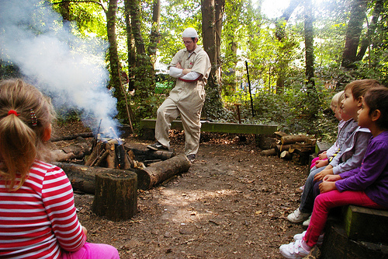 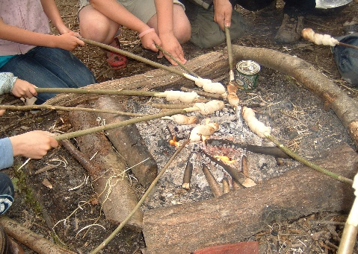

--------------------------------------------------------------------------------------------------------------------------------------

Please return this slip by 27th February if you wish to attend the information sesssion.

I/we will be able to attend the information session on Thursday 9th March at 8.50 am /1 pm.

Signed: Date: