Shotts Family Learning Centre

**Have your say feedback**

We have now analysed the responses collated from the recent consultations meeting in January and are pleased to advise that we are in the position to plan the following.

The coordinators for each of the family learning opportunities are:

* Play on Pedals Susan
* Big Chef Little Chef

Jen

* Forest School Nicola
* Stay and Play Isabel
* Infant Massage inc Story Yoga Christine
* Bookbug Rhyme Time

Amanda

* World Book Day Events Isabel, Emma, Kirsty and Pamela
* Sid & Shanarri

Elaine

* Mini Movers

Siobhan

Dates, times and details of these events will follow.

If you have any further suggestions, please hang it on the VIEWS Tree.



PERSONAL COMPUTING

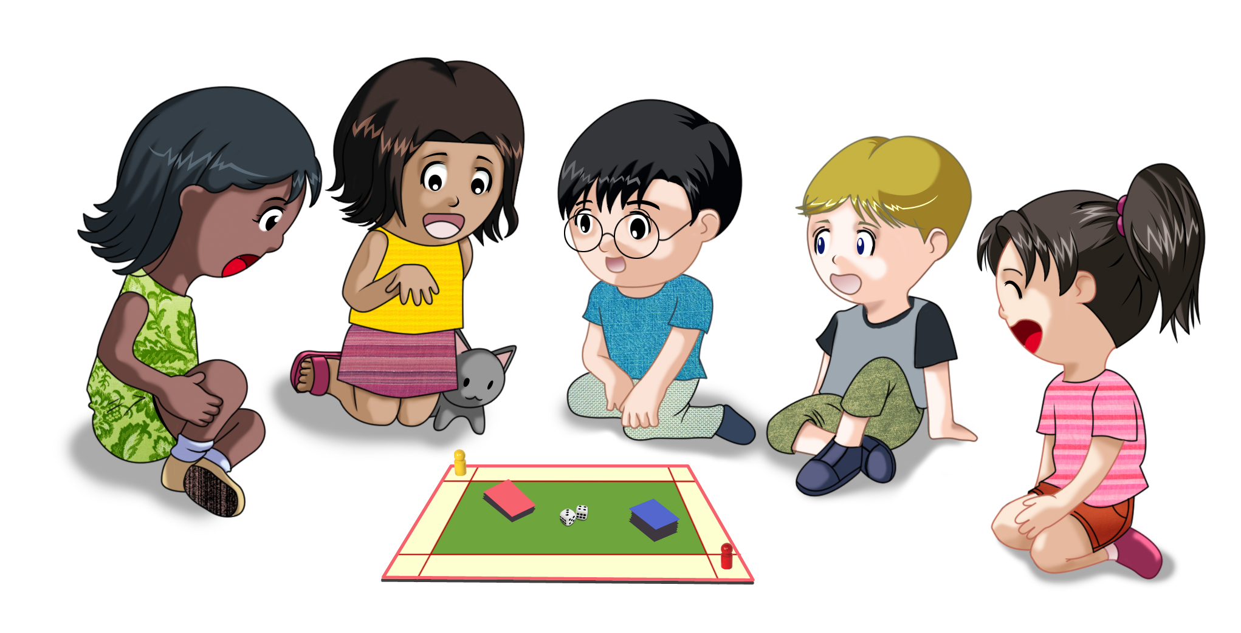



For each session, it is the responsibility of parents or carers to escort their child to and from the school.

This year we will be using your child’s termly Learning Stories to demonstrate progression in their learning as opposed to a final Progress Report.

Dates for individual Parental Consultations will be issued in June.

If you do not wish these to be shared with the receiving school please advise Isabel.



Each of the local schools will be planning their own individual transition sessions to suit their community of learners. Dates and times will be given direct form the schools or alternatively you can contact them on

Dykehead Primary School

01501 821772

Stane Primary School and Nursery

01501 826705

St Patricks Primary School and Nursery

01501 826711

Or alternatively you can follow them on Twitter.

**@Dykehead Primary**

**@ShottsStPats**

**@Stane Primary**

Early Level Transition Dates



Shotts Family Learning Centre

Shottskirk Road

Shotts

ML7 4ER

01501 826713

Transitions for children can be a time of anxiousness. Whether that is going from home to nursery or nursery to school. Therefore, there are many things you can do at home to support your child making their transition smooth.

Keep learning active & interactive.

Make use of everyday life.

Look to avoid teaching the children.

Make use of play and the children’s interests.

But most importantly,

relax and keep it FUN!

A few of the comments received

**“Reassured”**

**“I enjoyed being reassured about my son going to school”**

**“Interesting”**

**“Enjoyed all local parents together. Photos of the kids doing activities”**

**“Ready and reassured”**

**“There was a HUGE range of people here to talk to parents – one stop shop!”**

**“Impressed”**

**“Learning new ides to do at home to encourage learning “**

**“Lots of good ideas to make learning fun”**

**“Lovely event with lots of good information and leaflets to help with ideas to support my child for going to school”**

**“Empowered”**

**“Very informative event would definitely recommend for all areas of NLC.”**

**“Brilliant”**

February 2017

The 3rd Annual Early Level Community Assets event took place on Friday 10th February in Calderhead High School.

This event demonstrated how each of the early learning and child care settings along with the local Primary school work in collaboration with each other and partner organisations to support your child’s transition.

Scott Clark, Head Teacher from Stane Primary and Nursery welcomed everyone and set the scene.

Therese Henery, Quality Improvement Officer from North Lanarkshire Council spoke of how this event and its philosophy was sector leading in the authority.

Parents and carers then had the opportunity to participate in the information workshops whilst taking the opportunity to talk to many of the stall holders as they moved freely around the event.

A huge thanks to Elaine and Siobhan who demonstrated that learning is on continuum which the team around the child supports.

If for any reason, you were unable to participate in this event and would like more information please speak to Lynn.

http://www.educationscotland.gov.uk/parentzone/mychild/transitions/startingschool/index.asp

Shotts Early Level Community Assets Transition Event

**Parent Support Group**

As newly appointed depute, Isabel would like to extend an invitation to all parents and carers to her first Parents Support group Meeting.

On the Agenda will be:

Fund Raising for an end of term event.

Professional Photographs

Learning & Teaching

Grant Applications

Garden Tidy Event

Twitter

Please note that the Parent Room is now in the admin building.

**Tuesday 21st February 1.15 pm – 1.45 pm**

**Friday 24th February**

**9 am – 9.30 am**



End of term family event



“Becoming an artist outdoors”

**We could have either or both events if we get a group of parents to help plan and organise along with the staff**.

organise.





Outdoor learning

CAR PARK CONCERN

It has be brought to our attention that there are infants and young children being left unnatended in parked cars when either parents or carers are dropping off or collecting their child from nursery.

This is a serious Child Protection concern and would advise that if you are concerned that this is happening then you should report the vehicle number plates to Police Scotland, or alternatively if you are concerend about the child’s wellbeing then contact the Duty Social Worker at Wishaw Chldren and Families on 01698

348000

Its everyones responsibility to make sure children are alright.

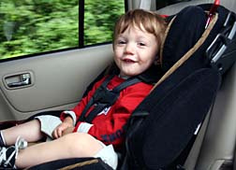



Fun day suggestions:

Sports Day with NL Leisure in the Bonaccord Park

Fun events in and around the nursery grounds?

Children’s entertainer

Gala Day Procession/Float

Possible outings:

Edinburgh Zoo

Almond Valley

Safari Park

Purves Puppets

M&D’ s

Day at the beach





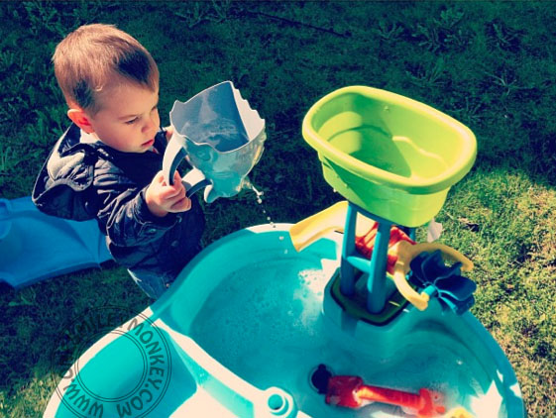

There is something magical about the ever-changing landscape of the seasons which helps our children become curious learners outdoors. 

However, many of our children are becoming frustrated when it comes to changing their clothing or footwear before going outdoors. To make it easier for your child can we ask that neither their indoor nor outdoor footwear contain laces?



We look forward to seeing as many parents/carers as possible at the forthcoming meetings.

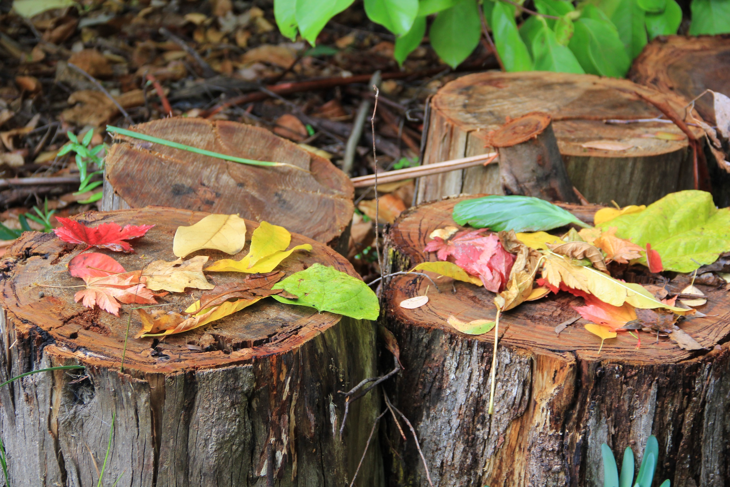

“There is no such thing as inappropriate weather, only inappropriate clothing”

