Prawn & Chorizo Paella
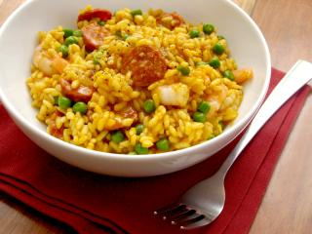

Ingredients

- 1 onion
- 1 garlic clove
- 100g chorizo , sliced
- 150g paella rice
- 1 teaspoon of paprika (hot or smoked, you choose)
- 400ml chicken stock
- Frozen prawns (defrosted)
- A handful of frozen peas
- 1 pepper

What you need to do
- Heat a tablespoon of olive in a shallow pan and gently fry the onion and garlic for a few minutes until softened. Add the chorizo and fry until it releases it's oils and coats the onions.
- Stir in the rice and paprika until it's all mixed together and then add the stock. Bring it all to the boil and simmer for 15 minutes, you may need to add a touch more water at the end.
- Add the prawns, pepper and peas and stir to warm through
You could also add some freshly chopped parsley at the end too

*Adapted from Jamie Olivers Prawn & Chorizo Paella

