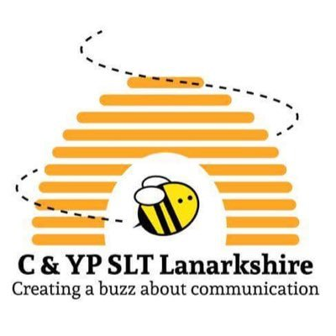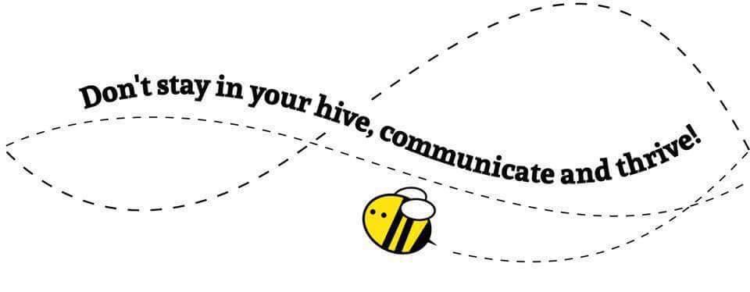



**@SLT North**



**Speech and Language Therapy NHS Lanarkshire**