Songs & Rhymes April 2016
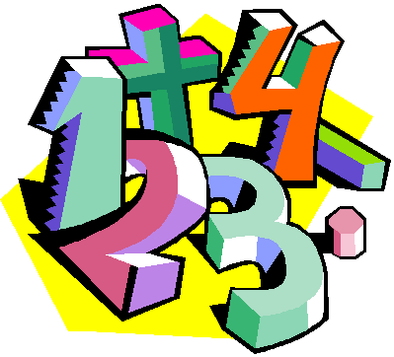
Writing Numbers
Write the numbers in the air along with your child as you sing.
Zero is where it all begins
Curve down around and up again.
Number one is so much fun
Pull straight down and you’ve got a one.
Number two is easy to do
Up around down and across makes two.

Number three is simple to see
Draw two humps sideways and that’s a three.

Number four I do adore
Go down, across, then down some more.

We’ve reached five, now let’s not stop
Pull down, circle round, put a hat on top.

Number six is easy to fix
Big curve, small loop will give you six.

Number seven is really sizzlin’
Straight across, slant down, and that’s a seven.

Number eight isn’t very straight
Make “S” then back up for an eight.

Number nine I think you’re fine
A loop on top of a long straight line.

Number ten we’ve reached the end
Put a one by a zero and count again.

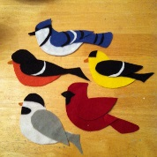

Five Little Birdies
Five little birdies, flying around our door,
The blue one flew away and then there were four
Four little birdies sitting in a tree,
The yellow one flew away and then there were three.
The Little birdies didn’t know what to do,
So the red one flew away, and then there were two.
Two little birdies sitting in the sun,
The brown one flew away, and there was one,
The little green birdie felt so all along
He/She flew away and then there was none

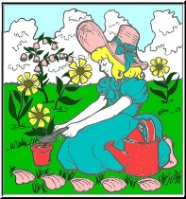

Mary Mary Quite Contrary
Mary, Mary, quite contrary,
How does your garden grow?
With silver bells and cockle shells,
And pretty maids all in a row.

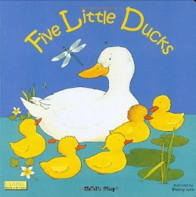

Five little ducks
FIVE little ducks went swimming one day
Over the hill and far away.
Mother duck said QUACK QUACK QUACK QUACK
And only FOUR little ducks came back!
FOUR little ducks went swimming one day
Over the hill and far away.
Mother duck said QUACK QUACK QUACK QUACK
And only THREE little ducks came back!
THREE little ducks went swimming one day
Over the hill and far away.
Mother duck said QUACK QUACK QUACK QUACK
And only TWO little ducks came back!
TWO little ducks went swimming one day
Over the hill and far away.
Mother duck said QUACK QUACK QUACK QUACK
And only ONE little duck came back!
ONE little duck went swimming one day
Over the hill and far away.
Mother duck said QUACK QUACK QUACK QUACK
And all her FIVE little ducks came swimming back!

Kodaly is a structured fun way of teaching music to children helping them to develop vocal skills and explore musical concepts such as beat, rhythm and pitch
Pitter Patter Raindrops (Kodaly song)
Sing each line along with your child using high and low pitches while keeping the beat steady throughout.
Pitter patter raindrops falling on the ground.
Can you hear the rhythm of that lovely pit pit sound?
Tomorrow will come sunshine.
We’ll all sing and shout.
Every little flower head will pop right out.

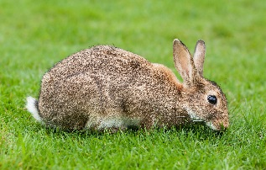
Roxy the Rabbit (Kodaly song)
Children to use a loud voice when singing the words giant and tall and a quiet voice when singing the words small.
Roxy the rabbit was singing one day.
Roxy the rabbit was hiding away.
Roxy the rabbit was giant and tall.
Roxy the rabbit was feeling so small.

