Book Week Scotland within Shotts Family Learning Centre
Monday 23rd November until Sunday 29th November 2015

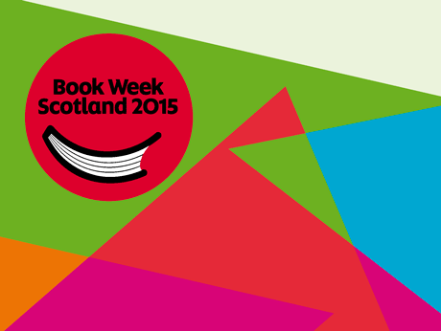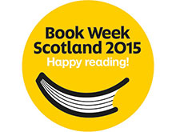

Book Week Scotland is a week-long celebration of books and reading that takes place every November.
Book Week Scotland 2015 will take place from Monday 23 – Sunday 29 November 2015.
During Book Week, people of all ages and walks of life will come together in libraries, schools, community venues and workplaces to share and enjoy books and reading. They will be joined in this celebration by Scotland’s authors, poets, playwrights, storytellers and illustrators to bring a packed programme of events and projects to life.
Within Shotts Family Learning Centre we will be involving children and families in a number of ways to help celebrate this Scottish event.
Over the course of the week we will be adding depth to the children’s learning by using particular stories as a focus in each area.
There will be individual key worker group sessions at the local library, (please remember to bring to child’s library card with them to the library.)
On Monday the 29th November your child will be asked to bring with them to nursery their own story which they have read with you throughout the course of the week along with your completed evaluation of their reading at home.
For more information on Scottish Book Week log on to
http://scottishbooktrust.com/reading/book-week-scotland/about

