Book Week Scotland within Shotts Family Learning Centre
Monday 23rd November until Sunday 29th November 2015
Child’s Name: Story read:

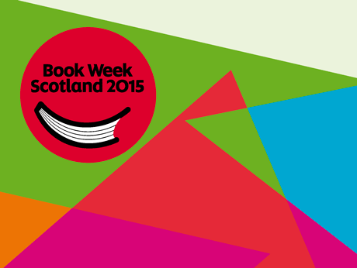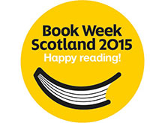
Within the nursery setting and through our home link programmes we aim to develop nurturing early readers, who will find enjoyment and pleasure being read to on a one to one and in small groups.
Over the course of the week we would like your child to choose one of their favourite books to be read to at home on a daily basis and bring this book with them to nursery on Monday 29th November to share with their friends in their group.
To help you deepen their knowledge of the story content could you help them to answer the following questions at the end of the week?
Ask your child what the title of their story was and who it was written by?
_____________________________________________________________________________
Can they tell you who the main character is?
____________________________________________________________________________
Are they able to share where the story was set? E.g forest, at the beach ,
______________________________________________________________________________
Can they share which their favourite part was?
_______________________________________________________________________________
Thank you for taking part in Book Week Scotland 2015, please return on Monday 29th November 2015

