Rochsolloch Nursery Class
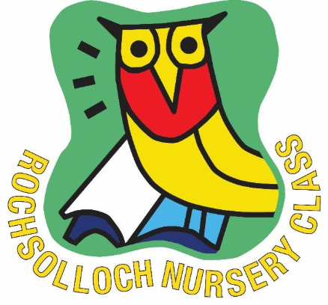

Loving Lunches
October 2025

Loving Lunches Policy
Rationale
Loving Lunches is an important part of the children’s day at Nursery. This policy outlines what Loving Lunches looks like at Rochsolloch Nursery Class as we strive to ensure the best possible experience for each child.
Loving Lunches
Practitioners are encouraged to view loving lunches time as a holistic learning experience for children and recognise the many benefits to a child’s development that this time can bring. Loving lunches is a time where children can come together with their friends to socialise, develop self-help skills, try, and explore a variety of new and healthy foods. Loving lunches should be supported in a relaxed, unhurried, nurturing environment where children are supported to make appropriate choices, to enjoy the food they are offered and have the opportunity to take part in the social interaction and learning experiences associated with eating and drinking together.
Lunch Menu
The lunches that are on offer are planned and provided by the Local Authority and the menus operate on a 3-week rotation. Every meal consists of a hot meal, a healthy snack and milk/water. A vegetarian option is also provided. If children have special dietary requirements/allergies, their parent/carer will be provided with a medically prescribed form which must be signed by a medical professional and emailed to North Lanarkshire Council’s Nutrition Team, in order for an alternative lunch to be provided. The lunch menu is posted weekly on our nursery noticeboard within the cloakroom and is also available on the newsletter.
Lunch Routine
- All children have their lunch from 12pm in the nursery playroom or the nursery garden.
- Children are invited to come for lunch in small groups, starting with the morning children.
- All children will wash hands before choosing their seat.
- Children are able to choose their own seat for lunch. This means that children are able to sit with their friends. However, in order to ensure that children get the most out of this experience, staff may decide to sit children near a positive role model.
- Cutlery and cups are available for the children to collect. Jugs of milk and water will be placed on the table for the children to pour independently with staff assisting if required.
- Our Catering Assistant will provide meals in trays for children to self-serve. There is an allocated nursery staff member who is responsible for assisting children if required. Outdoor lunches will be served by our Catering Assistant.
- When children are finished their lunch, they remove their photograph from the wall. Staff monitor to ensure everyone has had lunch.
Packed Lunches
On occasions, parents/carers may request for their child to bring their own packed lunch. Parents/carers must be advised that staff members cannot heat packed lunches during the nursery session. All packed lunches should be placed in an appropriate packed lunch bag with your child’s name clearly visible. Packed lunches will be stored in the nursery fridge in individual boxes labelled with the child’s name. Parents/carers should avoid the following items within their packed lunch: fizzy drinks, chocolate, sugary snack bars and products that contain nuts or traces of nuts (we are a strictly nut free school and nursery).
Monitoring of lunches/Feedback to parents
We have loving lunch tracking sheets which are completed by the staff member allocated to the lunch area. These indicate how much of the lunch the child has eaten that day and how much they have had to eat at snack. Tracking sheets are displayed at each child’s group area at collection time. This gives parents/carers a clear indication of how much their child has had to eat that day. Staff also have regular discussions with parents at collection times regarding more details of lunch/snack times and if there were any problems.

