Rochsolloch Nursery Class
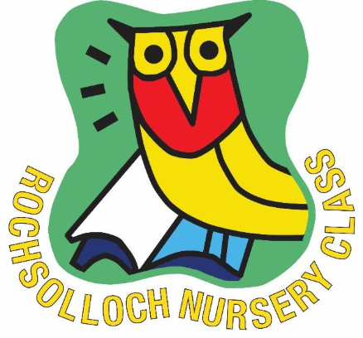

Duty of Candour
October 2025

Duty of Candour
The community of Rochsolloch Primary and Nursery endeavour to always act in an open and transparent way in our dealings with pupils, parents and stakeholders.
- We will encourage a culture of honesty in all our dealings with you.
- We will ensure that all staff members are aware of and supported in their responsibilities regarding a Duty of Candour.
- We will encourage and support staff members who report any incident and investigate fully.
- The Head Teacher, Depute Head Teacher or Principal Teacher will be responsible for any investigation and they will promptly appoint another member of the team if there is a conflict of interest.
- No staff member will be victimised or harassed as a result of reporting an issue.
- Where an error has occurred which has caused harm to any individual in the course of our work, we will openly admit the error and apologise to the individual and their parent or carer.
- We will ensure that all accounts of an error are complete and truthful.
- We will do our best to mitigate or correct any harm that has occurred and will provide support to persons affected.
- We will keep a record of all conversations and correspondence in connection with any such incident.
- We will notify the Care Inspectorate and any other appropriate body of any serious ‘Notifiable Safety Incident’ (those resulting in moderate or serious harm) as soon as possible.

