Rochsolloch Nursery Class

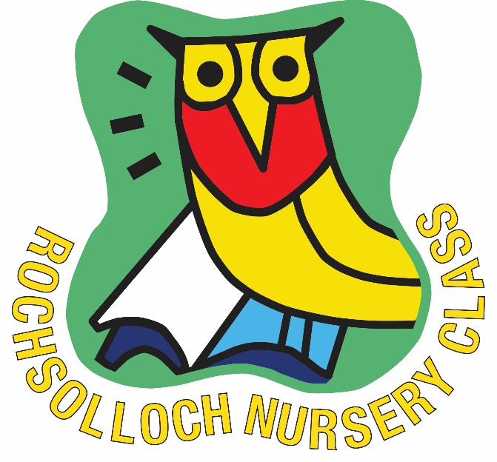

Child Protection & Safeguarding
October 2025

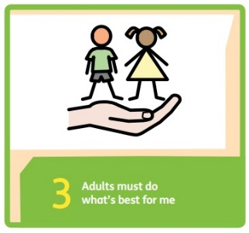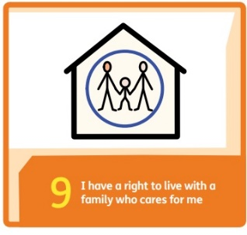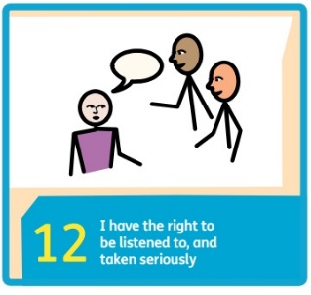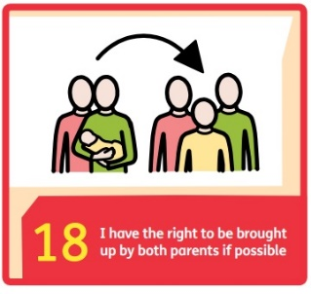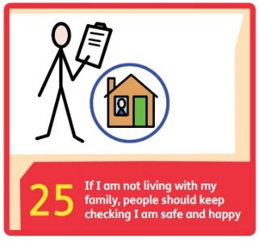
The child protection co-ordinator for Rochsolloch Nursery Class is Mark Wilson, Head Teacher (Term Time) and Kirsty Milligan, Principal Lead (School Holidays).
Any concerns around Child Protection should be brought immediately to the attention of Kirsty Milligan, Principal Lead or Mark Wilson, Head Teacher. In the Head Teacher’s absence, direct the concern to Jamie Innes, Depute Head Teacher (Mon, Tue & Wed) or Lindsay Torley, Depute Head Teacher (Thur & Fri).

Rochsolloch Nursery Class– Child & Adult Protection Policy

All children have a right to be protected from abuse and neglect (UNCRC Article 19 – ‘Children have the rights to be protected from being hurt and mistreated, in body and mind), therefore child protection is the responsibility of everyone. The shared responsibilities of Learning and Leisure Services and other agency employees are to protect children from abuse and exploitation, to respond appropriately when abuse is identified and to ensure whenever possible that all children can exercise their right to be raised in a warm, stimulating and safe environment with the support of staff, their families and carers. It is the clear responsibility of all those involved in our nursery to adopt good practice throughout their work. (For further information refer to the CP Team on Glow).

Aim
The aim of this policy is to provide advice and guidelines for staff in relation to issues of child protection and the health and wellbeing of the children in our nursery. The main purposes of the policy are:
• to raise staff awareness of the categories of abuse and the indicators which could
signify that abuse is taking place
• to identify the roles and responsibilities in the care and protection of our pupils
• to provide guidance and support to staff in carrying out their role and
responsibilities in the protection of our pupils.

Procedures

• All staff are issued with a copy of the Child Protection Action Guidance Leaflet and
receive an annual Child Protection update in August Inservice days. A copy is also displayed on the staff noticeboard.
• In addition, new staff are also required to complete the ‘Understanding Child
Protection Self Learning Pack’ and have this signed off by the Head Teacher
• The procedures outlined in this policy must be always followed meticulously and by all staff and should be implemented in conjunction with NLC Child and Adult
Protection Procedures and Guidance. A copy of this guidance is available for all stakeholders in the Head Teachers office.

What is child abuse and neglect?
The Scottish Government’s National Guidance for Child Protection in Scotland (2014) states that abuse and neglect are forms of maltreatment of a child. Somebody may abuse or neglect a child by inflicting, or be failing to act to prevent, significant harm to the child. This online document provides the following definitions of some of the ways in which children may experience abuse.
• Physical abuse – may involve hitting, shaking, throwing, poisoning, burning or
scalding, drowning or suffocating.
• Emotional abuse – may involve conveying to a child that they are worthless,
unloved or inadequate, they may be constantly criticised, ignored, humiliated. Some
level of emotional abuse is present in all types of ill treatment of a child but can occur independently of other forms of abuse.

• Sexual abuse – involves forcing or enticing a child to take part in sexual activities
which may involve physical contact, but which also applies to non-contact sexual activities such as involving children in looking at, or in the production of, indecent images. It includes using sexual language to a child or encouraging them to behave in sexually inappropriate ways.
• Neglect – may involve a parent or carer failing to provide for a child’s basic needs,
failing to protect a child from physical harm or danger, not ensuring access to
appropriate medical care or treatment. Neglect also incorporates ‘non-organic failure to thrive’ where a child has significantly failed to meet their normal development and growth milestones and there are no known genetic or medical reasons for this.

Indicators of Risk

The following circumstances are considered to be indicators that a child may be at increased risk of harm within their families:
• Domestic abuse
• Parental problematic alcohol and drug misuse
• Non-engaging families
• Children and young people experiencing or affected by mental health problems.
• Children and young people who display harmful or problematic sexual behaviour.
• Female Genital Mutilation (FGM)
• Honour based violence and forced marriage.
• Fabricated or induced illness (previously known as

Further detailed information on all of the above circumstances can be found within Part 4 of the National Guidance for Child Protection in Scotland 2014 (page 113). This can be accessed online at http://www.gov.scot/Resource/0045/00450733.pdf
The above guidance also provides information about ways in which children and young people can come to harm outside of the home and in specific circumstances e.g.
• Child trafficking
• Child Sexual Exploitation (CSE)
• Online and mobile phone safety
• Further detailed information on these and other specific circumstances can also be found within Part 4 of the National Guidance (Page 139).

UK Government Counter Terrorism Awareness

Contest is the overarching UK Government Counter Terrorism Strategy. It contains four work streams known as the 4 P’s i.e., Pursue Prevent Protect Prepare. PREVENT is the strategy published in 2011 as part of context. Key risk factors to be considered are ideologies. Is the child using language/engaged in activities to suggest they are at risk from being involved or drawn into any type of radicalisation.

Roles and Responsibilities

At Rochsolloch Nursery Class, Mark Wilson, Head Teacher has overall responsibility for all child protection issues. These responsibilities include the following:
• Ensuring that the North Lanarkshire Child and Adult Protection Procedures and
Guidance are brought to the attention of all staff on an annual basis, that staff have
access to the guidance and are issued with the Child Protection Action Guidance
Leaflet and that a copy of the leaflet is displayed on the staffroom wall.
• Ensuring that all staff know the name of the child protection co-ordinator in the
establishment and who to speak to in his/her absence.
• Developing establishment policy and practice to meet national and local authority
guidance.
• Ensuring child protection training for all staff
• Developing a school ethos and learning opportunities which promote the safety and
wellbeing of all children.
• Completing and returning all Child Protection paperwork as outlined in local
guidance.
All Staff

It is everyone’s responsibility to keep children safe therefore all nursery staff have an active role to play within this establishment. In terms of child protection, staff should be aware of the following grounds for concern, which can arise from a wide range of circumstances but will generally be covered by the following events:

Grounds for Concern:
• A child states that abuse has taken place, or the child feels unsafe
• A third party or anonymous allegation is received
• A child’s appearance, behaviour, play, drawing or statement cause suspicion of
abuse
• A child reports an incident of abuse which occurred some time ago
• Staff witness abuse

Responding to Grounds for Concern:
• Any grounds for concern should be reported immediately to the head of
establishment. On no account should staff tell a parent about what has happened at
this stage.
• If there is direct evidence or suspicion of child abuse the matter must be reported
immediately, staff should not wait to gather evidence nor agree to keep the
information secret or discuss the matter with others.
• Staff must follow the guidance given by the head of establishment in relation to
recording concerns, supporting the child, co-operating with subsequent actions to
investigate the grounds for concern, and protecting the child or children concerned.
• All information recording must be relevant, accurate, signed and dated as it may
become a legal document. Please ensure the child’s name and date of birth are
accurately recorded. The information should include a clear, succinct chronology of
events, all relevant information and a summary of the employee response and any agreements reached.
• Staff should provide an accurate report for the child protection coordinator when
requested.
• It is essential that there is no delay in initiating child protection procedures even
where the Head Teacher is absent or not available. In such circumstances staff
should speak to a the Depute Head Teacher. Further support is available from Child
Protection Development Officer, Michael Bradley, Civic Centre Motherwell.

Supporting the Child

During any disclosure of abuse by a child staff should respond in a sensitive and supportive
manner. The following strategies should be adopted:
• Listen with care.
• Treat the allegation in a serious manner.
• Reassure the child that he or she is right to tell.
• Affirm the child’s feelings as expressed by the child.
• Do not give a guarantee of confidentiality or secrecy.
• Do not ask leading questions.
• Ask open ended questions which seek to clarify information already given.
• Do not interrogate the child.
• Do not show disbelief.
• Do not be judgmental.
• Do not introduce personal or third-party experiences of abuse.
• Do not display strong emotions.

What happens next?

A medical emergency should be reported immediately to medical services and, if required, first aid should be administered before reporting the incident to the senior social worker. Child abuse is a criminal offence. Urgent circumstances may require help from the police, for example to immediately avoid further abuse, to ensure the immediate pursuit of an alleged abuser or to avoid destruction of evidence. The grounds for concern and action taken should be recorded, signed and dated (on the same day) a Notification of Concern (NOC). Two copies should be sent immediately as indicated on the form. The copy retained in the establishment should be stored in the confidential child file (located in the nursery office). Grounds for concern to be recorded on Early Years Pastoral Care Notes. Following a Notification of Concern, the police will investigate and may initiate an ‘Initial Referral Discussion’ (IRD). The purpose of the IRD is to ensure that key agencies/services are involved in the initial sharing and analysing of information to inform a collective decision about whether a notification of child protection concern should proceed to a child protection investigation. This ensures a collective responsibility and consistent involvement by police, social work, health, and education staff in sharing information and assessing risks and a single record of joint decision making.

Co-operating with Agencies involved in Child Protection Process

Following reporting and recording of concerns staff should co-operate fully with subsequent investigations and support plans as directed by the head of establishment and in consultation with the appropriate agency representatives. This may include attendance at case discussions, child protection conferences and reviews. Dealing with child protection issues can have stressful consequences for employees. Education, Youth and Communities have a duty of care to all employees. Support can be accessed through the Staff Welfare Officer.

The next course of action can take 2 paths:

No Child Protection Concerns – One or more of the following may happen:
• No further action
• Social work offer help to support the child and their family
• A case discussion is held to identify support needs of the child and family
• A referral to other agencies for help or support.
Ongoing Child Protection Concerns – One or more of the following may happen:
• A Child Protection Case Conference will be convened.
• A Child Protection Order, Exclusion Order, Emergency Police Powers are placed
• Criminal Enquiries - report to Procurator Fiscal
• Referral to the Scottish Children’s Reporter Administration (SCRA)
• White/Blue Care and Welfare Files
All information reported must be recorded and kept confidential. The recording must be relevant, accurate, signed and dated as it may become a legal document. The information should include a clear, succinct chronology of events, all relevant information and a summary of the employee response and any agreements reached.
It is important to note that we do not investigate or gather evidence and proof is not
required. All information must be confidential, and staff should not discuss concerns with others, but report to the Head Teacher. All children have the right to be cared for and protected from abuse and harm in a safe environment in which their rights are respected. By being aware of and following the procedures in this policy and by referring to local and national guidance we can remain vigilant in protecting our pupils and promoting their Health and Wellbeing.

Adult Protection

It is our duty to protect vulnerable adults as well as children. This could be children aged between 16 & 18, or vulnerable parents, carers or family members.
An adult is at risk of harm if they:
• Are unable to safeguard their wellbeing, rights, interests or their property.
• Are being harmed by other people.
• Have a disability, illness, or mental disorder, as they are more at risk of being
harmed than others who are not so affected.
All three elements above must be met for an adult to be considered at risk. All concerns should be reported immediately to the Head Teacher and an AP1 Form is completed.

Conclusion

All children have the right to be cared for and protected from abuse and harm in a safe environment in which their rights are respected. By being aware of and following the procedures in this policy and by referring to local and national guidance we can remain vigilant in protecting our pupils and promoting their Health and Wellbeing.

Useful Resources

NLC Child and Adult Protection Procedures and Guidance
Action Guidance Leaflet
Understanding Child Protection Self Learning Pack
National Guidance for Child Protection in Scotland 2014 (online)

UNCRC Links

Article 2: All children have these rights, no matter who they are, where they live, what their parents do, what language they speak, what their religion is, whether they are a boy or girl, what their culture is, whether they have a disability, whether they are rich or poor. No child should be treated unfairly on any basis.

Article 3: All adults should do what is best for you. When adults make decisions, they should think about how their decisions will affect children.

Article 4: The government has a responsibility to make sure your rights are protected. They must help your family to protect your rights and create an environment where you can grow and reach your potential.

Article 9: You have the right to live with your parent(s), unless it is bad for you. You have the right to live with a family who cares for you.

Article 11: You have the right to be protected from kidnapping.

Article 19: You have the right to be protected from being hurt and mistreated, in body or mind.

Article 22: You have the right to special protection and help if you are a refugee (if you have been forced to leave your home and live in another country), as well as all the rights in this Convention.

Article 26: You have the right to help from the government if you are poor or in need.
Article 27: You have the right to food, clothing, a safe place to live and to have your basic needs met. You should not be disadvantaged so that you can't do many of the things other kids can do.

Article 32: You have the right to protection from work that harms you and is bad for your health and education. If you work, you have the right to be safe and paid fairly.

Article 33: You have the right to protection from harmful drugs and from the drug trade.

Article 34: You have the right to be free from sexual abuse.

Article 35: No one is allowed to kidnap or sell you.

Article 36: You have the right to protection from any kind of exploitation (being taken
advantage of).

Article 37: No one is allowed to punish you in a cruel or harmful way.

Article 39: You have the right to help if you've been hurt, neglected or badly treated.

Article: 40: You have the right to legal help and fair treatment in the justice system that respects your rights.

Review Date
August 2026

