Rochsolloch Nursery Class

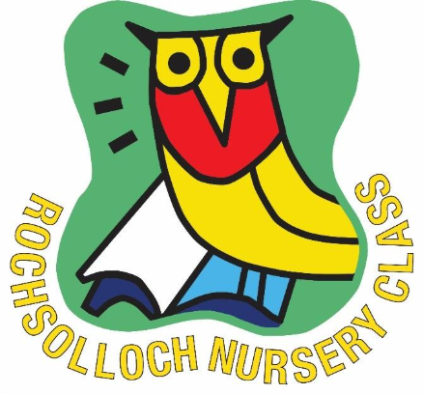

Accident and Incidents
October 2025

Accident/Incident Policy
In general, an accident is an unplanned, unexpected, and undersigned (not purposefully caused) event, which occurs suddenly and causes injury or loss, a decrease in value of the resources or an increase in liabilities.
First Aid Boxes are available around the nursery and are fully stocked and replenished when required. The First Aider is Jamie Innes.
All accidents/incidents no matter how minor, should be recorded on an accident/incident sheet. Parents/Carers are asked to sign this sheet to acknowledge they have been made aware of the accident/incident. Each group has their own accident/incident folder, where every child has an individual section for their forms. When a sheet has been completed (with all signatures) this should be filed away under the child’s name.
Procedure for Accident Forms
The accident/incident forms will record the following information:
- Child’s name
- Date and Time of Accident/Incident
- Location of accident/incident
- Circumstances of Accident/Incident (What happened)
- Extent of injuries
- What action was taken by staff and by whom?
- Which member(s) of staff witnessed the accident/incident?
- Signature of staff who witnessed/completed the form
- Signature of management
- Signature of parents/carers acknowledging they have been informed
- Dates of all signatures
It is the responsibility of the member of staff who has witnessed/first been made aware of the accident/incident that should complete the form. Where possible, they are also the person responsible for communicating this to the parent and asking the parent to sign it.
Parents will be contacted immediately if it is a head injury so they can decide on medical attention or collection.
If the injuries require medical attention but are not life threatening, staff will phone the child’s parent/carer or emergency contact to explain the circumstances and ask for them to take the child to the nearest accident and emergency department. Management will also be made aware of this and will act accordingly.
If the injuries are life threatening, an ambulance will be called, and the child’s parent/carer will be informed so they can join the child and member of staff at the hospital. A member of staff will accompany the child in the ambulance, and will take the accident/incident sheet, the child’s records, detailing the child’s doctor, any allergies etc. Management will also be made aware of this and will act accordingly.

Procedure for incident forms
An incident is defined as an apparently minor conflict, disturbance between people that may have serious consequences.
Incident forms are extremely important documents which hold details of incidents recorded when required.
If an incident occurs, all children involved must get an incident form completed and signed. Confidentiality and data protection must be respected at all times with information recorded accurately and without bias. Anything stated must be factual, without opinion, prejudice, or judgement.
Children’s names should not be stated on any other child’s form and must be referred to only as ‘another child’.
If there is a pattern in incidents with children, this should be discussed with management in order to put strategies in place to prevent it reoccurring.
Accident at home forms
Accident at home forms will be completed if a child presents at nursery with a visible injury that did not occur within nursery. The staff member will fill an accident at home form out stating the nature of the injury, when the child is being collected, staff should have a discussion with the parent/carer to enquire on how it occurred.
The accident at home forms will record the following information:
- Child’s name
- Date/Time that it was noticed at
- Nature of injury
- Explanation given (from parent/carer)
- Any treatment/action taken (from parent/carer)
- Staff signature
- Management signature
- Parent/Carer signature
Accident at home forms are treated in the same nature as accident/incident forms. The purpose of every form is to protect the health/welfare of all staff, children and families who use our service. Staff should always inform a line manager first of an accident at home form before speaking to the parent.

ALL forms should be signed by management before the parent/carer.
All accident/incident/accident at home forms are maintained properly and reviewed regularly by staff to identify risk areas or issues with equipment/resources.

