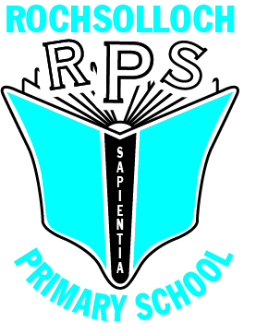
Rochsolloch Primary School
ICT Acceptable Use Policy

April 2025

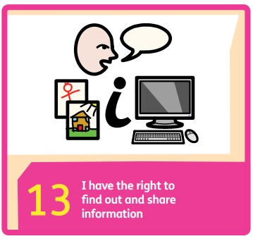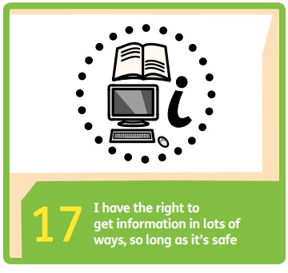

- Rationale
“If used effectively and appropriately, digital technology can enhance learning and teaching, equip our children and young people with vital digital skills and crucially, it can lead to improved educational outcomes.” (Enhancing learning and teaching through the use of digital technology, Scottish Government, 2016, p3)
It is the responsibility of all users to use North Lanarkshire Council ICT equipment and internet access appropriately and for the intended purpose of supporting the work of the school.
Rochsolloch Primary has created this policy in accordance with the Scottish Government strategy Enhancing learning and teaching through the use of digital technologies (2016), and is congruent with Features of Highly Effective Digital Learning, Teaching and Assessment in Schools (2022), the United Nations Convention on the Rights of the Child (UNCRC) (1992), and the six principles of nurture:
- Children’s learning is understood developmentally
- The environment offers a safe base
- The importance of nurture for the development of self-esteem
- Language is vital means of communication
- It is understood that all behaviour is communication
- The importance of transition in children’s lives is understood
Our vision is that ‘Everyone achieves their potential’. We endeavour to realise this ambition by taking action based on our shared values of Respect, Happiness and Achievement.
- Aim
- To provide clarity to all stakeholders about what constitutes safe and responsible use of ICT resources in Rochsolloch Primary School.

- Stakeholder Responsibilities

No personal devices should be connected to the school network at any time.

General
Children will
- not use personal devices in school without permission of a staff member.
- access only those websites, apps or programmes for which the teacher has given permission.
- ensure that all communication is polite, respectful, and only engaged in with people they know or who are approved by their teacher.
- only use their official school email account to send or receive communications and log in to platforms e.g., Microsoft Teams.
- tell a staff member if they see offensive or inappropriate content.
- be aware that all communications, files, saved content and web addresses visited will be checked by staff members to ensure they are being used appropriately.
- only download or print material if given permission by a staff member and only use material which is permitted under copyright legislation.
- protect themselves and others by not sharing personal information such as:

- name
- home address
- telephone numbers
- photographs
- any information about others
- not arrange to meet any online contact.
- tell a member of staff about any invitations to meet online contacts.
- use equipment respectfully and store properly to prevent damage.

Staff will
- use school devices to take photographs and videos.
- access appropriate websites, apps or programmes that relate to education.
- use only their North Lanarkshire Council email account to send work related emails.
- only download appropriate material and use material that is permitted under copyright legislation.
- monitor pupil use of ICT and report any misuse to SLT.
- use and store equipment properly to prevent damage.

Social Media
Social media applications and websites enable users to create and share content or to participate in social networking. Rochsolloch Primary does not use social media platforms to communicate with parents.

The school maintains an X account, which is primarily used for community partners to tag the school in events or notifications.

The Senior Leadership Team will be responsible for monitoring social media. We will block followers who:
- appear not to be relevant to the school or school business.
- have usernames not in keeping with North Lanarkshire Council objections or the ethos of the school e.g., football team affiliated, sexualized or drug or alcohol related names.

On our school X account, we will:
- welcome likes and retweets, and positive comments only.
- only follow educationally linked accounts; no personal accounts unless they are educationally linked, will be followed.
- ensure children are not able to be identified.
- not respond to replies; it is not the appropriate platform to discuss school or individual issues. These should be directed to the appropriate member of SLT.

Children will:
- be aware of how to report abuse and inappropriate content.
- not record images or videos of others without consent.
- not make inappropriate comments (including in private messages) about the school, staff members or other children.
Staff will:
- report abuse or inappropriate content to SLT.
Parents will:
- not post photos, videos, screenshots or comments that include other children.
- raise concerns and complaints directly with the school rather than posting them on social media.
- not post anything malicious about the school or any member of the school community.

Anyone found not following any of the above guidance should in the first instance be reported to the Head Teacher and further action may be taken thereafter.

Policy Date April 2025
Review Date April 2027

