
Rochsolloch Primary School
Relationships Policy

January 2024

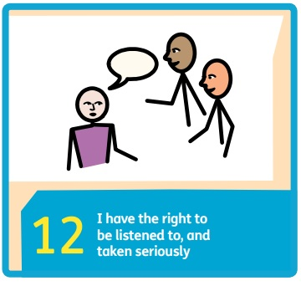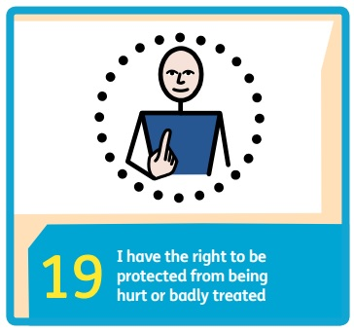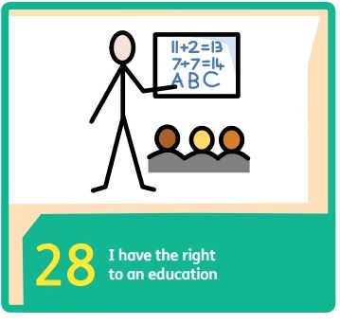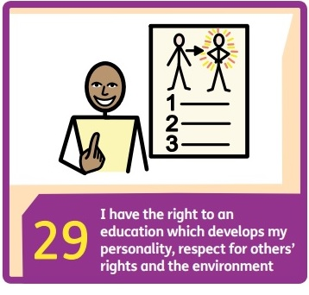

- Rationale
Rochsolloch Primary School has created this policy in accordance with the United Nations Convention on the Rights of the Child (UNCRC) (1992), with specific consideration given to the Articles listed below, as well as the six principles of nurture.

Article 3: The best interests of the child must be a top priority in all actions concerning children.
Article 12: Every child has the right to say what they think in all matters affecting them and have their views taken seriously.
Article 14: Every child has the right to think and believe what they want and follow their own religion as long as they are not stopping other people from enjoying their rights.
Article 15: Every child has the right to meet with other children and young people and to join groups and organisations, as long as this does not stop other people from enjoying their rights.
Article 23: A child with a disability has the right to live a full and decent life in conditions that promote dignity, independence and an active role in the community.
Article 28: Every child has the right to an education.
Article 29: Education must develop every child’s personality, talents and abilities to the full. It must encourage the child’s respect for human rights, as well as respect for their parents, their own and other cultures, and the environment.
Article 30: Every child has the right to learn and use the language, customs and religion of their family whether or not these are shared by the majority of the people in the country where they live.
Article 31: Every child has the right to relax, play and join in a wide range of cultural and artistic activities.
Article 40: A child accused or guilty of breaking the law must be treated with dignity and respect. They have the right to help from a lawyer and a fair trial that takes account of their age or situation. The child’s privacy must be respected at all times.

Six Principles of Nurture
- Children’s learning is understood developmentally
- The environment offers a safe base
- The importance of nurture for the development of self-esteem
- Language is vital means of communication
- It is understood that all behaviour is communication
- The importance of transition in children’s lives is understood
Our vision is that ‘Everyone achieves their potential’. We endeavour to realise this ambition by taking action based on our shared values of Respect, Happiness and Achievement. This policy has been informed by reflection on a range of professional texts, training, accounts of best practice, and our own experiences.

Factors that can affect how a child presents in school

- A child’s background, building on prior knowledge from points of transition.
- A child’s home circumstances.
- An individual’s development.
- Any known conditions which may affect a child’s ability to conform to the school standard.
- Protected characteristics covered by the Equalities Act, 2010:
  - Disability
  - Gender reassignment
  - Pregnancy and maternity
  - Race
  - Religion and belief
  - Sex and sexual orientation

- Aim
- Create a culture of outstanding behaviour for learning, for community and for life.
- To ensure all learners are treated fairly and with dignity, shown respect and supported to develop good relationships.
- To help learners manage their behaviour and be responsible for the consequences of it.
- To build a community that values respect, happiness and achievement.

- Consistency
Professional judgement is central to our practice, but consistency in approach is essential.
Consistent language
- Simple and clear expectations reflected in all conversations about behaviour, centred on the school rules Ready, Respectful, Safe. Children are reminded of their, and others, rights and encouraged to consider the impact their actions have on others.
- Staff greet children each morning positively and make a determined effort to learn as much about the children in their care as possible through casual interactions and planned curriculum activities.
- Staff respond to behaviour with regulated emotions, and in a way that takes account of the needs of the learner and their developmental stage.
Consistent follow-up
- Ensuring ‘certainty’ and staff dealing with behaviour with support from colleagues.
- After an appropriate number of interactions to remind learners of expectations, the following consequences/rewards may be used to maintain a positive learning environment for all learners.
Consequences | Rewards
Short time working in other area of class | Positive Postcard home
Short time out of class in open area | Positive phone call home
Time working in another class | Aim High Hero Certificate
Side by side conversation with SLT | Hot Chocolate Friday
Phone call to parent/carer
Meeting with parent/carer
Spending break times indoors

Consistent positive reinforcement
- Aiming for a notional 5:1 ratio of positive to negative interactions with children throughout the day.

- Accountability
It is the responsibility of all adults in the school to reflect on their role in supporting positive behaviour norms around the school and always act in the best interests of the child. The Senior Leadership Team will provide feedback and engage in dialogue to attempt to identify patterns of, or triggers for, dysregulated behaviour. The following questions may be used to facilitate discussion around supporting the child:
- Is there consistency of practice, as described in section 3?
- Is the learning environment appropriate?
- Are the expectations of behaviour appropriate?
- Are the activities provided appropriately challenging and engaging?

- Monitoring behaviour
As appropriate, teachers monitor behaviour, consequences and rewards using the RPS Weekly Behaviour Record. This is used to inform conversations around patterns of behaviour and possible underlying triggers.
Policy Date October 2024
Review Date October 2026

