Driving Equity and Excellence

Improvement Action Plans

Session 2023-24

School: | Rochsolloch Primary School
Cluster: | Airdrie Academy
Head Teacher: | Mark Wilson

Improvement Plan Summary
Cluster Priority: | Raise attainment for a specific group of children/young people by fostering resilience, boosting attendance, and further nurturing their life, learning, and work-related skills.
School Priority 1: | Increase attainment in reading by 3%, writing by 5%, and numeracy by 3% across all stages by June 2023 by improving assessment evidence.
School Priority 2:
Nursery Class Priority: | To ensure that considered, robust approaches to self-evaluation, tracking and monitoring and increased opportunities for collegiate working have a direct and measurable impact on attainment of learners.

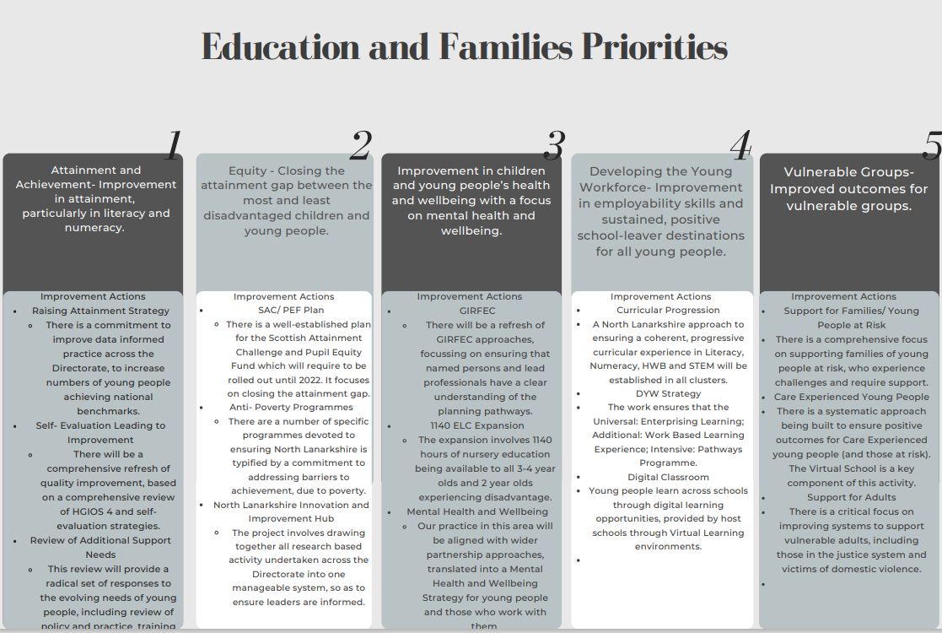

School Vision and Values
Vision: Everyone achieves their potential

Values
Respect
Achievement
Happiness

Audit and Consultation

In arriving at our improvement priorities, the school has taken account of Education and Families’ priorities, an audit of the previous year’s improvement plan and engagement with parents/carers and learners.

Details of engagement (pupils, parents/carers, partners)

Parent Survey: May 2023
Pupil Focus Groups: June 2023

2023-24 Improvement Plan

Cluster Priority: Long Term Outcome
What do you hope to achieve? What is going to change? For whom? By how much? By When?
Person(s) Responsible
Who will be leading the improvement?

(Please insert the relevant information below using the codes above)
NIF Priority: |  | NIF Driver:
NLC Priority: |  | QI:
PEF Intervention: |  | Developing in Faith/UNCRC:
If you used any aspect of your PEF fund to support this priority; please detail the expenditure here:

RATIONALE (WHY?) Why have you identified this as a priority? What data did you have to support this?

Resources: Please include costs and, where relevant, state where cost is being met from, specifically if using PEF. Please denote PEF/or colour code if preferred, to indicate where PEF spend aligns with targets.

EXPECTED IMPACT  (SHORT TERM TARGETS) | INTERVENTIONS/ACTIONS TO SUPPORT IMPROVEMENT: HOW? |  | HOW WILL YOU TRACK PROGRESS?  MEASURES | EVALUATION CHECKPOINT 1 (Internal Process) | EVALUATION CHECKPOINT 2  (Internal Process)
What will be the benefit for learners (be specific)? | What are you going to do to make the change? What key actions are required? Consider links to the NIF Drivers. |  | What ongoing information will demonstrate progress? (Qualitative, Quantitative – short/medium/long term data)
Final evaluation:

Priority 1: Long Term Outcome  What do you hope to achieve? What is going to change? For whom? By how much? By When? |  | Increase attainment in reading by 3%, writing by 5%, and numeracy by 3% across all stages by June 2023 by improving assessment evidence.
Person(s) Responsible  Who will be leading the improvement? | Teaching Staff will work in relevant groups to undertake aspects of the Priority.

(Please insert the relevant information below using the codes above)
NIF Priority: 1/3 |  | NIF Driver: 2/4/5
NLC Priority: 1/2 |  | QI: 1.3/2.2/2.3
PEF Intervention: 4/6/7 |  | Developing in Faith/UNCRC: Article 3/Article 29
If you used any aspect of your PEF fund to support this priority; please detail the expenditure here:

RATIONALE (WHY?) Why have you identified this as a priority? What data did you have to support this?
Work is continuing from last session to improve approaches to reading and writing. Further work on reading and writing will embed approaches for sustainable improvement over time.
There has been a decline in numeracy over the last 3 years, therefore a focus on creating a rigorous approach to identifying and monitoring target children is anticipated to have a positive effect on attainment.
Resources: Please include costs and, where relevant, state where cost is being met from, specifically if using PEF. Please denote PEF/or colour code if preferred, to indicate where PEF spend aligns with targets.
0.5FTE Class Teacher (PEF)

EXPECTED IMPACT  (SHORT TERM TARGETS) | INTERVENTIONS/ACTIONS TO SUPPORT IMPROVEMENT: HOW? |  | HOW WILL YOU TRACK PROGRESS?  MEASURES | EVALUATION CHECKPOINT 1 (Internal Process) | EVALUATION CHECKPOINT 2 (Internal Process)
What will be the benefit for learners (be specific)? | What are you going to do to make the change? What key actions are required? Consider links to the NIF Drivers. |  | What ongoing information will demonstrate progress? (Qualitative, Quantitative – short/medium/long term data)
- Attainment in Reading is improved by 3%. | Reading  - Embed ‘Reading for Enjoyment’ as per Reading Schools audit.  - Aspects of ‘Reflective Reading’ are embedded (P4-7).  - Embed aspects of ‘Reflective Reading’ (P4-7).  - Small group support for identified children. |  | - TPJ.  - Almost all features of Reading Schools audit completed.  - Identified aspects of ‘Reflective Reading’ are embedded (P4-7).
- Attainment in Writing is improved by 5%.  - >75% of children enjoy writing activities ‘most of the time’. | Writing  - Evaluate Talk for Writing materials.  - Agree approaches to writing organisation and resources. |  | - TPJ.  - Agreed approaches to writing organisation and resources.  - Pre/post writing assessments.
- Increase staff understanding of, and confidence in using, observation as an assessment tool to identify next steps in learning. | Play/PEBL  - Review/revise assessment calendar.  - Agree format/frequency of observations.  - Agree format for recording child-led activities. |  | - Staff survey.  - Assessment calendar updated.  - Observation format/frequency agreed.  - Format for recording child-led activities agreed.
- Attainment in Numeracy is improved by 3%. | Numeracy  - Agree appropriate time allocation for teaching numeracy.  - Agreed process for identifying/monitoring target children.  - Small group support for identified children. |  | - TPJ.  - Pre/post MALT assessment for identified children. | - Appropriate amount of teaching time agreed at Tracking Meetings/Staff Meetings.  - Target children identified through assessment calendar activities and Tracking Meeting discussions. Monitoring of progress through frequent meetings with additional teacher and PT. Adjustments to target children made if necessary.
Final evaluation:

Priority 2 (Nursery Class): Long Term Outcome  What do you hope to achieve? What is going to change? For whom? By how much? By When? |  | To ensure that considered, robust approaches to self-evaluation, tracking and monitoring and increased opportunities for collegiate working have a direct and measurable impact on attainment of learners.
Person(s) Responsible  Who will be leading the improvement? | Jamie Innes, Lauren Fox, Maureen Orr, Nicola Doherty

(Please insert the relevant information below using the codes above)
NIF Priority: 1 |  | NIF Driver: 2, 5
NLC Priority: |  | QI: 1.1, 1.3, 2.2, 2.3, 3.2
PEF Intervention: |  | Developing in Faith/UNCRC:
If you used any aspect of your PEF fund to support this priority; please detail the expenditure here:

RATIONALE (WHY?) Why have you identified this as a priority? What data did you have to support this?
- Self-evaluation marked as essential in Early Years by NLC
- Aspects of self-evaluation carried froward from last year’s Improvement Plan
- Robust tracking and Monitoring identified by SLT through self-evaluation as gap in current learning provision for children

Resources: Please include costs and, where relevant, state where cost is being met from, specifically if using PEF. Please denote PEF/or colour code if preferred, to indicate where PEF spend aligns with targets.

N/A - No significant resources required

EXPECTED IMPACT  (SHORT TERM TARGETS) | INTERVENTIONS/ACTIONS TO SUPPORT IMPROVEMENT: HOW? |  | HOW WILL YOU TRACK PROGRESS?  MEASURES | EVALUATION CHECKPOINT 1 (Internal Process) | EVALUATION CHECKPOINT 2 (Internal Process)
What will be the benefit for learners (be specific)? | What are you going to do to make the change? What key actions are required? Consider links to the NIF Drivers. |  | What ongoing information will demonstrate progress? (Qualitative, Quantitative – short/medium/long term data)
Self-Evaluation  All staff will contribute to nursery self-evaluation, creating clear next steps for improving experiences for learners | Make use of authority pro-forma for collecting staff views on both HGIOELAC and CI Quality Framework  All staff will be regularly involved in self-evaluation (every in-service day and at some staff meetings)  Create and use observation pro-forma to support evidence gathering for self-evaluation  Seek views from parents to support regular staff self-evaluation  Seek views from children to support regular staff self-evaluation |  | Review of staff Self-Evaluation entries – ensure that CI 1.1/1.3 and HGIOELAC 1.1, 2.3, 3.2 have entries by June at a minimum  In-service agendas reflective of opportunities  Parent Feedback via MS Forms  Children’s focus group feedback collected at three points across the year
Tracking and Monitoring  Planning following tracking meetings will result in increased/sustained attainment against 2022/23 session:  - Literacy attainment sustained (currently at 88% on track)  - Numeracy attainment sustained (currently 89%)  - Health and Wellbeing by 7% (currently at 75% on track) | Create pro-forma for tracking and monitoring to gather attainment details on Literacy, Numeracy and Health and Wellbeing  SLT to work with staff to connect planning, targets and learning journals to ensure robust tracking of attainment  SLT to meet with staff twice per term to record attainment data and discuss next steps |  | Tracking and Monitoring pro-forma will be updated 6 times across the year  Learning journal evidence (red/amber/green)  Meeting minutes from professional dialogue updated 6 times across the year
Staff Collegiality  All staff will take on a champion role, utilising that role to create new experiences for learners | SLT to work with staff team to identify opportunities for leadership/champion roles at PRD  SLT to hold coaching conversations with staff around development of their champion/leadership roles  Staff have regular opportunities at staff meetings to update staff on progress of leadership/champion roles |  | PRD records reflect chosen leadership opportunities  Coaching conversation points will be noted  Staff meeting minutes will reflect regular staff input
Final evaluation:

nOrth Lanarkshire Council
PEF ALLOCATION: £32928

Education & FAMILIES
EQUITY PLAN 2023-24

Rationale for EQUITY (PEF) plan
Please provide below detail around your rationale for the Equity plan. Highlight how PEF expenditure is integrated to support improvement priorities.
For priorities around equity please detail the poverty related gap which you are addressing and the data which supports your rationale.
Consider the following: attainment, health & wellbeing, attendance, exclusion, participation, engagement.

Link to Improvement Plan | Detailed Costings | Priority/Description | Intended Outcome/Impact  Please describe your planned use of SAC resource/PEF allocation and what you intend to achieve. | Evidence/Measures  Please indicate what evidence you are going to collect to show impact and progression.
Priority 1 | N/A at time of writing | Increase attainment in reading by 3% and numeracy by 3% across all stages by June 2023 by improving assessment evidence, and reduce the poverty-related attainment gap by 3%.  Across P1-7 there is a poverty-related attainment gap of 19.7% (Reading) and 20.5% (Numeracy) | 0.5FTE class teacher to provide additional small group support to identified learners. The aim is to increase the number of learners achieving in line with national expectations. | - TPJ  - Pre/post writing assessments  - Specific numeracy assessment evidence (e.g., SEAL assessments/MALT)

Appendix 1:
When considering your Cluster and School Improvement Priorities, you are asked to provide links to the following, as well as the Quality Indicators within HGIOS4 and HGIOELC:
UNCRC | HGIOS 4 & HGIOELCC | National Improvement Framework: priorities and drivers
Article 1 - definition of the child  Article 2 - non-discrimination  Article 3 - best interests of the child  Article 4 - implementation of the Convention  Article 5 - parental guidance and child's evolving capacities  Article 6 - life, survival and development  Article 7 - birth registration, name, nationality, care  Article 8 - protection and preservation of identity  Article 9 - separation from parents  Article 10 - family reunification  Article 11 - abduction and non-return of children  Article 12 - respect for the views of the child  Article 13 - freedom of expression  Article 14 - freedom of thought, belief and religion  Article 15 - freedom of association  Article 16 - right to privacy  Article 17 - access to information from the media  Article 18 - parental responsibilities and state assistance  Article 19 - protection from violence, abuse and neglect  Article 20 - children unable to live with their family  Article 21 – adoption  Article 22 - refugee children  Article 23 - children with a disability  Article 24 - health and health services  Article 25 - review of treatment in care  Article 26 - social security  Article 27 - adequate standard of living  Article 28 - right to education  Article 29 - goals of education  Article 30 - children from minority or indigenous groups  Article 31 - leisure, play and culture  Article 32 - child labour  Article 33 - drug abuse  Article 34 -sexual exploitation  Article 35 - abduction, sale and trafficking  Article 36 - other forms of exploitation  Article 37 - inhumane treatment and detention  Article 38 - war and armed conflicts  Article 39 - recovery from trauma and reintegration  Article 40 - juvenile justice  Article 41 - respect for higher national standards  Article 42 - knowledge of rights | 1.1: Self-evaluation for self-improvement  1.2: Leadership for learning  1.3: Leadership of change  1.4: Leadership and management of staff  1.5: Management of resources to promote equity  2.1: Safeguarding and child protection  2.2: Curriculum  2.3: Learning teaching and assessment  2.4: Personalised support  2.5: Family learning  2.6: Transitions  2.7: Partnerships  3.1: Ensuring wellbeing, equality and inclusion  3.2: Raising attainment and achievement  3.3: Increasing creativity and employability  Specific to HGIOELC  3.2: Securing children’s progress  3.3: Developing creativity and skills for life | NIF Priorities  - Placing the human rights and needs of every child and young person at the centre of education  - Improvement in children and young people’s health and wellbeing;  - Closing the attainment gap between the most and least disadvantaged children and young people;  - Improvement in skills and sustained, positive school leaver destinations for all young people  - Improvement in attainment, particularly in literacy and numeracy.  NIF Drivers  - School and ELC Leadership  - Teacher and Practitioner Professionalism  - Parent/Carer Involvement and Engagement  - Curriculum and Assessment  - School and ELC Improvement  - Performance Information
PEF INTERVENTIONS
- Early intervention and prevention
- Social and emotional wellbeing
- Promoting healthy lifestyles
- Targeted approaches to literacy and numeracy
- Promoting a high quality learning experience
- Differentiated support
- Using evidence and data
- Employability and skills development
- Engaging beyond the school
- Partnership working
- Professional learning and leadership
- Research and evaluation to monitor impact
Education and Families Priorities
- Improvement in attainment, particularly literacy and numeracy
- Closing the attainment gap between the most and least disadvantaged children
- Improvement in children and young people’s health and wellbeing with a focus on mental health and wellbeing
- Improvement in employability skills and sustained, positive school leaver destinations for all young people
- Improved outcomes for vulnerable groups
Developing In Faith
Roman Catholic Schools are required to provide links within their SIP and SIR to the themes contained within ‘Developing in Faith’, as requested by the Bishops’ Conference of Scotland.
1. Honouring Jesus Christ as the Way, the Truth and the Life
2. Developing as a community of faith and learning
3. Promoting Gospel Values
4. Celebrating and Worshiping
6. Serving the common good.

