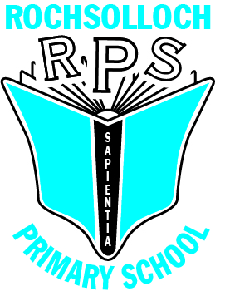
Rochsolloch Primary School
Digital Policy

February 2023

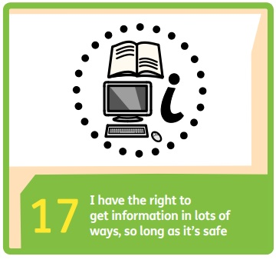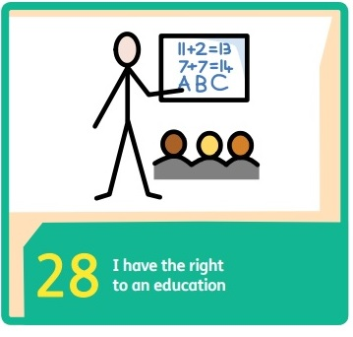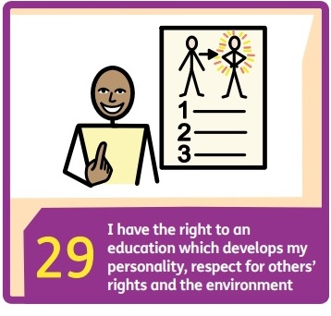

- Rationale
“…digital technology can enhance learning and teaching, equip our children and young people with vital digital skills and crucially, it can lead to improved educational outcomes.” (Enhancing learning and teaching through the use of digital technology, Scottish Government, 2016, p3)
Rochsolloch Primary has created this policy in accordance with the Scottish Government strategy Enhancing learning and teaching through the use of digital technologies (2016), and is congruent with Features of Highly Effective Digital Learning, Teaching and Assessment in Schools (2022), the United Nations Convention on the Rights of the Child (UNCRC) (1992), and the six principles of nurture:
- Children’s learning is understood developmentally
- The environment offers a safe base
- The importance of nurture for the development of self-esteem
- Language is vital means of communication
- It is understood that all behaviour is communication
- The importance of transition in children’s lives is understood
Our vision is that ‘Everyone achieves their potential’. We endeavour to realise this ambition by taking action based on our shared values of Respect, Happiness and Achievement.
- Aims
- To give children opportunities to develop their knowledge and skills in the use of digital technologies through a progressive and responsive curriculum.
- To enhance the quality of learning and teaching and raise attainment through the use of digital technologies.

- Roles and Responsibilities

Class Teacher
- Provide learning experiences that are consistent with the 7 design principles of Curriculum for Excellence.
- Embed digital technologies in all teaching and learning.
- Continuously enhance professional knowledge and skills by participating in CLPL opportunities.

Senior Leadership Team
- Support teaching staff in the delivery of the digital curriculum by creating/directing to CLPL opportunities and providing appropriate resources.
- Monitor and evaluate the quality and impact of digital technologies across the school.

- Learning and Teaching Approaches
Digital technologies are integrated in to learning and teaching across the whole day; children have access to a wide range of hardware and software to enhance learning. Appropriate devices are timetabled to ensure all children have the opportunity to be taught skills according to the NLC Progression Pathway, and then given opportunities to embed and enhance these skills through various contexts and curriculum areas across learning.

- Digital Safety
All staff will operate in accordance with NLC’s Acceptable Use of ICT policy (2021) and both pupils and staff sign Rochsolloch Primary’s Acceptable Use of ICT and Social Media policy. Parents/carers complete an online form agreeing to adhere to our safe usage guidelines and our internet access is filtered by NLC. All children experience a curriculum that teaches them about staying safe online and takes account of the impact that online activity can have on mental health and wellbeing.

Policy Date February 2023
Review Date February 2025

