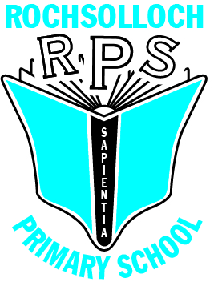
Rochsolloch Primary School
Anti-Bullying Policy

August 2022

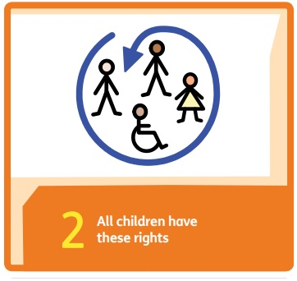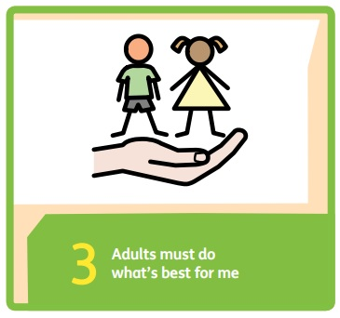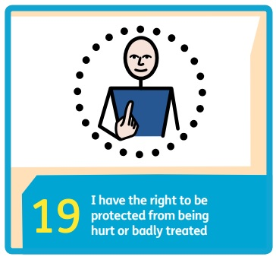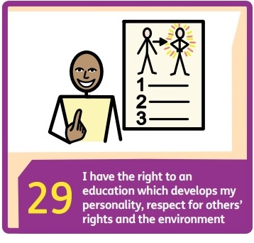
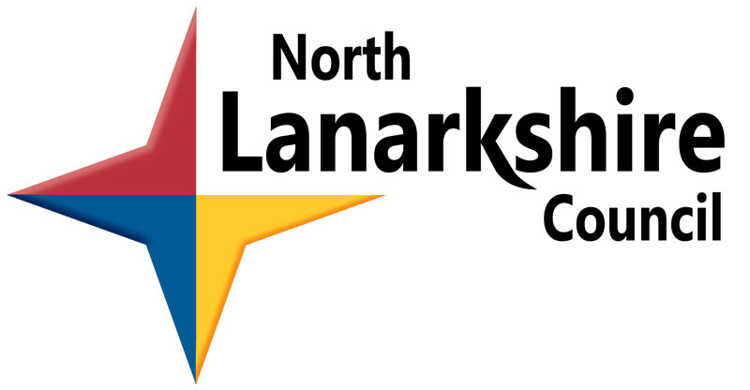
- Rationale
Rochsolloch Primary School has created this policy in accordance with the Scottish Government policy A National Approach to Anti-Bullying for Scotland’s Children and Young People (2017), the Equality Act (2010), the North Lanarkshire Council policy Bullying: It’s Never Acceptable (2012), the United Nations Convention on the Rights of the Child (UNCRC) (1992), and the six principles of nurture:
- Children’s learning is understood developmentally
- The environment offers a safe base
- The importance of nurture for the development of self-esteem
- Language is vital means of communication
- It is understood that all behaviour is communication
- The importance of transition in children’s lives is understood
Our vision is that ‘Everyone achieves their potential’. We endeavour to realise this ambition by taking action based on our shared values of Respect, Happiness and Achievement.
This policy will outline a shared definition and understanding of bullying; the processes for reporting, investigating and recording bullying behaviour; and the staged intervention approach school will follow in its response to allegations of bullying.
- Definition of Bullying
Bullying is both behaviour and impact; what someone does and the impact it has on a person’s capacity to feel in control of themselves. We call this their sense of ‘agency’.
(http://respectme.org.uk/bullying) April 2019

Intent is not required in order to confirm an incident as bullying, as in some circumstances a child may not be aware that their behaviour is bullying. The focus is on the impact the behaviour has had, rather than whether or not the person acted deliberately to cause harm. Bullying does not have to be persistent in order to have an impact on a child’s wellbeing. A single incident can have an effect on mental health, confidence, and self-esteem. Bullying can affect children in different ways, and Rochsolloch Primary School will take account of the effect this is having on an individual child, in order to reduce the impact and restore the child’s ability to cope and respond to the feelings they are having.

- When it’s Not Bullying
Children will inevitably fall out and disagree as they learn how to form and maintain respectful relationships. It is important that children learn how to manage conflict as positively as possible, as this helps them to learn about cooperation and develops their resilience. In such cases the school can be a source of support for children in repairing relationships. This would be managed by involving children in conversations with an adult. It is important to be mindful that if such behaviour is left unchecked, it can lead to bullying. Disagreements can lead to bullying behaviour where the balance of power in the relationship is unequal, for example an older child to a much younger child, or a group of children falling out with or excluding one child.

- Prejudice Based Bullying
Bullying behaviour can be a result of prejudices relating to actual or perceived differences. The Equality Act 2010 makes it illegal to discriminate against people based on characteristics including:
- Age
- Disability
- Gender
- Race
- Religion
- Sexual Orientation or Gender Identity
The school aims to create an environment where diversity is celebrated, and any behaviour demonstrating discrimination based on any of the above characteristics is deemed unacceptable. This becomes criminal harassment, rather than bullying, and such cases could be referred to our Community Police Officer to determine the best course of action.
In a digital age, bullying behaviour can also take place online. This will normally take place outside of school, where children have access to social media. This behaviour may still be reported at school, and the management team would refer the matter to the children’s parents. The school would strongly advise that parents adhere to the minimum age guidelines on social media use. More guidance on this can be found at www.respectme.org.uk.
We are aware that children operate online in school through Microsoft Teams, and respectful interactions must be maintained.
The school will support children, as appropriate, through the Health & Wellbeing Curriculum.
- Reporting of Bullying Behaviour
The school aims to create an environment in which all children feel safe in reporting bullying behaviour, and understand how to report what they have seen. Children must also be taught what to report, how, when and to whom.
- What? A clear definition of bullying is shared with children.

- How? Children know that they can approach a member of staff, or a trusted adult outside of school, in order to report bullying.

- When? An important part of the message for children is that they should not wait to see whether things get better. They are encouraged to report instances of bullying behaviour, as soon as possible after it occurs.

- Who? Children know that they can report bullying to any member of school staff. This will be considered against the definition of bullying and passed to Senior Leadership Team (SLT) as appropriate.

- Investigation of Bullying Allegations
The SLT take responsibility for investigating allegations of bullying promptly. This will involve taking testimonies from all children involved or who may have witnessed the incident.
If the school feels the incident is substantiated as bullying, according to the definition above, staff will follow the stages of intervention outlined below.

- School Response to Bullying
In Rochsolloch Primary, we recognise that all behaviour is communication.
Following investigation, Rochsolloch Primary School will respond to substantiated incidents of bullying using a staged intervention approach. In all cases, a balance will be struck between supportive actions and consequences as deemed appropriate. At each stage, the school will make reference to the rights of all children under the UNCRC.
If the behaviour is not deemed to be bullying, but is still an issue, then Stage 1 interventions can also be considered, along with existing school behaviour management strategies (see Rochsolloch Primary Relationships policy)
Stage 1
- Make clear that the type of behaviour being exhibited is totally unacceptable.
- Work with the person displaying bullying behaviour to make them aware of the impact of their actions on others, and support them in making positive choices to minimise the risk of recurrence.
- Offer the opportunity for both children to attend a meeting together or separately (as appropriate) with a member of the SLT, where they can suggest their own solutions to resolve conflict or improve relationships.
- Continue to monitor and support the person being bullied to assess the impact on their emotional wellbeing.
- Inform parents of the incident and any action taken in supporting their own child, seeking to work in partnership to prevent a recurrence of the bullying behaviours.
- Utilise school-based nurturing approaches to support the children where appropriate e.g. engaging children in conversations to help identify any possible motivations or triggers for the behaviour.
- There may be times when a consequence, such as keeping a child inside at interval and/or lunchtime, is appropriate for safety reasons, or have another privilege withdrawn.
Stage 2
For more severe incidents, involving physical violence, or for incidents that have recurred despite Stage 1 support strategies being employed.
- Any actions from Stage 1 that may not yet have been taken.
- Regular communication with parents.
- Involvement of other agencies as appropriate, for example Educational Psychology.
- Solution-focused meeting with school staff, pupil, parents and Community Police Officer.
- Specific targets created to help modify behaviour.
Stage 3
In extreme cases such as physical attacks and ongoing harassment, a young person showing bullying behaviour may be excluded from school. Stage 1 and Stage 2 strategies may still apply upon their return to school in order to support the pupil and prevent a recurrence.
Exclusions will be considered according to NLC Management Circular B2.
- Recording of bullying
Bullying incidents are recorded on SEEMIS, (North Lanarkshire Council’s online Education Management Information System) in accordance with local authority guidelines. Incidents are to be recorded within three days of the investigation being completed. The SLT will also record actions taken, and any opinions expressed by the parents.
Where other agencies are involved, this will mean sharing of information about the incident. Information is shared in compliance with General Data Protection Regulations (GDPR).
- Involvement of Parents
Parents have a key role to play in supporting their children when they have experienced bullying or have displayed bullying behaviour towards other children. At Rochsolloch Primary School we aim to involve parents in our Anti-Bullying strategy. Parents will be informed at the earliest stage of a bullying investigation.
Any meetings between parents and the SLT are conducted with complete confidentiality, and we will never discuss personal information about a child with other parents.
Parents can access information and advice at www.respectme.org.uk .

- Complaints or Comments
We welcome feedback from parents, however if you are not satisfied with the way in which an allegation of bullying has been dealt with by the school, please raise this in the first instance with the Head Teacher. Your concern will be investigated and you will be informed of the action (if any) that is to be taken within 28 days; our aim is to pass on information within 5 working days. If you are unhappy with action taken by the school you may choose to direct your concern to NLC Education and Families.

Policy Date: October 2022
Review Date: October 2024

