Solihull Approach  Understanding your child  Free Online Parent & Carer Guide  An enjoyable online guide focusing on nurturing and supporting relationships between children and their carers.  To access this guide visit:  www.InOurPlace.Co.UK |  | Understanding Pregnancy, Labour, Birth and Your Baby  Antenatal Guide  North Lanarkshire: LANERCH1  South Lanarkshire: OWEN123
 | 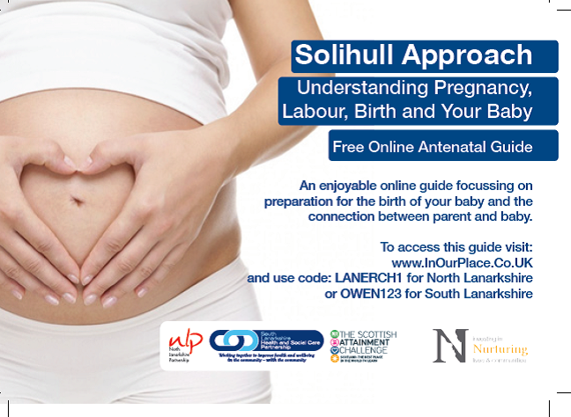
 |  |  |  | 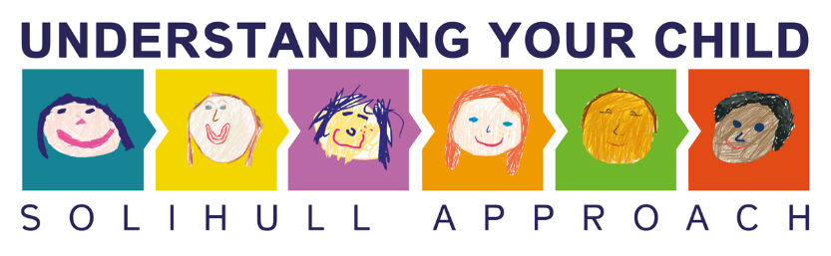

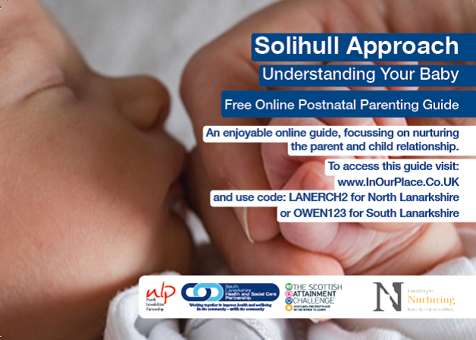 |  | Understanding Your Child  Parent & Carer Guide  North Lanarkshire: LANERCH3  South Lanarkshire: OWEN123 |  | 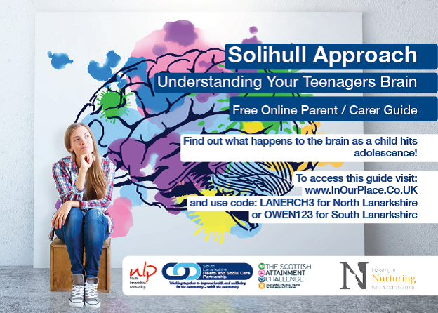
Understanding Your Baby  Postnatal Parenting Guide  North Lanarkshire: LANERCH2  South Lanarkshire: OWEN123 |  |  |  | Understanding your Teenager’s Brain  Parent & Carer Guide  North Lanarkshire: LANERCH3  South Lanarkshire: OWEN123
 |  | 