Early Level Maths & Numeracy Home Activities
Create a pattern using a variety of shapes and numbers.  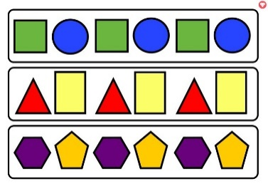 | Use play-doh to create as many numbers as you can.  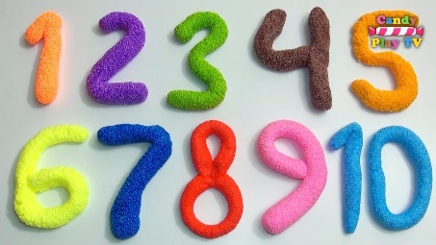 | Find as many different examples of numbers and shapes around your house.  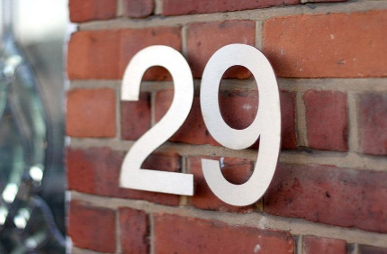 | Practise the days of the week. Youtube has videos and songs to help you.  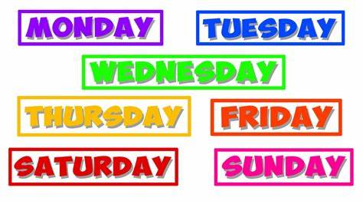
How many people are in your house? How many hands? How many eyes? Etc. | Log on to Sumdog. How many questions can you answer correctly? | Collect loose items from your garden or house. Count and sort them. | Practise counting forwards and backwards. Also say the number before and the number after.  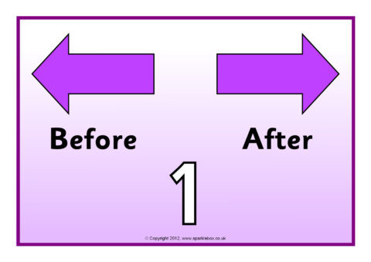
Measure different items in your house using your hands. E.g. how many hands long is your table?  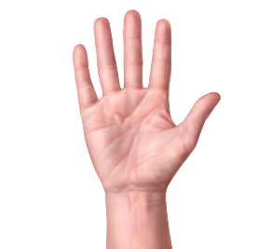 | Draw/paint a picture which has shapes and numbers in it.  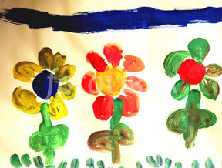 | Practise your number bonds to 10. Use objects to help you.  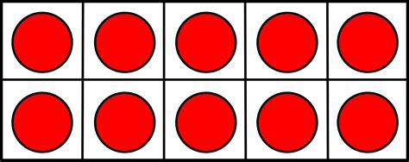 | Play snap with number cards.  