North Lanarkshire Early Learning & Childcare

On-line Support for Parents - Learning at Home
Web Address | Content
https://education.gov.scot/parentzone/learning-at-home/ | A variety of fun ideas and resources for parents to do at  home with their child including literacy, numeracy and  health & wellbeing
https://www.khanacademy.org/parent | 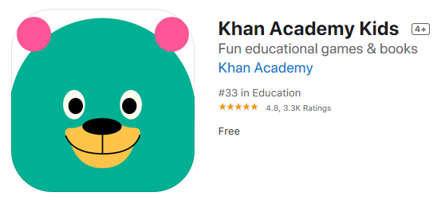4 years + Free on-line educational games
https://www.e-learningforkids.org/

https://www.bbc.co.uk/sounds/series/p02pnn9d

Free on-line Apps for early years | 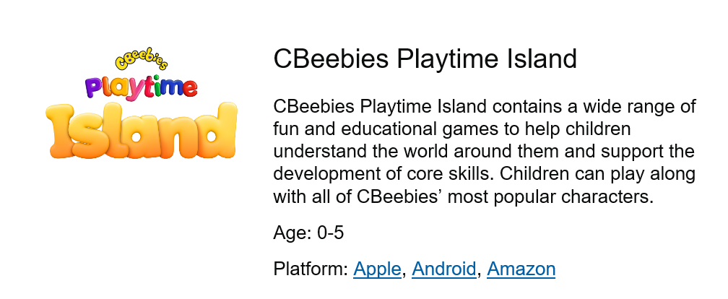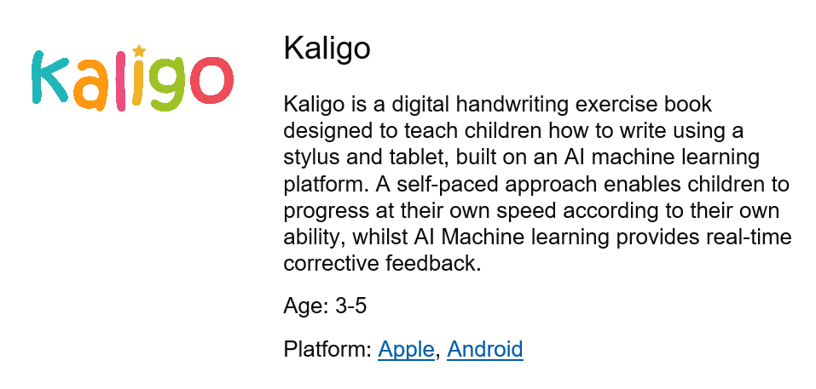  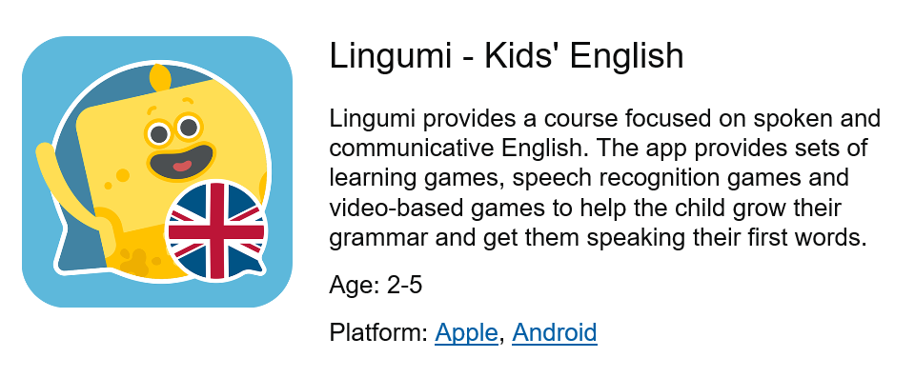
https://famly.co/blog/inspiration/10-sensory-play-ideas-to-develop-motor-skills/ | 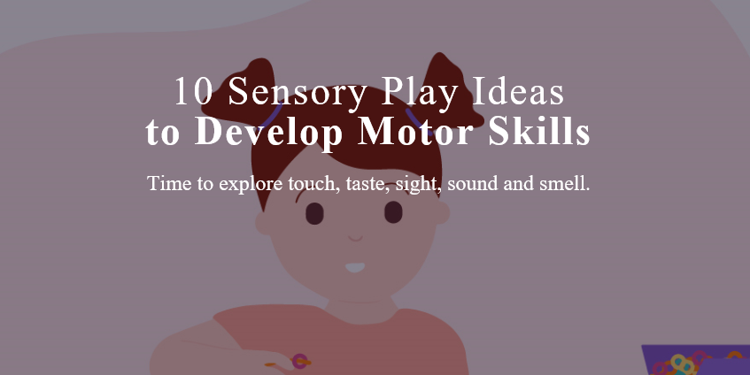
https://family.gonoodle.com/
A range of home activities to keep moving!
https://www.scottishbooktrust.com/reading-and-stories/bookbug/bookbug-app?utm_source=twitter&utm_medium=organic_social&utm_campaign=bookbug&utm_content=post | 