All about me

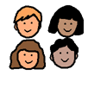

I am starting Primary 1 at Redburn School.

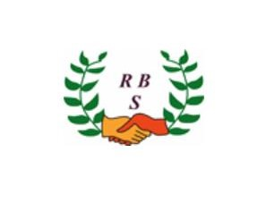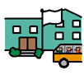

|  |  |
| --- | --- |
| My name is: |  |
| I live with: |  |
| My pets are: |  |
| My favourite foods are: |  |
| My favourite things to do are: |  |
| I don’t like: |  |
| Any other information:  Clubs I go to,  Things I am good at,  Things I need help with. |  |