**How to access Microsoft Teams.**

Step 1: Search “Glow” on your internet browser.

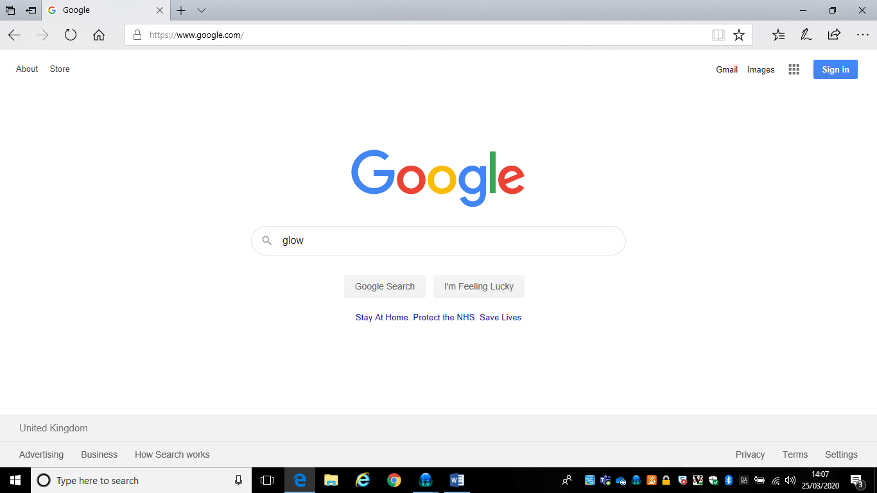

Step 2: Select “Glow – Sign In- RM Unify”

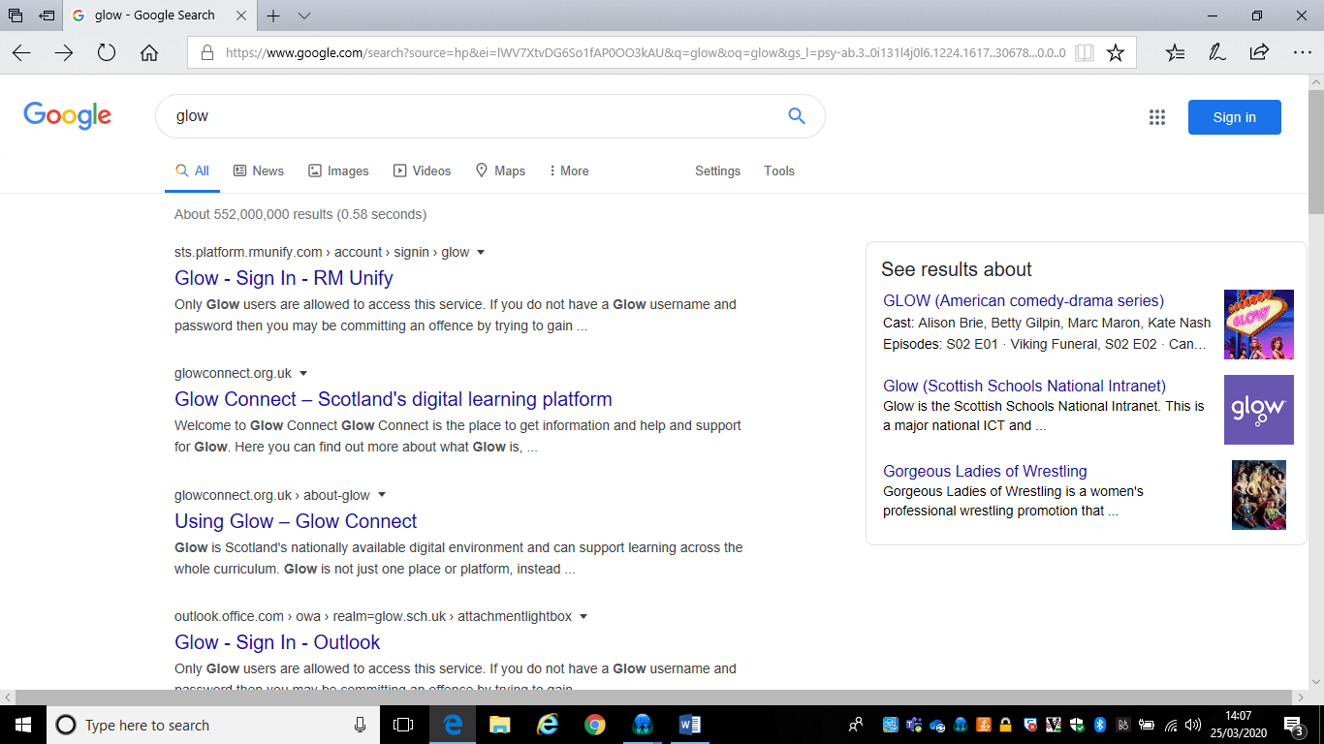

Step 3: Log in using child’s glow email and password

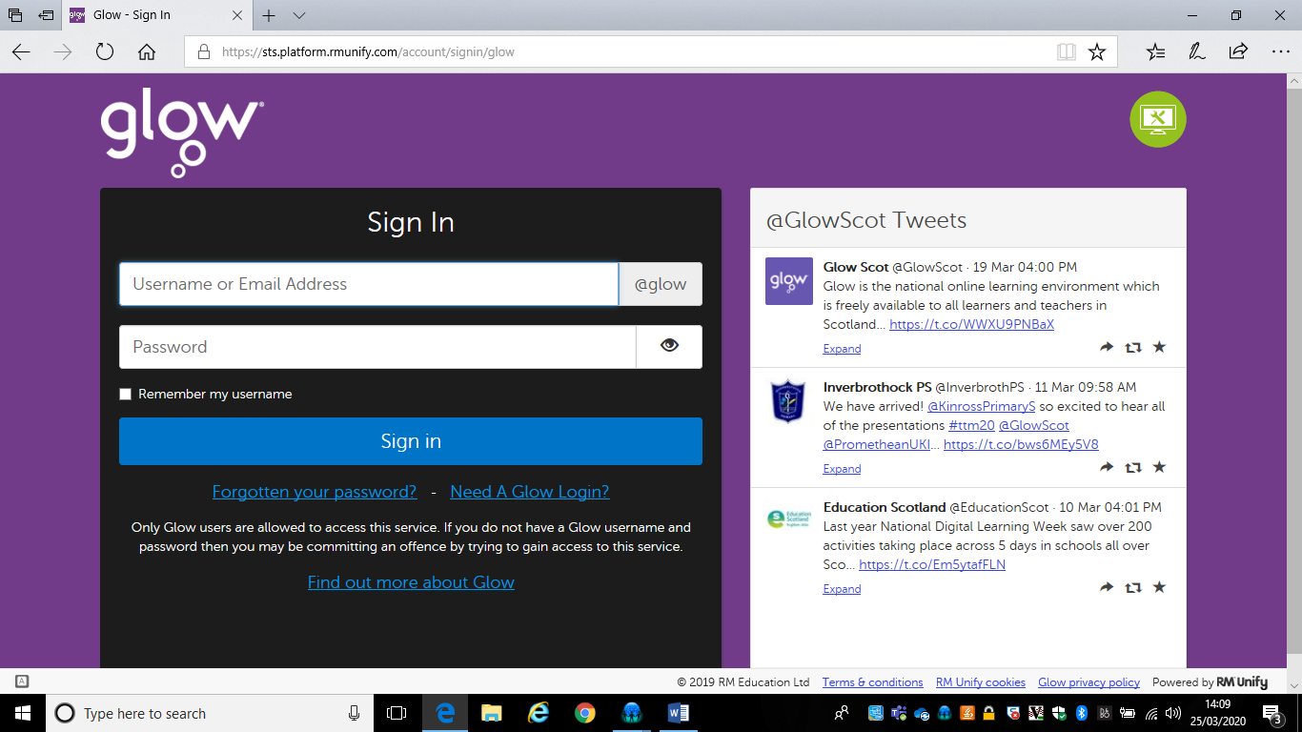

Step 4: Find “Microsoft Teams”

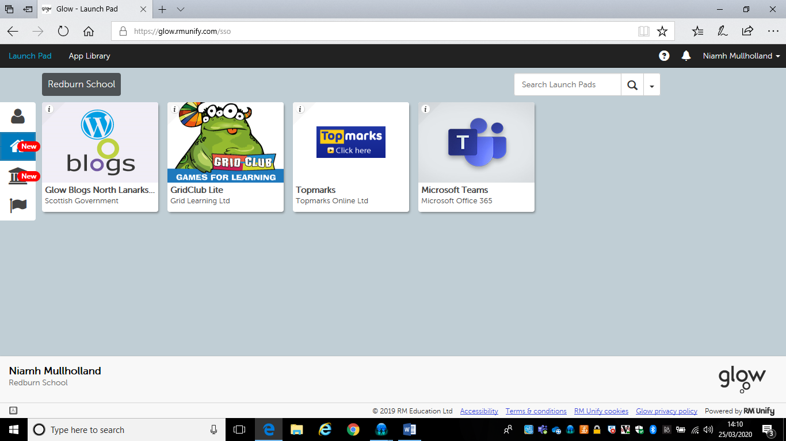

Step 5: Find your class

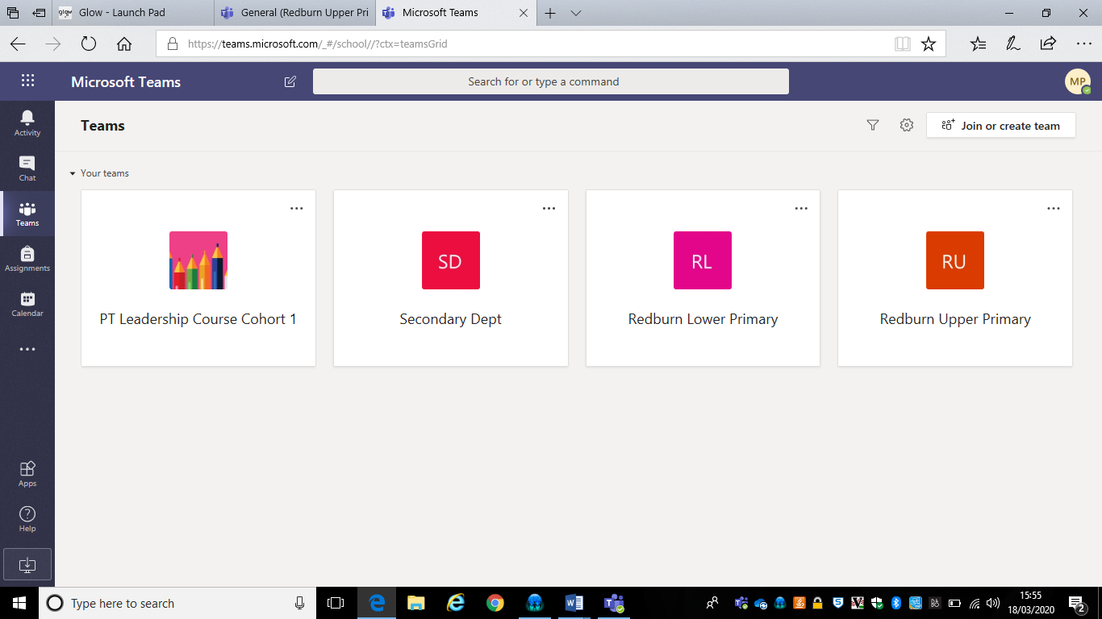

Step 6: Documents and information for your class will be shared in this area.

You can also talk to staff and other pupils/parents here

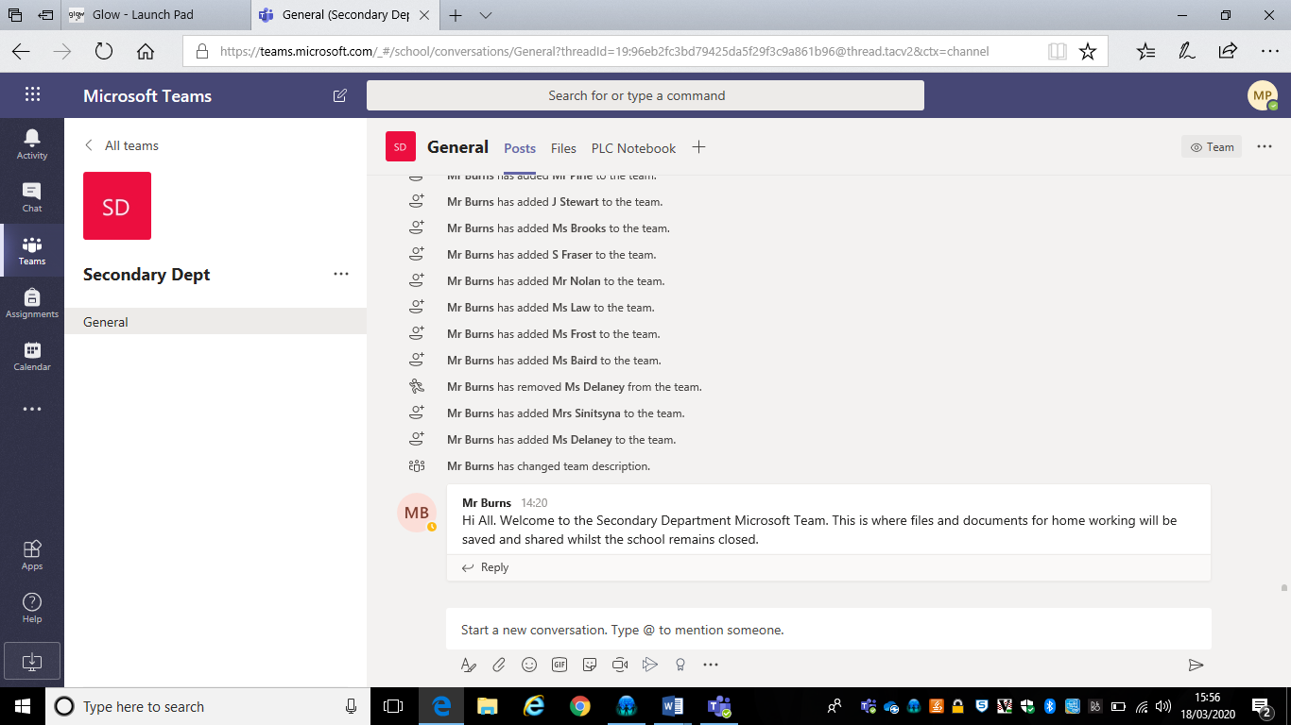

Step 7: You can download the app to your desktop here.

