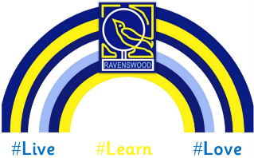
Induction Transition Feedback, 2025

How you felt…
- 100% were happy with the communication from the school about transition.
- 100% were happy with the amount of visits their child got.
- 100% thought taking part in Stay and Play sessions was beneficial.
- 100% felt additional transition resources, such as videos, were helpful.
- 98% were very pleased with their child’s transition to Ravenswood.
You said…
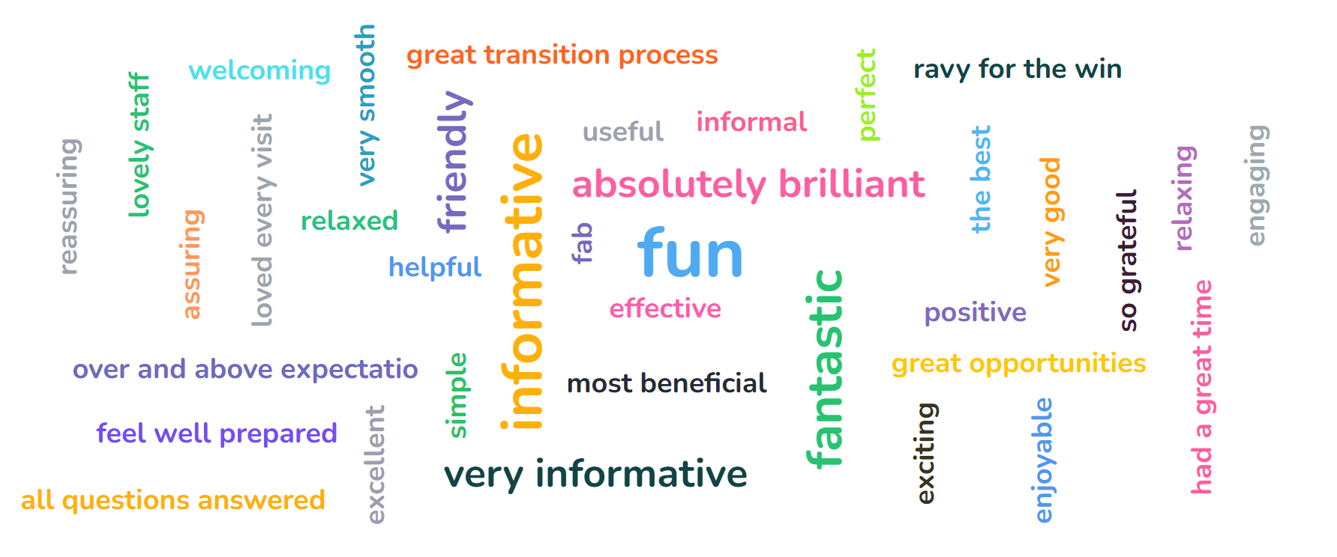
You said we could improve on…
Nothing noted, you were all happy with the transition programme as is.

A HUGE thank you for your support!

