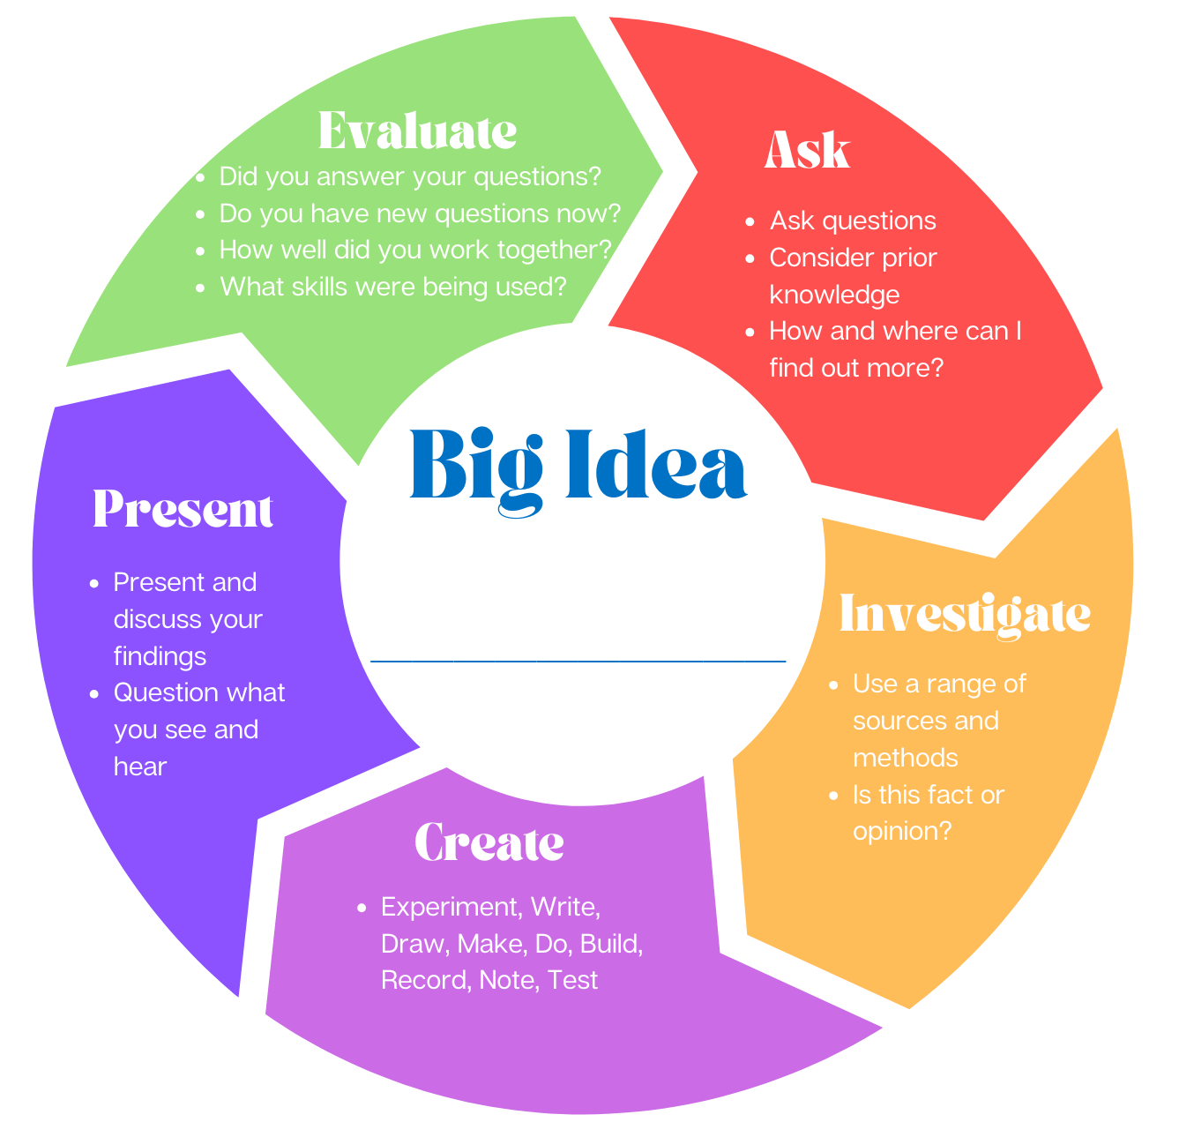
Ask – Possible guided questions/areas want to explore

Evaluate – What learning and skills developed?

Present – Do they need to be taught any skills or technology for this? What options do they have?

Investigate – what knowledge/ skills will need to be taught to allow this?

Create – what resources will be provided?

Insert Big Idea

