Resource | Uses and Purpose
  Communication tools | e.g. picture boards, language cards and prompts/visuals, communication devices, or sign language resources used to support language and communication.
Toys  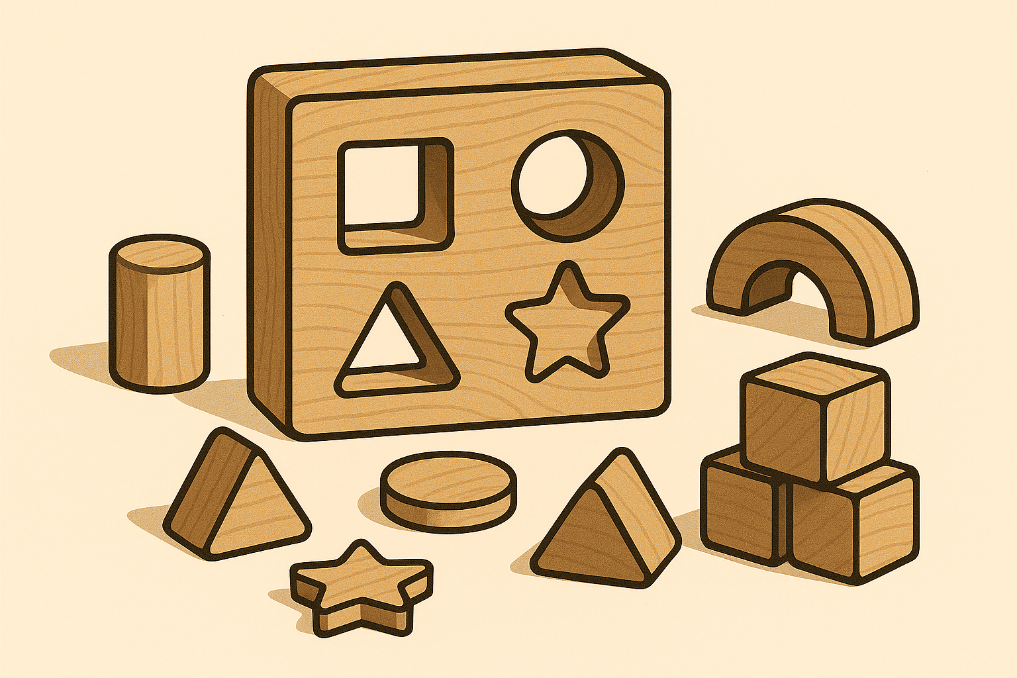 | Toys that are inclusive and accessible for varying fine motor abilities (e.g. Chunky blocks, Velcro puzzles).  Transition toys help some children to move to different areas of the schools and can make them feel safe.
Schematic Play Knowledge (link to this can be found in Schematic Play section)   | Gives a better insight into the learning taking place during play for children with additional support needs. By focusing on one schema per week and providing opportunities for this during play, children are likely to find their schema-if not already identified.
Sensory Checklist (link to downloadable resource available)  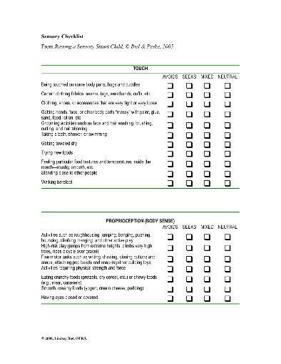 | Understanding a child’s Sensory Profiles: Involves examining how each person processes and responds to sensory input, including touch, sound, muscle feedback, bodily sensations, movement sight, taste and smell (yes- 8 senses!)  Tailored Interventions and Support: Armed with the knowledge gained from a sensory assessment will allow us to incorporate specific sensory activities into daily routines.  Enhancing Communication: A sensory assessment can be transformative. Understanding how sensory experiences influence a child’s behaviour and communication can open up new avenues for effective interaction.  Improved Emotional Regulation: A sensory assessment can pinpoint triggers that may lead to emotional dysregulation and meltdowns.  Optimising Learning and Daily Activities: For children, a sensory assessment can be instrumental in optimising their learning experiences.
Sensory Classroom Audit (link to downloadable resource available)  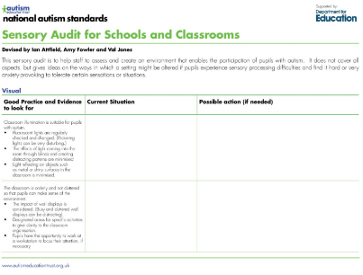 | Assess and create an environment that enables the participation of pupils with ASD. It does not cover all aspects but gives ideas on the ways in which a setting might be altered if pupils experience sensory processing difficulties and find it hard or anxiety-provoking to tolerate certain sensations or situations.
Milestones to Support Learners with Complex Additional Support Needs (link to downloadable resource available)  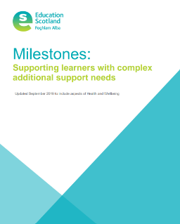 | Tracks progress of learners with an additional support need. This allows teachers to plan appropriately for pupils who are not meeting the CfE Early Level Benchmarks in some curricular areas.
Developmental Stages of Play (link to this can be found in Stages of Play section)   | Ensure learning opportunities through play meets the needs of all learners.
Alternative spaces  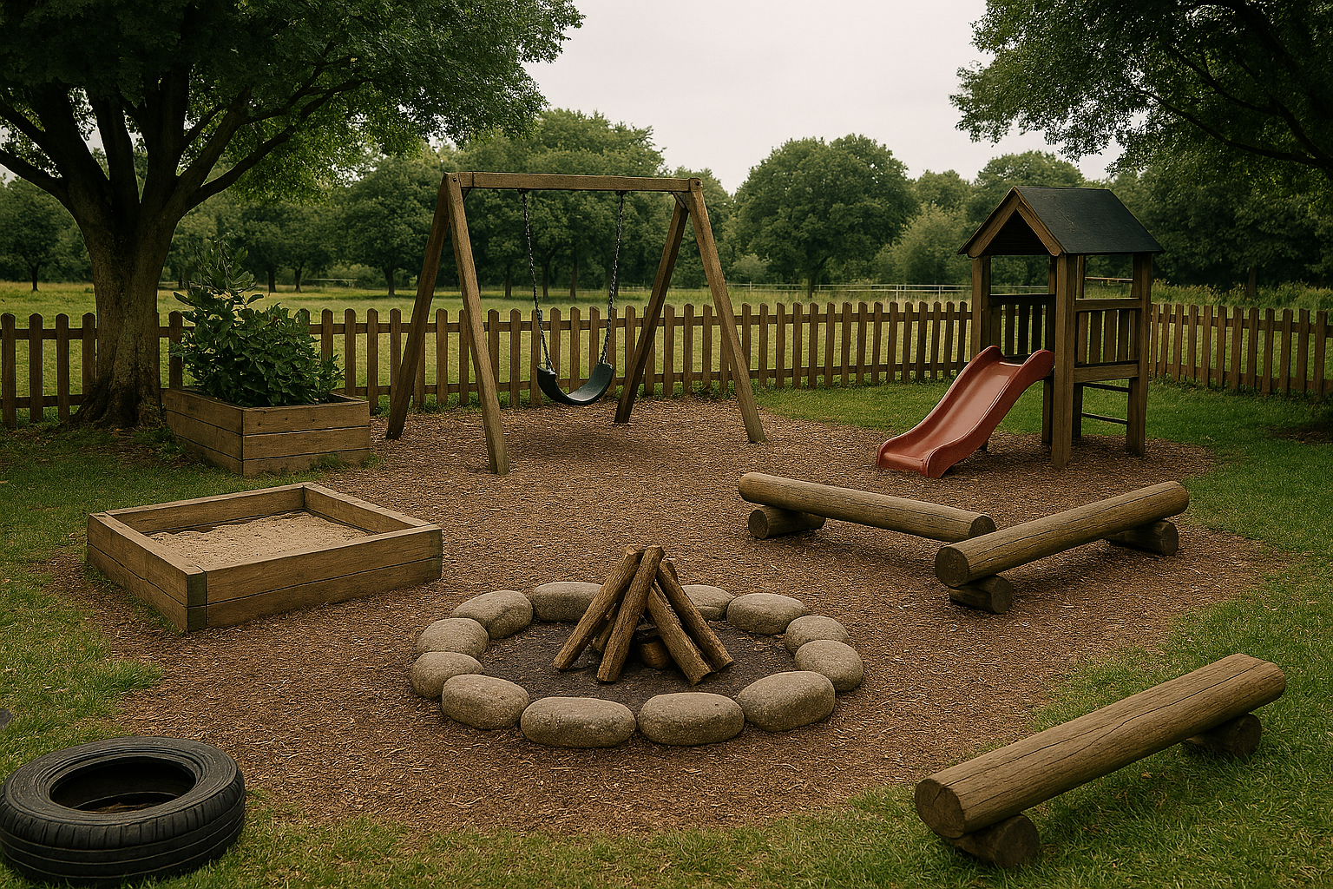 | Helps to regulate emotions e.g. soft play, sensory room, outdoor area, etc.
Play Prompts (see link to continuous provision prompts)  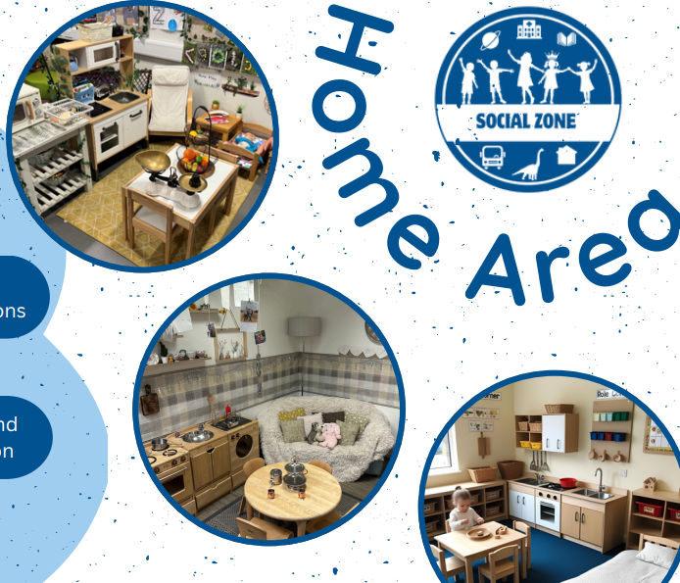 | Can be displayed around the class in each play area. This gives adults prompts and observation guides to look out for during play and will ensure every child is able to make progress based on their needs

