Play/ Enquiry Observation |  | Adult - Initiated |  | Adult - Led |  | Child - Led
Name: | Date: |  | Observed by:
 |  |  | Play area:
Skills Observed (highlight / tick) |  |  | Observation notes: Notice, Analyse, Act
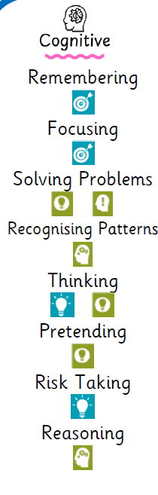
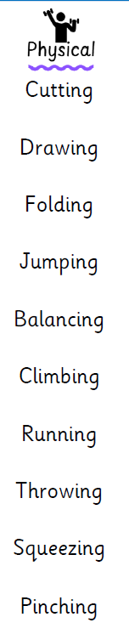
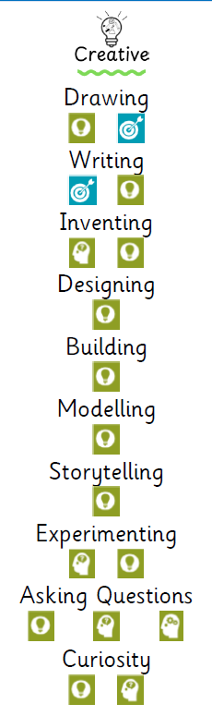
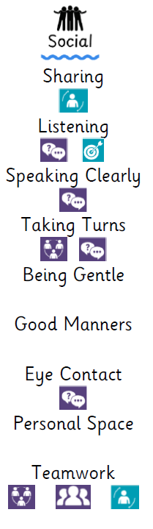
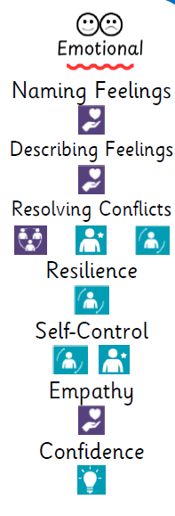
 |  |  | Wellbeing |  | Engagement
 |  |  | - Extremely low  - Low  - Moderate  - High  - Extremely high |  | - Extremely low  - Low  - Moderate  - High  - Extremely high
Action Plan/Possible Lines of Development |  |  | Pupil Voice

