
Plains Primary School

Attendance Policy
Vision Statement
At Plains Primary School, we aim to provide a safe, happy, and respectful learning environment where every child can grow and thrive. Regular attendance is essential to ensure that pupils benefit fully from their education and reach their potential.


Aims
- To promote excellent attendance and reduce absence.
- To ensure every pupil has access to full-time education.
- To identify and address attendance issues early.
- To support families in overcoming barriers to regular attendance.
Expectations
- Pupils are expected to attend school every day unless they are ill or have an authorised reason for absence.

Parents/carers are expected to:
- Ensure their child attends school regularly and punctually.
- Inform the school of any absence by 9:30am on the first day.

Authorised and Unauthorised Absences

Authorised Absences include:
- Illness (with parental notification)
- Medical appointments
- Religious observance
- Bereavement

Unauthorised Absences include:
- Holidays during term time (unless exceptional circumstances)
- Absence without explanation
- Truancy
Procedures
- Attendance is monitored daily.
- Parents will be contacted if no reason is provided for absence.
- All parents are emailed every month with their child’s attendance to date.

Persistent absence (below 90%) will trigger intervention:
- Initial contact and support from the school, in the form of a phone call and/or letter
- An initial meeting with the school to identify barriers to attendance and support strategies
- Cluster support resources
- Monitor individual cases and further meetings as and when required.
Lateness
- Pupils arriving after 9:00am must report to the school office.
- Repeated lateness will be monitored and addressed with parents to identify any supports required.
Rewards and Recognition
- Certificates and praise for excellent attendance.

- Support
- The school will work with families to support attendance.
- Referrals for Cluster support or external services may be made where appropriate.
Roles and Responsibilities
- Head Teacher: Oversees the implementation of the attendance policy and liaises with the local authority.
- Class Teachers: Monitor daily attendance and report concerns.
- Parents/Carers: Ensure regular attendance and communicate absences.
- Pupils: Attend school regularly and on time.
- Family Engagement Support Assistant: Supports the school in managing persistent absence.

Review Cycle
This policy will be reviewed annually as part of the school improvement plan. Updates will reflect changes in local authority guidance and national legislation.

Alignment with North Lanarkshire Council Guidelines
This policy is aligned with North Lanarkshire Council’s standards for maintaining school attendance and reflects the principles outlined in national guidance such as "Included, Engaged and Involved Part 1". The school adheres to operational procedures for recording and managing attendance/absence as set out by the local authority
Accessibility and Communication
This policy will be made available on the school website and in printed format upon request. It will be shared with parents/carers during Primary 1 induction. A simplified version will be available for pupils.

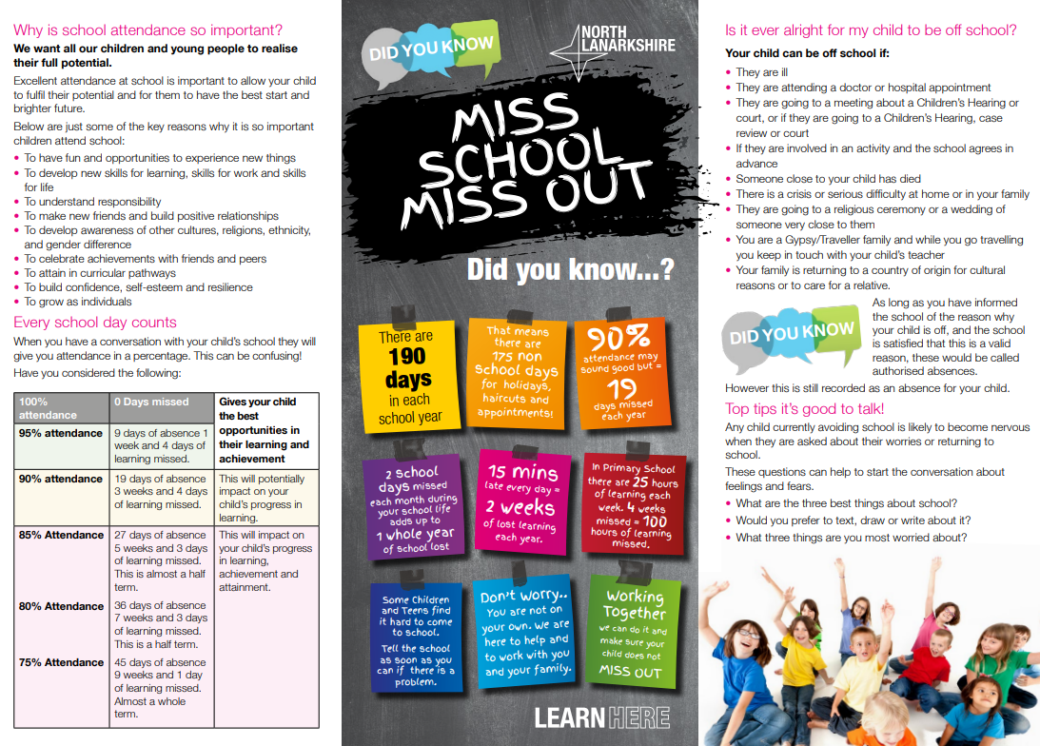
Attendance is everyone’s responsibility – together we can support every child’s success.

