EDUCATION AND FAMILIES

PLAINS PRIMARY SCHOOL HANDBOOK
JANUARY 2022/23

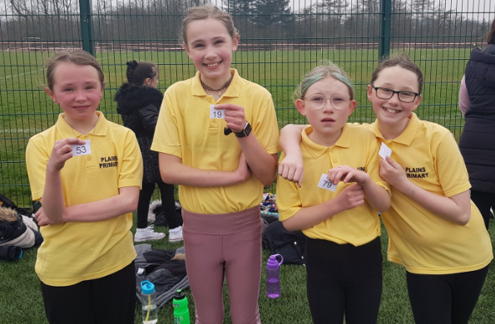
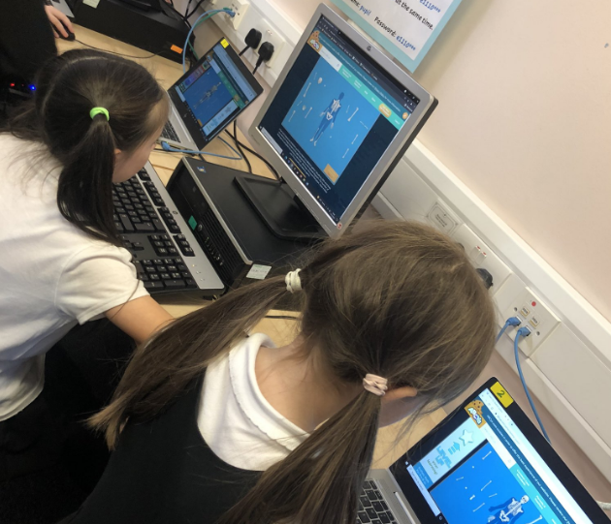
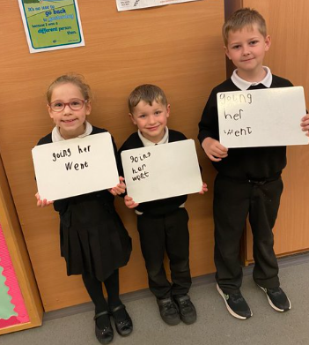

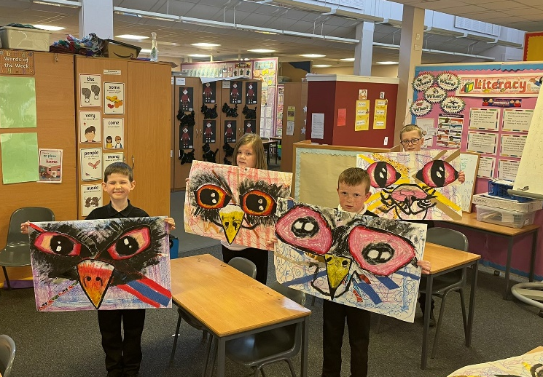
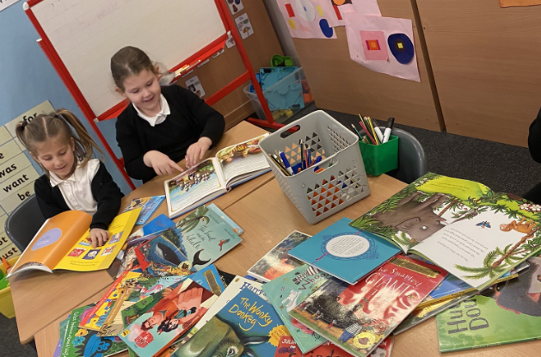
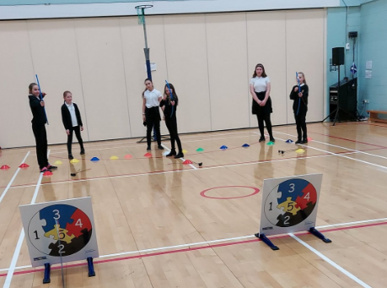
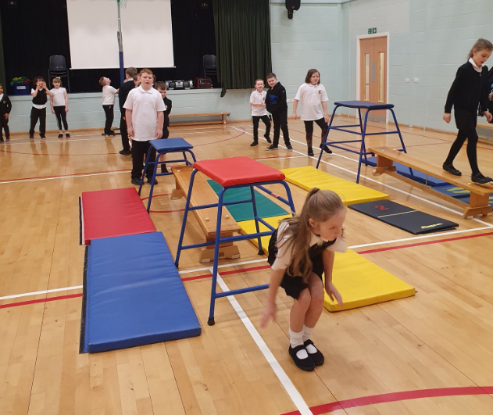
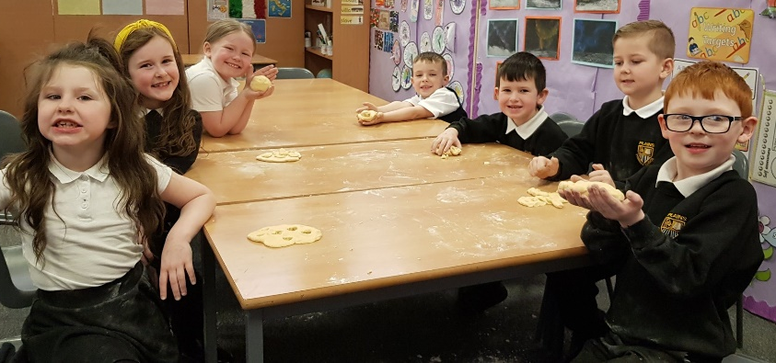
INTRODUCTION FROM THE ACTING HEAD TEACHER

In Plains Primary School we pride ourselves on our teamwork. Our hard working staff support each other to ensure we provide the best education for every young person in our care.

We set very high standards for ourselves and our pupils, and we aim to work in partnership with parents and our wider community.

We nurture our children and encourage them to achieve their full potential. We teach them life skills including compassion, resilience and commitment. We prepare our pupils for the years ahead as they are Scotland’s Future.

Covid-19 Pandemic

NLC will continue to align supports, from across the service, in response to the Covid-19 pandemic, to support children and families and maintain educational provision. Further information is available directly from the school or from North Lanarkshire Council’s website www.northlan.gov.uk

SCHOOL INFORMATION

School name: Plains Primary School

Address: 1 Annieshill View Plains
Airdrie ML6 7NY
Telephone Number: 01236 632144
E-mail: nlrooneya1@northlan.org.uk
Website: https://blogs.glowscotland.org.uk/nl/plainsprimaryblog/

Denominational Status: Non-denominational
Planning Capacity: 150
Working Capacity: 125
Parents should note that the working capacity of the school will vary dependent on the number of pupils at each stage and the way in which the classes are organised. The maximum number of children in a composite class is 25.
Present role: 96
Stages covered: Primary 1 –7
Present Class Structure Primary 1/2 Primary 2/3 Primary 4/5 Primary 5/6 Primary 6/7

COMMUNITY FACILITIES
We have a Community Learning and Development Worker (CLD) assigned to our school two days per week. This adult works closely with our pupils and their families. We have a community room for events.

North Lanarkshire Council encourages the use of schools out with school hours. Such use by groups and clubs will be in accordance with approved letting procedures and enquiries should be directed to the Community Education Officer on (01236) 632778

JOINT CAMPUS
We are delighted to share our campus with St David’s Primary School and Nursery Class.

Associated Secondary School Caldervale High School Towers Road
Airdrie ML6 8PG
(01236) 794855

PARENT COUNCIL
We have a very active Parent Council who are keen to include new parents. Please ask at our school office, or contact our Chairperson, Mr Graeme Paterson, on gjpaterson@btinternet.com for more details.

STAFF
Mrs G Wilson Acting Head Teacher
Mrs C Murphy Acting Principal Teacher
Mrs K Forbes P1/2 class teacher
Mrs F Bruce / Mrs A Paterson P2/3 class teacher
Mrs K Goldie P4/5 class teacher
Mrs A Munro P5/6 class teacher
Mrs E McLuckie P6/7 class teacher
Mrs K Robertson/Mrs L Wotherspoon Senior Clerical Officer (Job Share)
Mrs D Paul Classroom Assistant (Wednesday – Friday)
Mrs D Fromberg Additional Support Needs Assistant
Mrs I Reid Additional Support Needs Assistant (Mon – Thurs am)

SCHOOL HOURS
School opens 9.00am
Interval 10.30 - 10.45am
Lunch break 12.15 - 1.00pm
School closes 3.00pm
All primary 1 pupils attend full-time from the first day of the session.

THE SCHOOL YEAR 2022 – 2023
Monday 15th August 2022 In-service Day – Pupils do not attend
Tuesday 16th August 2022 In-service Day – Pupils do not attend
Wednesday 17 August 2022 PUPILS RETURN TO SCHOOL
Friday 23rd – Monday 26th September 2022 September Weekend School Holiday Monday 17th – Friday 21st October 2022 October Week School Holiday Monday Monday 14th November 2022 In-service Day – Pupils do not attend
Friday 23rd December 2022 – Friday 6th January 2023 (Inclusive)Christmas School Holiday
Monday 13th and Tuesday 14th Feb 2023 February School Holiday
Wednesday 15th February 2022 In-service Day – Pupils do not attend
Monday 3rd April – Monday 14th April (Inclusive) Spring Break including Easter Monday Monday 1stMay 2023 May Day School Holiday
Tuesday 2nd May 2023 In-service Day – Pupils do not attend Friday 26 May to Monday 29th May 2023 May School Holiday

Wednesday 28th June 2023 SCHOOL CLOSES AT 1.00pm

TRANSFER/ENROLMENT
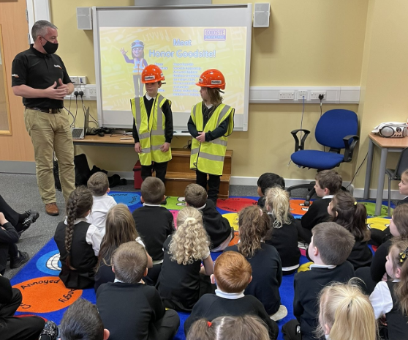
We aim to make our pupils’ transfer into Primary One as simple as possible. We support parents and carers, as well as our young people, in all aspects
of the transition programme. We actively encourage parents to book an appointment, through our school office, in order to visit our school and have
a tour of Plains Primary School. We aim to visit our local nurseries to meet our new pupils on several occasions throughout the year and we invite local nurseries to events including school
shows and sports days. We plan to hold transition events, between April and June, for our new August Intake.

EQUAL OPPORTUNITIES
Plains Primary School is committed to ensuring that every pupil who comes to our school is given the same opportunity, irrespective of sex, race, religion, culture or disability. We are committed to ensuring our policies and practices do not impact adversely on any particular group(s) of people and opportunities to promote equality are actively pursued.

Implementation of the Education and Families Equality Policy including The Equality and Human Rights Commission’s Technical Guidance for Schools in Scotland is the essential guide for the school community to promote equality. This can be accessed at https://www. equalityhumanrights.com/en/publication-download/technical-guidance-schools-scotland

CURRICULUM FOR EXCELLENCE - WHAT IS THIS?
Curriculum for Excellence is Scotland’s national curriculum. It provides a coherent and inclusive curriculum from 3-18 years wherever learning is taking place, including early learning childhood centres, schools, colleges and community learning. It places children and young people at the heart of Scottish Education.
The purpose of Curriculum for Excellence is encapsulated in the four capacities – to enable each child or young person to be
- a successful learner,
- a confident individual,
- a responsible citizen and
- an effective contributor.
These four capacities govern the entire curriculum from age 3 to 18 and aim to raise the standards of achievement for all learners.
Curriculum for Excellence is underpinned by the values inscribed on the mace of the Scottish Parliament – wisdom, justice, compassion and integrity.
Throughout Curriculum for Excellence there is a strong focus on Literacy, Numeracy and Health and Wellbeing across all aspects of learning and every teacher will support learners with the development of these, including digital literacy skills.
Curriculum for Excellence is defined as:
The totality of all that is planned for children and young people throughout their education’.
The opportunities for learning and teaching are governed by the Four Contexts for Learning, which ensure that the education your child receives is informative, interesting, relevant and fun.

These contexts are:
  - Ethos and life of the school as a community
  - Curriculum areas and subjects
  - Interdisciplinary learning
  - Opportunities for personal achievement.
What are the Curriculum for Excellence levels?
There are five levels and these are flexible depending on pupils’ needs and abilities (some
children and young people may achieve these levels earlier or later dependent on ability):
  - Early level pre-school to P1
  - First level to the end of P4
  - Second level to the end of P7
  - Third and fourth levels S1 to S3
  - Senior phase S4 to S6 and other forms of study.
What is the Broad General Education?
The Broad General Education (BGE) is the first phase of two closely connected phases of education. The BGE phase stretches from age 3 until the end of S3 after which learners move into the Senior Phase which starts in S4.
Curriculum Areas and subjects
The BGE is delivered via 8 curricular areas which, in secondary school cover years S1 to S3, and may be subdivided further into individual subjects.
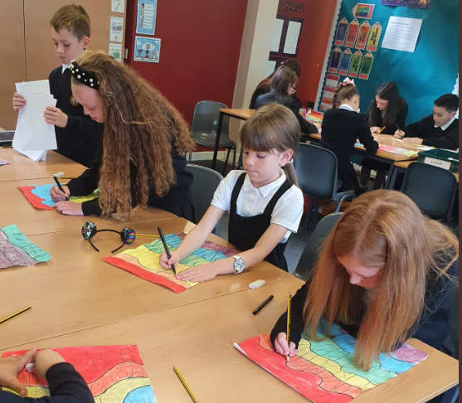
The 8 curricular areas are:
  - Expressive Arts
  - Languages and Literacy
  - Health and Well Being
  - Mathematics and Numeracy
  - Religious and Moral Education
  - Sciences
  - Social Studies
  - Technologies.

Personal Support/Career Planning

From 3-18 years, learners are supported to achieve their full potential and, as they progress through broad general education into senior phase, to plan and prepare for further learning, training or employment. All schools and nurseries in North Lanarkshire are working hard to raise standards
so that children and young people will develop all of the skills necessary to continue to be successful when leaving school and entering the world of higher education, training or work. As part of
developing skills for learning, life and work, young people will be offered careers information
advice and guidance to ensure they leave school and enter a positive post-school destination of
higher education, further education, pre-employment training, employment (including modern apprenticeships), activity agreement or volunteering.

Assessment and Reporting

Assessment is an important part of the Curriculum for Excellence and, at all levels, pupils’ progress is closely monitored by teachers and staff.
In turn, teachers and staff work with pupils to reflect on their results, looking at their strengths and learning needs, agreeing next steps and action based on these. As they progress, pupils become more involved in this process, as they develop the skills to make effective judgments on their own learning, developing personal expertise that will be important to them throughout life. Assessment also helps teachers plan learning experiences which are motivating and challenging.
Children who may have additional support needs will be assessed using methods best suited to their individual requirements. We will provide one report card and two parents evenings per session. Parents may request additional appointments where necessary.

Our staff, parents and pupils play an active part in supporting new curricular developments. Parents will be informed in advance if their child is learning about sensitive issues including relationships, sexual health, parenthood and drug awareness.

Please contact Mrs Gail Wilson, Acting Head Teacher, should you require further information.

ADDITIONAL SUPPORT NEEDS
Plains Primary School complies with the Additional Support for Learning (Scotland) Act 2004 as amended by the Additional Support for Learning (Scotland) Act 2009 and the Additional Support for Learning: Statutory Guidance 2017.

We continually track attainment and support all of our pupils. Pupils with additional needs are identified by their class teacher and short or long-term interventions are put in place to meet their needs.

Provision is made available for children or young people with English as an additional language as well as pupils who are looked after out with their own family home.

Parents/carers and young people can request an assessment at any time to establish whether a child or young person has additional needs and/or requires a Co-ordinated Support Plan.

GETTING IT RIGHT FOR ME
(GIRFMe) enable staff to plan effectively for children and young people when interventions are requires to support their learning to improve outcomes. Parents/carers and pupils are an essential part of the assessment; planning and review processes and their views will be actively sought.
Some children and young people may require significant support from education and at least one other agency, such as health, social work and/or voluntary agency to help them meet their learning targets. Where this support requires a high level or co-ordination the opening of a Co- ordinated Support Plan (CSP) may be considered. A CSP may be initiated by the school or another agency.
Parents/carers and young people can, if they wish, request that a CSP be considered and would be involved in the process.
Parents/carers will receive letters from the Education Authority throughout the CSP process.
Parents/carers and young people will be invited to take part in multiagency meetings and their views will be recorded in the plan.
Where more intensive support for a child or young person needs to be planned for, usually when a number of agencies are involved in supporting their wellbeing then a Child’s Plan may be developed. The plan will tell you what actions need to be taken and who will help with each action. It will usually be someone called a ‘Lead Professional’ who will have the job of making sure that the actions outlined in the plan take place and things get better for the child or young person.

DISPUTE RESOLUTION
North Lanarkshire Council is committed to resolving any differences of views through discussion, dialogue and building on common ground.

If the matter cannot be resolved with the Education Authority you have the right to request mediation. An independent mediation service is available to parents and young people through Resolve (see contact details at the back of this handbook). Mediation is free through Resolve and independent of the Education Authority.

In the event that a disagreement cannot be resolved through mediation, then an application for Independent Adjudication (see contact details at the back of this handbook) can be made by parents free of charge. The Independent Adjudicator will make recommendations to the Education Authority about how the dispute should be resolved.

The Additional Support Needs Tribunal has been set up to hear appeals made by parents/carers or young people on the decisions made by the Education Authority relating to Co- ordinated Support Plans, placing requests and post school transition. If you disagree with any decision relating to your child’s Co-ordinated Support Plan, either the creation of a CSP, or the content of it, you may be entitled to refer to the Tribunal.

IMPROVEMENT PLAN
Our priorities for improvement in 2022-2023 are likely to be:
- Continuing to raise attainment in literacy and numeracy
- Continue to enhance Modern Languages in the Primary School

In Plains Primary School we continually strive for excellence and equity. We monitor our pupils’ attainment and achievements and actively seek to improve all aspects of our school.
In 2021-2022, as part of our School Improvement Plan, we improved the mental, social, emotional and physical health of pupils. We upskilled our staff in digital learning and worked hard to recover our curriculum post lockdown. We revised our modern languages curriculum and will continue to work on this next session.

We will continue to provide very high standards of Learning and Teaching in all curricular areas. We will ensure that our pupils are nurtured and their Health and Wellbeing will be at the heart of everything we do. We will continue to enhance our Numeracy and Literacy programmes and provide differentiated activities to meet the needs of all of our learners.
Over the next three years we plan:
- to continue to provide a range of targeted interventions in order to meet the needs of all pupils
- to enhance our Numeracy and Mathematics programme of study.
- to target and improve the literacy skills of all pupils
- to enhance digital learning throughout the school
- to continue to enhance our Nursery – Primary One transition programme.
- to moderate our pupils’ learning against other local schools
- to provide two modern languages for all pupils
- t

HOMEWORK
Whilst homework is not a compulsory part of a child’s school work it is a very valuable way of maintaining
contact between home and school. We provide a range of homework both via Microsoft Teams and through the following:

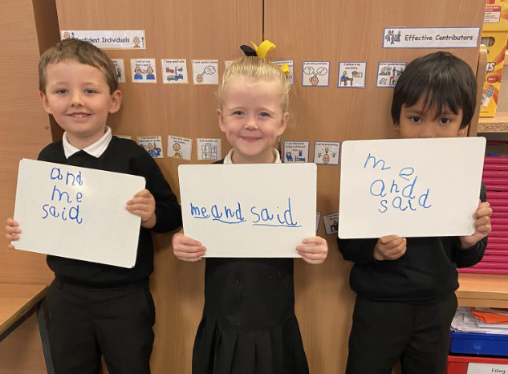
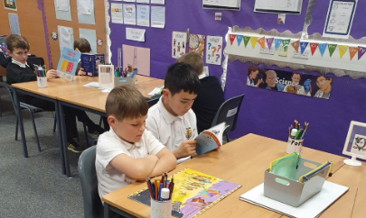
Infant children will bring home a variety of reading books and parents are asked to prepare reading every evening and return books to school daily. Pupils will also be given ‘common words’ and sounds to learn. Other items of homework including numeracy may be issued.

Older, and more able, pupils will be asked to read novels, complete spelling tasks and other literacy activities. Numeracy tasks and topical activities may also be included in our homework programme. Whatever the homework task, parents are asked to support and encourage their child’s efforts.

SCHOOL ETHOS
In Plains Primary School we aim to make everyone feel welcome, included and appreciated. We place great emphasis on respecting others and working in partnership. We currently have good relationships with our community including local churches, shops and nurseries as well as Airdrie Foodbank and the Plains Community Futures Group. We intend to build on these relationships over the coming years.

We promote positive behaviour at all times and aim to provide a calm atmosphere where staff and pupils can learn together and motivate one and other. We celebrate good manners and effort, as well as school and wider achievements.

SPIRITUAL, SOCIAL, MORAL AND CULTURAL VALUES
As part of our school community, children and adults are expected to show courtesy and consideration to the needs and rights of others regardless of race, gender, religion etc. We share responsibility for our own and others safety and well-being.
As a school we encourage all pupils to participate fully in all curricular activities. Mixed teams of boys and girls take part in a variety of sports and recreational team games. All children are given equal opportunities to develop their interests and skills to their fullest potential.
Pupils are taught about Christianity and Other World Religions. This is to develop an educated understanding of the world in which we live. Parents may request in writing that their child be excluded from religious observance lessons.

Parents/carers from ethnic minority religious communities may request that their children be permitted to be absent from school in order to celebrate recognised religious events. Only written requests will be considered. Appropriate requests will be granted on not more than three occasions in any one school session and the pupil noted as an authorised absentee in the register.

EXTRA-CURRICULAR ACTIVITIES
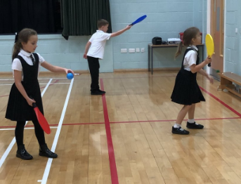
Our staff and parents normally offer a range of extra-curricular activities including Football; Netball; Cross-country; Arts and Crafts; Karate; Choir and Book Club. Pupils are trained to be Junior Sports Leaders providing games
and activities, during intervals and lunchtimes, for our younger pupils.

FREEDOM OF INFORMATION
Freedom of Information (Scotland) Act 2002 came into force in 2005. The Act allows anyone to ask for information
held by the Council and imposes a time-scale of 20 working days for the Council to respond. To deal with Freedom of Information requests, the Council has appointed a Corporate Freedom of Information Officer with the support of an officer in each Service. The Freedom of Information Co- ordinator can be contacted by telephone on 01698 302484.

GENERAL DATA PROTECTION REGULATIONS (GDPR) STATEMENT FOR EDUCATION
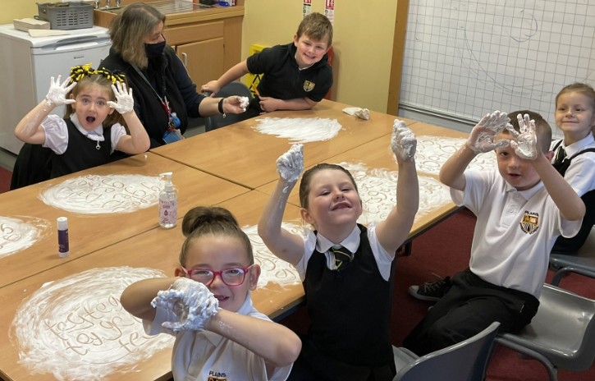
What is this statement?
This statement explains when and why we collect personal information about you, your child or young person and how this information is used, the conditions under which it may be disclosed to others and how it is kept secure.

Who are we?
North Lanarkshire Council is a Local
Authority established under the Local Government etc. (Scotland) Act 1994. Education, and Families is located in Civic Centre, Motherwell, ML1 1AB.

Why do we need your personal information and that of your child or young person?

The Council has a legal obligation to deliver an effective education service to all children and young people in North Lanarkshire. In order to do this we need to collect personal information about children, young people and their families so that we can help them to learn and keep them safe.

Legal basis for using your information
We provide this service as part of our statutory function as your Local Authority. Processing your personal information is necessary for the performance of a task carried out in the public interest by the Council. If the information we have asked for is not provided, then we will not be able to provide this service to your child or young person.

Your personal information
Education uses the national IT system, SEEMiS, to store personal information electronically. We ask parents/carers during registration and enrolment to provide us with their child’s name, date of birth, gender, address, family contact details (phone/email). We will also ask you to update this information annually.
We may also ask you for information about medical conditions, additional support needs, religion, and ethnicity. We may also record information you might wish to provide about your family circumstances.
We require this information to ensure children and young people are educated appropriately, supported, and that we take account of their health and wellbeing.
During a child’s journey through education a pupil’s record is kept, this core record is mainly paper based and is stored securely in the child or young person’s establishment. If the establishment has requested assistance from educational staff outwith the nursery or school, key staff from these services may also store information securely about your child or young person.

How will we use this information?
Your personal information will be used:
- to enrol your child or young person in nursery or school
- to provide your child or young person with an appropriate education
- for teaching, assessment and planning purposes and to monitor educational progress of children and young people
- to support pupil learning, improve outcomes and identify where additional support is needed to help children and young people
- to provide appropriate pastoral care to support health and wellbeing of children and young people

- to keep children and young people safe
- to maintain records e.g. of attendance, absence, attainment and behaviour of children and young people (including exclusions)
- to support children and young people during transitions when moving on each year from nursery to primary, primary to secondary and when they move or leave school
- to enable schools and establishments to process personal data in support of SQA and Further Education
- to monitor and report on pupil attainment and achievement in relation to the national improvement framework issued by the Scottish Government
- to assure the quality of our education services in line with national expectations from Education Scotland
- when we require to contact you by post, email, telephone or text.

Who do we share information with?
To support your child or young person’s access to appropriate education and meet our legal obligations, personal information may be shared internally between Services of the Council. From time to time, education staff may also need to share information about you, your child or young person with another person from another agency or service, e.g. Social Work, Health.
We also share information with Scottish Government and bodies such as Education Scotland, Scottish Qualifications Authority, Skills Development Scotland and other organisations that support children and young people’s learning.

When a child or young person moves or transfers to another school the Council has an obligation to pass on information with regards to pupil records to the new school.
Only identified staff and those who require to have the information to enable them to carry out their job, will have access to you, your child or young person’s information. We care about the information we hold in respect to the education of children and young people. We will keep this information safe and secure.

How long do we keep your information for?
We only keep personal information for the minimum period of time necessary. Sometimes this is set out in law, but in most cases it is based on what we need to fulfil our function. We maintain a ‘records retention and disposal schedule’ which sets out how long we hold different types of information for. You can view this on our website at http://www.northlanarkshire.gov.uk/index. aspx?articleid=15003.

Your rights under GDPR
You can:
- Request access to your information – you have the right to request a copy of the personal information that we hold about you, your child or young person. You can ask us to confirm what personal information is being used and with whom it has been shared with.
- Request a correction to your information – we want to make sure that all personal information is accurate, complete and up to date. Therefore you may ask us to correct any personal information that you believe does not meet these standards.
- Request the restriction of processing – this enables you to ask us to suspend the processing of personal information about you, your child or young person, for example if you want us to establish its accuracy or clarify the reason for processing it.
- Request the transfer – you can request the transfer of your information to another party.
- Deletion of your information – you have the right to ask us to delete personal information about you, your child or young person where:
- you think that we no longer need to hold the information for the purposes for which it was originally obtained

- you have a genuine objection to our use of personal information
- or, use of personal information is contrary to law or our legal obligations.

If you wish to update any personal information, retrieve it, or have it removed from records please
contact your child or young person’s head teacher or head of establishment in the first instance.

The Council’s Data Protection Officer
If you have any questions or are unhappy about the way that we use the personal information of
your child, young person or yourself you can contact the Data Protection Officer.

Data Protection Officer (DPO)
Civic Centre, Windmillhill Street,
Motherwell ML1 1AB
or by email to AITeam@northlan.gov.uk

The Information Commissioner
You also have the right to complain to the Information Commissioner about the way the Council has handled your rights, to enquire about any exercise of these rights or to complain about the way the Council has dealt with your rights (or any other aspect of data protection law).

Information Commissioner’s Office,
45 Melville Street, Edinburgh, EH3 7HL or by e-mail to casework@ico.org.uk

Transferring Educational Data about Pupils
Education authorities and the Scottish Government
Education Portfolio (SGEP) exchange data about pupils either on paper or electronically through the ScotXed programme.
The data collected and transferred covers areas such as date of birth, postcode, registration for free-school meals, whether a pupil is looked after by his/her local authority, additional support needs including disability, attendance, absence and exclusions from school. Pupil names
and addresses are collected by the school and the council but they are not passed to SGEP. The postcode is the only part of the address that is transferred. Data is held securely and no information on individual pupils can be published by SGEP
Providing national identity and ethnic background data is entirely voluntary. You can choose the ‘not disclosed’ option if you do not want to provide this data. However, we hope that the explanations contained in this message and on our website will help you understand the importance of providing the data.

Why do we need your data?
In order to make the best decisions about how to improve our education service, SGEP and education authorities need accurate, up-to-date data about our pupils.We are keen to help all our pupils do well in all aspects of school life and achieve better educational outcomes. Accurate and up-to-date data allows SGEP, education authorities and schools to:
- plan and deliver better policies for the benefit of all pupils,
- plan and deliver better policies for the benefit of specific groups of pupils,
- better understand some of the factors that influence pupil attainment and achievement,
- target resources better.

Your GDPR rights
The collection, transfer, processing and sharing of ScotXed data is done in accordance with the GDPR. We also comply with the National Statistics Code of Practice requirements and other legislation related to safeguarding the confidentiality of data. GDPR gives you the right to know how we will use your data. This message can give only a brief description of how we use data. Fuller details of the uses of pupil data can be found on the ScotXed website (www.scotxed.net). SGEP works with a range of partners including Education Scotland and the Scottish Qualifications Authority. On occasion, we will make individual data available to partners and also academic institutions to carry out research and statistical analysis. In addition, we will provide our partners with information they need in order to fulfil their official responsibilities. Any sharing of data will be done under the strict control and prior agreement of the Data Access Panel in SGEP, which will ensure that no subject specific data will be made public as a result of the data sharing and that such data will not be used to take any actions in respect of an individual.
Further details are available on: www2.gov.scot/Topics/Statistics/ScotXed/PrivacyInformation

Any Concerns
If you have any concerns about the ScotXed data collections you can email school.stats@ scotland.gsi.gov.uk or write to:
The ScotXed Support Office, SEGP, Area 1B, Victoria Quay, Leith, EH6 6QQ.
Alternative versions of this page are available, on request from the ScotXed Support Office, in
other languages, audio tape, braille and large print.

Want more information?
Further details about ScotXed data exchanges are available on the ScotXed website, http://www. scotxed.net.

Child Protection
Every adult in Scotland has a role in ensuring all our children and young people are safe and protected from harm at all times and in all situations.
The Head Teacher is responsible for the schools actions in response to Child Protection concerns. If there are any Child Protection concerns the Head Teacher or the Child Protection Co-ordinator will follow North Lanarkshire Child Protection Procedures and Guidelines

Child Protection Co-ordinator is: Mrs Gail Wilson
Telephone number: (01236) 632144

Adult Protection
The Council has responsibility under the Adult Support and Protection (Scotland) Act 2007 for the protection and support of adults at risk of harm within North Lanarkshire. Its employees therefore have the responsibility to ensure the welfare of all adults at risk of harm with whom they come into contact, as well as providing the highest possible standard of care for some of the most vulnerable members of our society. If there are any Adult Protection concerns the Head Teacher or the Adult Protection Co-ordinator will follow North Lanarkshire Adult Protection Procedures and Guidelines

Adult Protection Co-ordinator is: Mrs Gail Wilson
Telephone number: (01236) 632144

SCHOOL DISCIPLINE
The behaviour and attitude required of children and the school’s approach to discipline are based on the principles of respecting others and working in harmony. ‘Behaviour’ is dealt with in the context of social education and a great deal of emphasis is placed on children’s need to understand the kind of behaviour expected and why. Positive reinforcement and praise are always encouraged. The school uses circle time techniques to encourage positive attitudes. We rely greatly on parents to support us on the management of their child’s behaviour.

School Rules
READY, RESPECTFUL AND SAFE

ANTI-BULLYING
We continually strive to achieve our aims:
- create a welcoming, safe, happy and nurturing environment where we work in partnership with our wider community
- provide learning opportunities which equip children with skills for learning, skills for life and skills for
work
- promote equal opportunities, respect diversities, and value the contribution everyone can make

In line with North Lanarkshire Council’s promoting positive relationships: Respect for All: Anti Bullying Policy (May 2019) we continually promote a positive ethos.

Supervision in Non-Class Times
During adverse weather pupils are supervised within their classrooms.
An adult presence is provided in playgrounds at break times in terms of the Schools (Safety and Supervision of Pupils) (Scotland) Regulations 1990.

Home and school links
Under normal circumstances we pride ourselves on our ‘Open Door Policy’ in Plains Primary School and endeavour to engage with our parents as often as possible. We are fully committed to involving our parents and carers in all aspects of their child’s learning and we actively encourage parents to help in our school. We provide a ‘Dates for your diary’ early in the new term to allow parents to plan ahead. Our monthly newsletters, regular letters, text messages, emails and Twitter, keep parents and carers informed about all aspects of our school. We provide open afternoons, assemblies and events to enhance our parental engagement. Our Parent Council are proactive in encouraging new parents to join us at meetings please find them on Facebook

ATTENDANCE AT SCHOOL
Section 30 of the 1980 Education Act places a duty on every parent of a child of ‘school age’ to ensure that their child attends school regularly. Attendance must be recorded twice a day, morning and afternoon. Regulation 7 of The Education (School and Placing Information) (Scotland) Amendment, Etc., Regulations 1993 requires each child’s absence from school to be recorded in the school register as authorised or unauthorised: As defined by the Scottish Government.

At the start of each school session, parents/carers will be asked to provide contact details including at least one emergency contact number. Parents/carers are required to inform the school if these contact details change during the course of the school year.

Parents and carers are asked to inform the school if a pupil is unable to attend from the start of the school day on the first day of absence. Failure to do so will result in school staff accessing all contact numbers provided for the school. In the interests of child safety the police will be contacted if all attempts to locate the child have been exhausted. Parents/carers should inform the school by letter, telephone or Parent Portal if their child is likely to be absent for some time

FAMILY HOLIDAYS DURING TERM TIME
Every effort should be made to avoid family holidays during term time as this both disrupts the child’s education and reduces learning time. Parents/Carers should inform the school by letter of the dates before going on holiday. Absences will be classified as authorised only in exceptional circumstances. Such circumstances may include:
A family holiday judged to be important to the wellbeing and cohesion of the family, following serious or terminal illness, bereavement or other traumatic events.
A family holiday classified under the ‘authorised absence’ category will not include such reasons
as:
- The availability of cheap holidays
- The availability of desired accommodation
- Poor weather experience during school holidays
- Holidays which overlap the beginning or end of term
- Parental difficulty obtaining leave (except in cases where evidence is provided by the employer that it cannot accommodate leave during school holidays without serious consequences)

Family holidays with the above similar characteristics will be classified as unauthorised absence. Where the head teacher’s prior agreement has not been sought the absence will automatically be classed as unauthorised.

EXTENDED LEAVE WITH PARENTAL CONSENT
Where most family holidays will be recorded as unauthorised absence (see above) extended leave with parental consent will not be considered the same as a family holiday. Leave in such circumstances will be authorised under circumstances such as:
- Extended overseas educational trips not organised by the school
- Short-term parental placement abroad
- Family returning to its country of origin (to care for a relative, or for cultural reasons
- Leave in relation to the children of travelling families

EXCEPTIONAL DOMESTIC CIRCUMSTANCES
Parents/carers may request permission for such leave in writing and the school may authorise such requests under the following:
- The period immediately after an accident or illness
- A period of serious or critical illness of a close relative
- A domestic crisis which causes serious disruption to the family home, causing temporary relocation.
It should be emphasised that the school investigates unexplained absence, and that the authority has the power to write to, interview or prosecute parents/carers, or to refer pupils to the Reporter of the Children’s Panel, if
necessary.

CLOTHING AND UNIFORM
All North Lanarkshire schools must have a dress code which encourages pupils to dress in a way which is appropriate to attendance at school. This dress code must not lead to direct or indirect discrimination on the grounds of race, religion, gender or disability. Prior to drawing up the dress code the parents/carers, pupils and staff were fully consulted. It is the expectation of Education and Families that parents/carers will be keen to support the dress code and written agreement may be sought.
Clothing which is unacceptable in school under any circumstances. Includes items which:
- could potentially encourage factions(e.g. football colours) could cause offence (e.g. anti- religious symbolism or political slogans)
- could cause health and safety difficulties such as loose fitting clothing, dangling earrings
and other potentially dangerous jewellery
- are of flammable materials which may be a danger in certain classes (e.g. shell suits)
- could cause damage to flooring
- carry advertising in particular for alcohol or tobacco,
- could be used to inflict injury to other pupils or to be used by others to do so.

Parents/carers in receipt of a clothing grant from the Council will be encouraged to purchase items which are in accordance with the school dress code. Approval of any requests for such grants in other circumstances are at the discretion of the Executive Director of Education and Families. Information and application forms may be obtained from First Stop Shops and can be downloaded from the Council website www.northlan.gov.uk.

Parents/carers are entitled to receive a clothing grant if they are in receipt of any of the following benefits: Income Support, Job Seekers Allowance (income based). Employment & Support Allowance (income related), Universal Credit (with an income below £625 per month), housing benefit, council tax reduction.

Whilst in general terms it would not normally be the policy of the authority to exclude a pupil from school solely on the basis of his/her dress, persistent refusal to respond to a reasonable dress code may be deemed to be a serious challenge to the head teacher’s authority and to be detrimental to the wellbeing of the whole school community. In such circumstances a head teacher may justify the use of the school discipline procedure.

The Council wishes to minimise claims arising from the loss of pupils’ clothing and/or personal belongings. Parents/carers are asked to assist in this area by ensuring that valuable items and unnecessarily expensive items of clothing, jewellery, etc., are not brought to school. Parents/ carers should note that any claims submitted to cover the loss of such things are likely to be met only where the authority can be shown to have been negligent.

MEALS
We are proud to share the dining area, as well as our playground and gym hall, with the pupils of St David’s Primary School.

North Lanarkshire Council provides a free breakfast and a free lunch to every pupil with a free meal entitlement, as well as every pupil from primary one to five. Parents/carers of primary six and seven can apply for free school meals online or ask in school for an application form. Alternatively parents can supply a packed lunch from home which pupils can eat in our school dinner hall.

Diets required as a result of a medical condition (a medically prescribed diet e.g. coeliac disease, diabetes, PKU, food allergy or intolerance) can be provided in school by our catering staff. A medically prescribed diet form must be completed and signed by the child’s Registered Dietician or General Practitioner. Procedures and forms can be accessed online through North Lanarkshire Council’s website, by the school, the catering service or also in some cases by the child’s dietitian or doctor. For some conditions (PKU, coeliac) parents/carers may be asked to supply prescription foods or attend a meeting to discuss the child’s dietary requirements.

For information; a vegetarian meal option is offered on a daily basis.
Some children with additional support needs may require food to be adapted to an appropriate texture and consistency. In this instance the child’s Registered Dietician or Speech and Language Therapist will liaise with the Head Teacher and school catering service including the nutritionist to ensure appropriate food provision. In this case a form will still need to be signed by a medical professional including a Speech and Language Therapist.
It is important that the Head Teacher is aware of any medically prescribed diets within the school and, on occasion, parent/carers may be asked to attend a meeting.
Forms that have not been signed by a medical professional will be rejected. The form will be returned to the parent along with a letter stating the reason for the refusal and also they will be issued with a new form.
Any change in the child’s dietary requirements must be advised through a Registered Dietitian or Medical Practitioner to the Facilities Support Services (FSS) Nutritionist. When children move to a High School or change schools FSS will need to be informed as soon as possible.

Other
Children of parents/carers receiving Income Support, Job Seekers Allowance (income based),
and Employment & Support Allowance (income related), Universal Credit (with an income below
£625 per month), are entitled to a meal without charge.
All P1 to P5 pupils are entitled to a free meal and free milk. Pupils in P6-P7 who qualify for a free school meal are entitled to free school milk. However, milk will be available for purchase in the school during the lunch period.
Information and application forms for free school meals can be downloaded for the Council website www.northlan.gov.uk and are available in first stop shops.
Parents/carers are entitled to receive a clothing grant if they are in receipt of any of the following benefits: Income Support, Job Seekers Allowance (income based). Employment & Support Allowance (income related), Universal Credit (income below £625 per month), housing benefit and council tax rebate.
Information and application forms for clothing grants may be downloaded for the Council website www.northlan.gov.uk and are available in first stop shops.

PLACING REQUESTS
You have the right to make a placing request for your child to be educated in a school other than the local school. In December each year, the authority will advertise its arrangements for placing requests.

There are sound educational reasons for trying to ensure that the transfer or admission of children to a school takes place at the start of a school session. Other than those who are moving home to a new area, parents/carers are advised to time any placing requests so that they take effect from the beginning of the new school session.

Every effort will be made to try to meet the parental wishes, but you should note that it is not always possible to grant every placing request to a particular school. Placing requests to Primary School does not necessarily ensure that your child will have a direct entry to the associated secondary. Advice on this must be sought from the Primary School Head Teacher. Further information on placing requests and procedures is available from the school or the council’s website.

Parents/Carers and Young People have a right under the Additional Support for Learning Act 2009 to make a placing request for their child or young person to attend a nursery (including partnership nursery), ASN School or ASN class managed by the home authority. In the event of a successful placing request the authority are not required to provide transport. The Act also enables parents

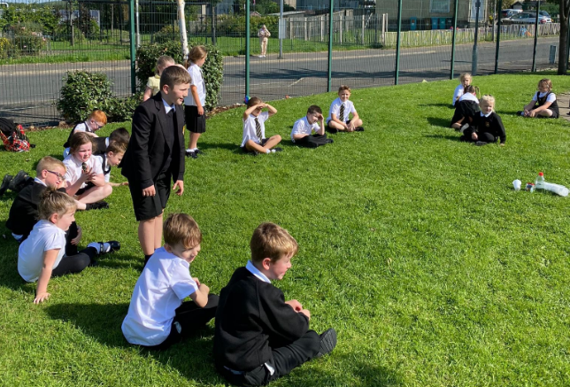
and young people to make a placing request to attend a school/establishment belonging to another authority.

TRANSPORT
- General
The Council has a policy of providing free transport to all primary pupils who live more than one mile from their catchments school by the shortest suitable walking route. This policy is more generous than the
law requires. This provision may be reviewed at any time. Parents/carers who consider they are eligible should obtain an application form from the school or from Education and Families. These forms should be completed and returned before the end of February for those pupils beginning school in August to enable the appropriate arrangements to be made.
Applications may be submitted at any time throughout the year but may be subject to delay whilst arrangements are made. There is discretion in certain circumstances to grant privilege transport for pupils to travel in transport provided by the authority, where spare places are available and no additional costs are incurred.
- Pick-up points
While free transport is provided it may be necessary for pupils to walk a certain distance to the vehicle pick-up point. Walking distance in total, including the distance from home to the pick-up point and from the drop-off point to the school in any one direction, will not exceed the authority’s limits (see above paragraph). It is the parent’s/carers responsibility to ensure their child arrives at the pick-up point in time. It is also the parent’s/carer’s
responsibility to ensure the child behaves in a safe and acceptable manner while boarding, travelling in and alighting from the vehicle. Misbehaviour could result in a loss of the right to free transport.
- Placing Requests
The council does not provide transport for those pupils in receipt of a placing request other than in exceptional circumstances. In the case of early entry requests if the child is offered a place in the catchment area school, transport will be provided in accordance with the Council’s policy stated above.

Medical and Health Care
Parents must inform us of any medical condition their child may have. Emergency contacts must be provided incase children become ill in school. Our First Aider will assess any medical concerns and inform parents as necessary.

Many of our pupils brush their teeth daily in school. Our Childsmile team visit regularly to support us with this. Other visiting specialists, including our school nurse, also visit us on occasion. In North Lanarkshire, children and young people are treated in the paediatric in-patient unit within Wishaw General Hospital. It is not common for children and young people to have extended stays in Wishaw General, and therefore North Lanarkshire Council does not require a dedicated hospital education service.

Children and young people resident in North Lanarkshire and in hospital in Glasgow, may access education through the Hospital Education Service (HES). The service is provided by Glasgow City Education Department and Social Work Services. For further information please contact the school.

INFORMATION IN EMERGENCIES
We make every effort to maintain a full educational service, but on some occasion’s circumstances arise which lead to disruption. For example, schools may be affected by severe weather, temporary interruption of transport, power failures or difficulties of fuel supply. In such cases we shall do all we can to let you know about the details of closure or re-opening.
We shall keep you informed by using letters, notices in local shops and community centres, announcements in local churches and announcements in the press on local radio, on the NLC website and twitter.

THE PARENT FORUM
As a parent/carer of a child at this school you are automatically a member of the Parent Forum. The Parent Forum is composed of all the parents and carers of children at the school.
As a member of the Parent Forum you can expect to:
- get information about what your child is learning
- get information about events and activities at the school
- get advice/help on how you can support your child’s learning
- be told about opportunities to be involved in the school
- have a say in selecting a Parent Council to work on behalf of all parents at the school
- be invited to identify issues for the Parent Council to work on with the school.

THE PARENT COUNCIL
We currently have 10 parents on our Parent Council, but we are delighted to welcome new parents at any time. Our Head Teacher, Mrs Alison Rooney, advises the Parent Council as necessary and is required to attend all meetings. Our meetings are open to members of the public however non-members are not permitted to vote. Parents are elected into posts during our Annual General Meetings.

Our members include:
Chairperson Graeme Paterson gjpaterson@btinternet.com
Treasurer Sheena Nelson
Secretary Laura Wilson
Staff member Gail Wilson

Other Parent Members
Gillian Cleland, Wendy Graham, Claire Kane, Christine Pritchard, Amanda Roebuck, Kirsty Sinnock and Claire Sneddon

The Parent Council’s rights and duties include:
- supporting the work of the school;
- representing the views of parents;
- consulting with parents and reporting back to the Parent Forum on matters of interest;
- promoting contact between the school, parents, pupils, and the wider community;
- fundraising;
- taking part in the selection of senior promoted staff;
- receiving reports from the head teacher and education authority; and
- receiving an annual budget for administration, training and other expenses.
- Improving home school partnership and facilitating parental involvement

Members of Parent Councils, on a voluntary basis, may also have an advisory role in decisions on placing requests by parents in respect of those situations where the number of placing requests for a particular school, or for a particular stage in a particular school, exceeds the number of places available.

USEFUL NAMES AND ADDRESSES
Education and Families
Education Offices, Civic Centre, Windmillhill Street, Motherwell ML1 1AB
Tel: 01236 812222

Councillor Sophia Coyle CoyleS@northlan.gov.uk
Councillor Alan Beveridge beveridgeal@northlan.gov.uk
Councillor Tommy Morgan morgant@northlan.gov.uk
Councillor David Cullen cullend@northlan.gov.uk

Neil Gray MSP
The Scottish Parliament, Holyrood, Edinburgh, EH99 1SP
Constituency Office, Office 9, Airdrie Business Centre, 1 Chapel Lane, Airdire, ML6 6GX

Anum Qaisar-Javed MP
House of Commons, London, SW1A 0AA
Constituency Office, Office 15, Airdrie Business Centre, 1 Chapel Lane, Airdire, ML6 6GX

Des Murray
Chief Executive
Civic Centre, Windmillhill Street, Motherwell, ML1 1AB

Community Learning and Development (CLD)
Can be contacted within our school office.

Education Manager: Jackie Cahill
Head of Service (Central) Janie O’Neill
CIIL Darren Deighan

QUALIFYING STATEMENTS
Although the information is accurate at the time of printing, there could be changes affecting any of the matters dealt within this document
  - Before the commencement or during the school year in question.
  - In relation to subsequent school years Education Authorities are required by law to issue a copy of the school handbook to certain parents in December each year. It details the current policies and practices of both the council and the school.

CONTACTS IN RELATION TO SUPPORT FOR LEARNING
Help and advice on any matters relating to Support for Learning can be obtained from:
Darren Deighan, DeighanD@northlan.gov.uk

You can also get more help and advice from:
Enquire
The Scottish advice service for additional support for learning operated by Children in Scotland, Enquire offers independent confidential advice and information on additional support for learning. Enquire also provide a range of factsheets,
Tel No: 0345 123 2303
Enquire
Children in Scotland
Rosebery House
9 Haymarket Terrace
Edinburgh
EH12 5EZ

Email: info@enquire.org.uk
Website: www.enquire.org.uk for parents/carers and practitioners
Website: www.enquire.org.uk for children and young people

Children in Scotland - Resolve Mediation
0131 313 8844
Email: resolve@childreninscotland.org.uk

Independent Adjudication
Scottish Government
Directorate for Learning
Support and Wellbeing Unit
Area 2C North
Victoria Quay
Edinburgh
EH6 6QQ

Reference to Additional Support Needs Tribunal (Scotland)
ASNTS
Health and Educational Chamber
First Tier Tribunal for Scotland
Glasgow Tribunals Centre
20 York Street
Glasgow
G2 8GT
0141 302 5860
www.asntscotland.gov.uk

NHS Lanarkshire (Please insert details of the Health Centre)
Airdrie Health Centre
01236 772200

Social Work Airdrie
01236 757000

COMMUNITY LEARNING & DEVELOPMENT LOCALITY OFFICES
Airdrie CLD Locality Office Chapelside Community Centre Waddell Street
Airdrie ML6 6DL
Tel: 01236 638538
E: CLD-Airdrie@northlan.gov.uk

Plains Primary School
1 Annieshill View
Plains
Airdrie
ML6 7NY

t : 01236 632144
e : nlwilsong1@northlan.org.uk
w : https://blogs.glowscotland.org.uk/nl/plainsprimaryblog/
tw : @Plains_Primary

