- Access GLOW through the favourites (yellow star)
- Put in username and password
- Remind children of tiles:
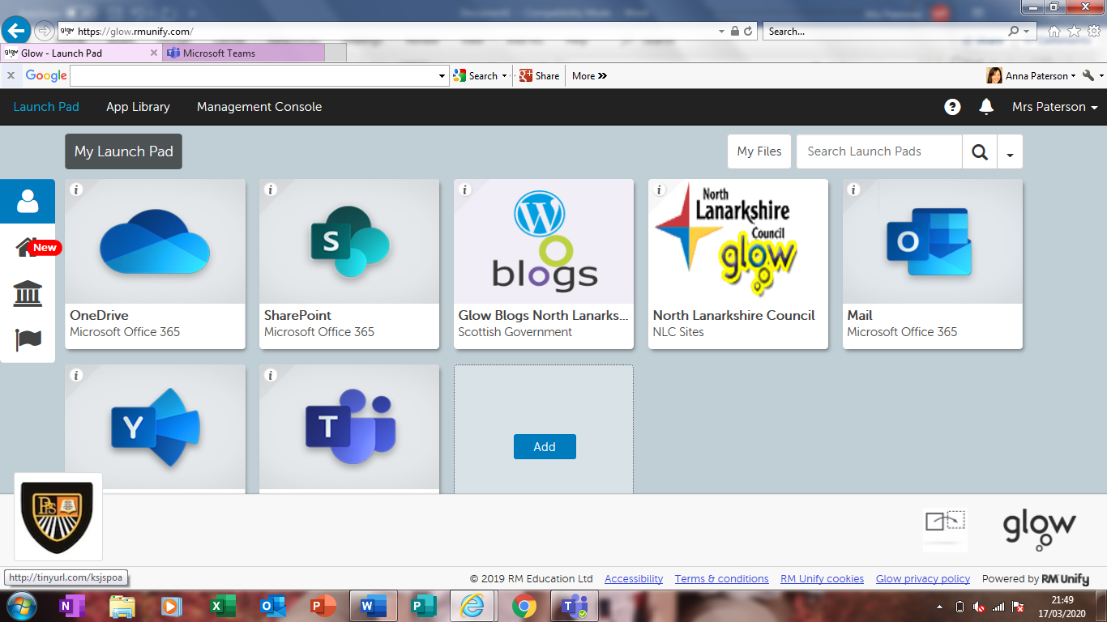
Outlook – for emails; NLC Glow – for resources; Teams for work

- Show children GLOW classroom within the NLC Glow tile – loads of literacy and maths resources and games in there.
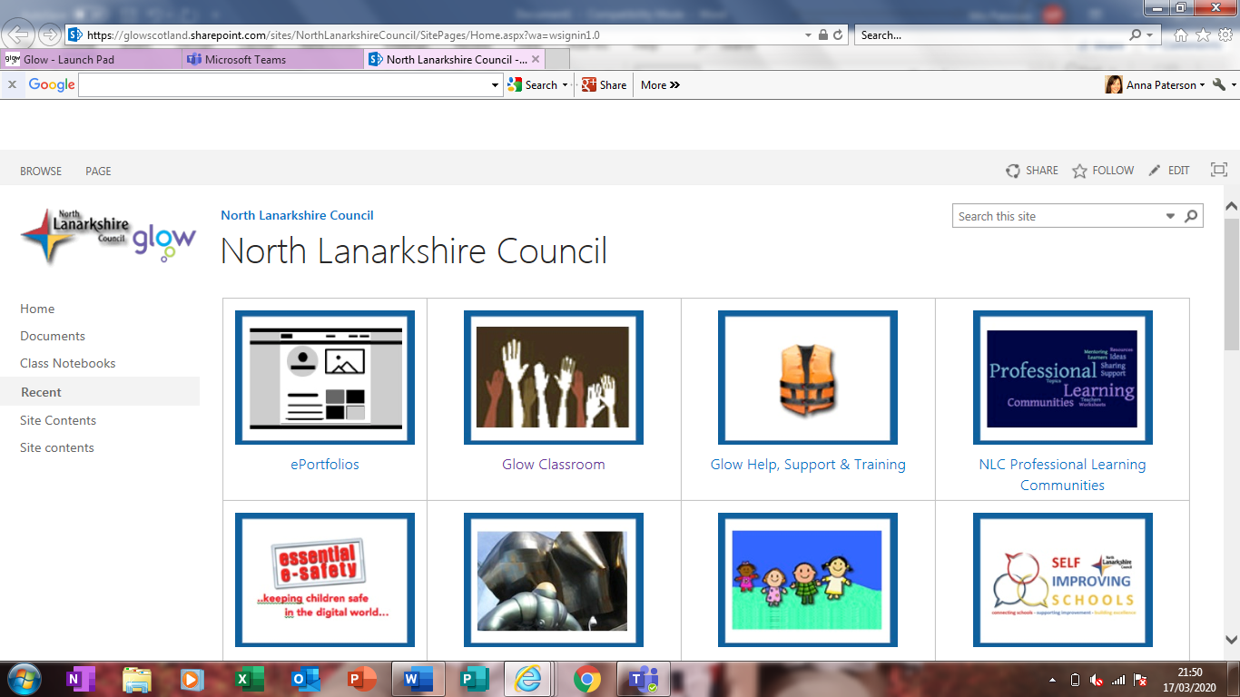

TEAMS
You’re Teams should now look like this.
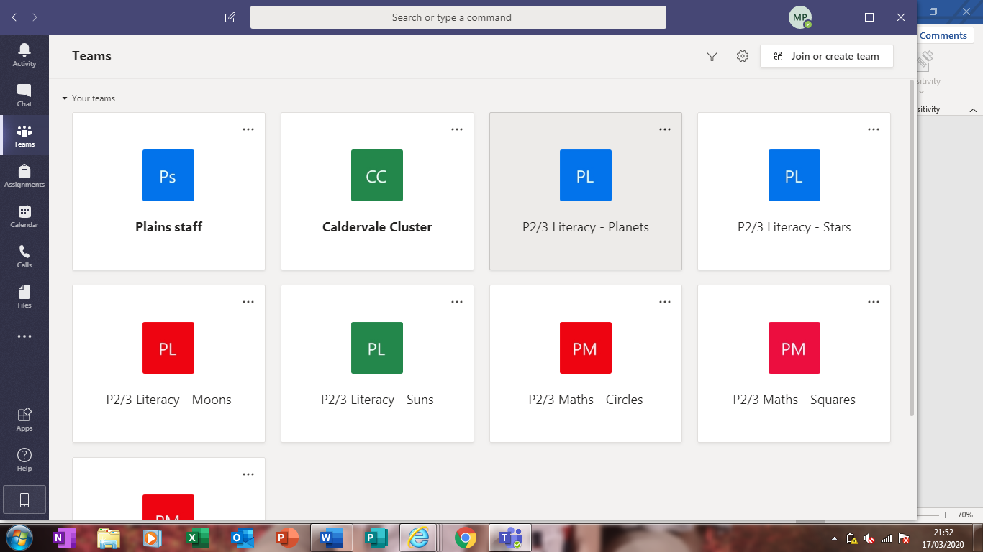

To add work:
1.Choose a team.
2. Choose files along the top and then click the add symbol.
3. You can upload apps and files.
