How to Access Teams from Home
- Google Glow login: click on the RM Unify tab
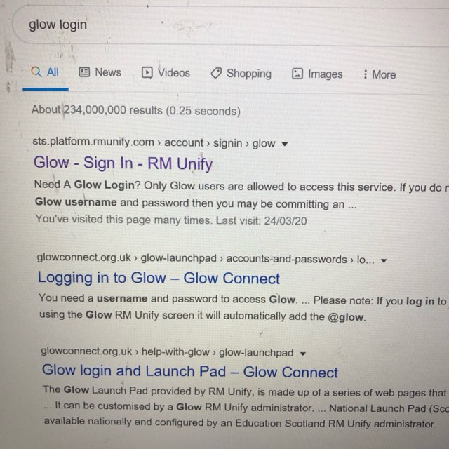
- This will bring you the glow log in page. Your child’s log in details were sent home.
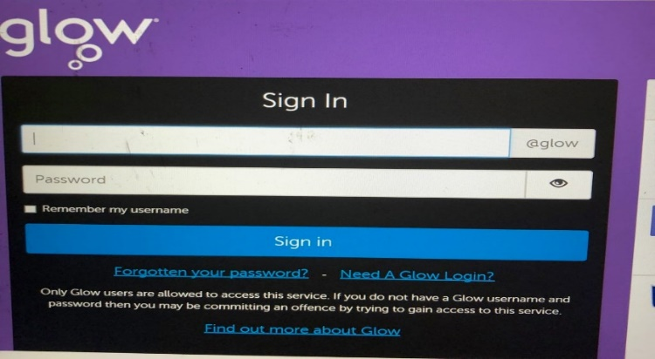
- This will take you to your launch pad. The person icon on the left hand side is your child’s personal launch pad. The one below that, looks like a house, is Plains Primary and the one underneath is the Councils. This is where you will find tiles that have been added for your child. They can access other games and activities here.
Click on the Teams tile.
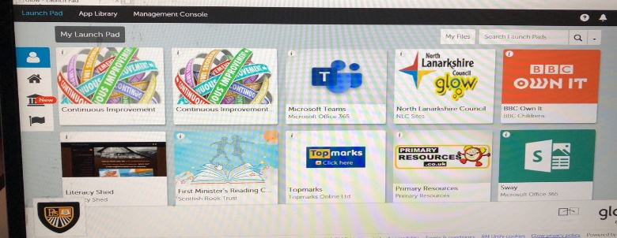
- This will direct you to the page where you will find the teams you are part of. Click on the one that you want to visit. (In this case p4/5 class)
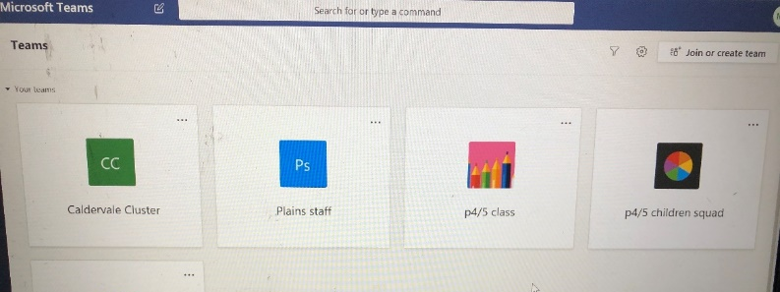
- In the general area you will find the heading Posts. This is where your teacher can post instructions, answer questions and offer support. The class can also chat. Remember this is for educational purposes only.
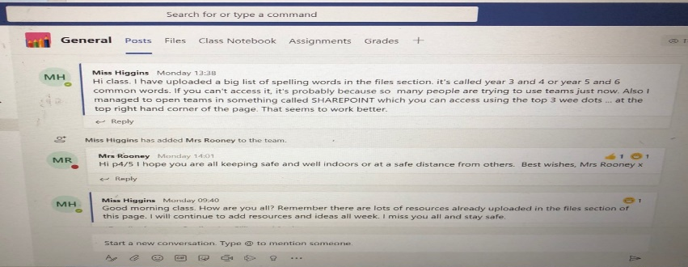
- You should also see the heading Files. If you click on here, it will take you to the area your teacher has uploaded work. In this case you would click on the class materials folder. Children can also upload completed work here.
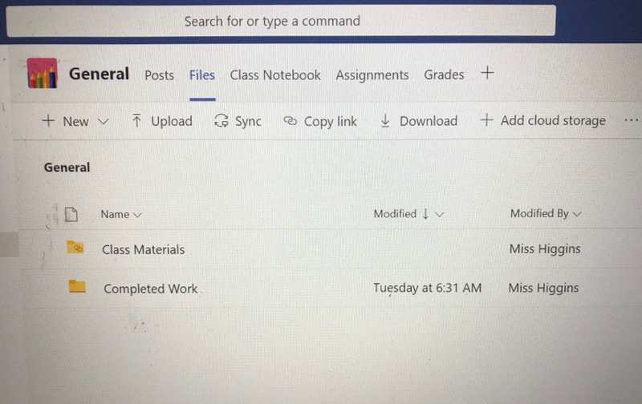
- If you are having trouble accessing Files, you can open in Sharepoint. Click on the 3 dots in the top right hand corner and pick from the drop down menu. It will ask you to place your log on details again (with @glow.sch.uk)
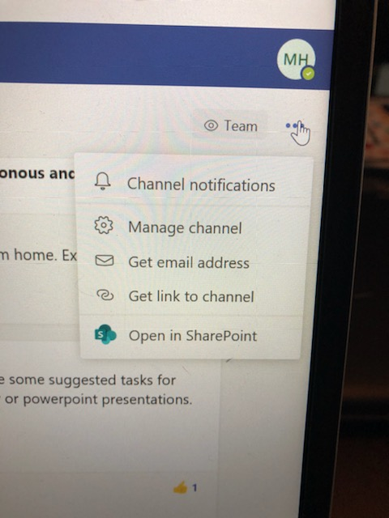
- In this format you will see the class materials folder down the left hand side.
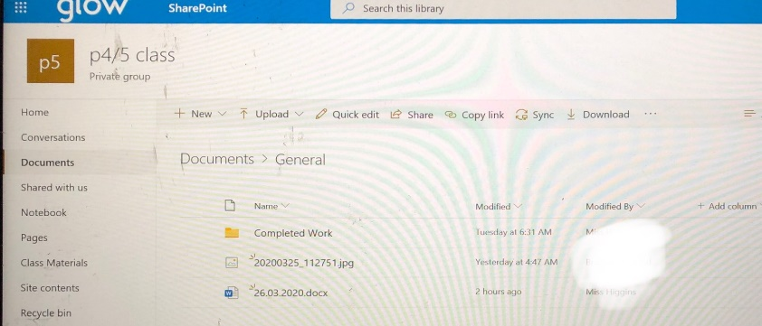
- Another top tip is to download teams as a desktop app. This means in the future you can go directly there. This also seems to make the Files section easier to access.
To do this, click on the screen icon on the bottom left.
