**Raising Attainment**

We continue to work hard every day in school and nursery to raise attainment, particularly in literacy and numeracy.

Mrs McAleese has attended Bookbug Training and has planned the events for BookBug Day on Thursday 22nd March.

Mrs Yardley attended a training session to support staff in introducing SHANARRI health and wellbeing themes to our children.

Miss McConnachie and Mrs McAleese are attending VERP Training which is a programme that studies a practitioners interactions with the children with a view to improving them.

**P1 Induction Programme**

Our P1 Induction Programme is ready to begin.

All children due to attend school in August 2018 are invited to attend with parents/carers.

Individual letters have been sent out to each child.

Monday 26th March at 1pm – Easter Egg Hunt around the school environment.

Monday 23rd April at 11am – Construction and numeracy activities in the gym hall.

Thursday 10th May at 1pm – Health and Wellbeing activities in The Hub.

Thursday 24th May at 1pm – Pencil control, sequencing and literacy activities in P1 classroom.

Thursday 7th June at 11am – School information, Headteacher presentation and parent/child school lunch in dinner hall.

Gillian McOwat, our Community Learning and Development Worker and Miss Sangster, Principal Teacher for P1-P3 will be in touch to arrange home visits in week beginning 14th May.

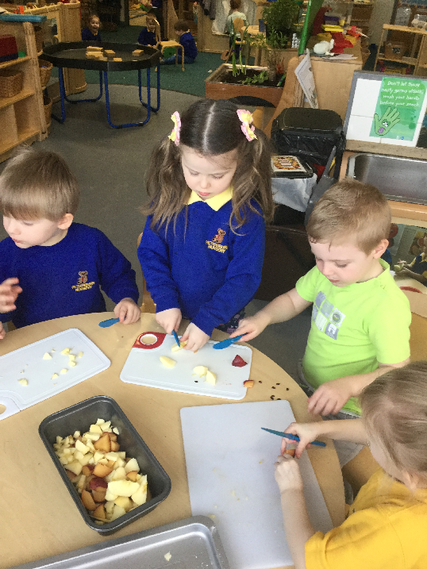 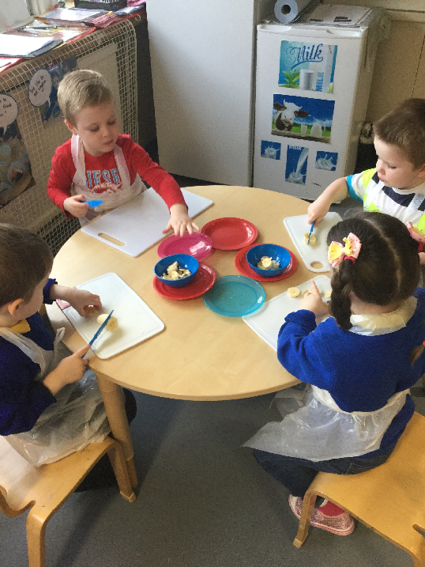

Preparing our snack

Listening and talking at Airdrie Library.

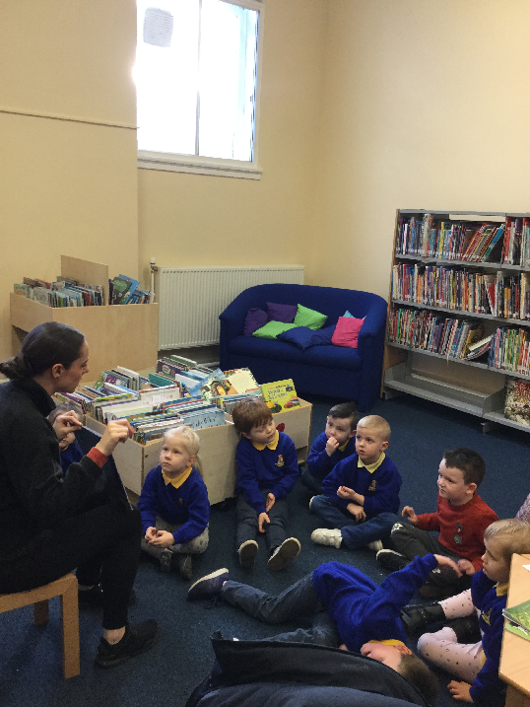

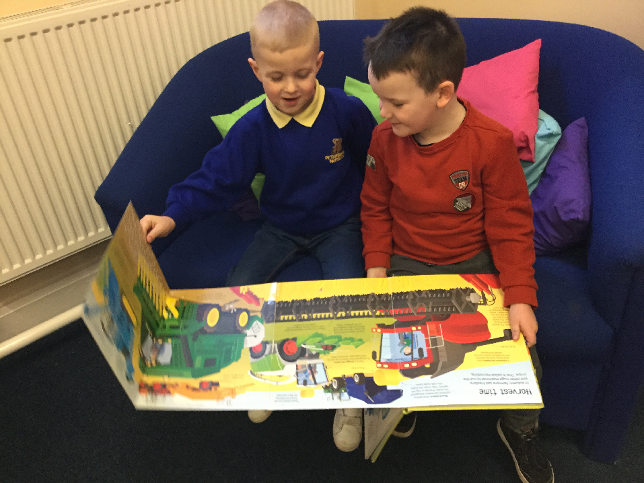

We love reading in nursery!

**Nursery Reports for each child will be sent home shortly.**

**Appointments for parents meetings will be arranged after the Easter break.**

**Nursery Care inspectorate visit**

Our recent Care Inspectorate Report is now published and can be viewed online.

The nursery was awarded ‘good’ and ‘very good’ in the two themes they reported on.

All nursery parents have been given a copy of the report and further copies are available at the school office on request.

**Validated Self-Evaluation Visit**

We had a visit from the local authority on 7th and 8th February. The team visited all classes and the nursery to observe learning and teaching and how we support our children. The team also spoke to children and staff.

The team have now given us a report which highlights how well we are doing and gives us some points for improvement.

We have a plan in place to meet all the improvements asked of us over the coming months.

If you would like to see a copy of the report please ask a member of the Parent Council or contact the school office.