Wednesday 3rd June reading

L.I. I can identify the meaning of words.

Algae- A type of plant that grows in water and has no roots.

Bait- Food put on the end of a fishing line to catch a fish.

Coral- a type of sea creature that looks like a plant. Their skeletons from coral reefs

Lava- molton rock that comes from volcoanos 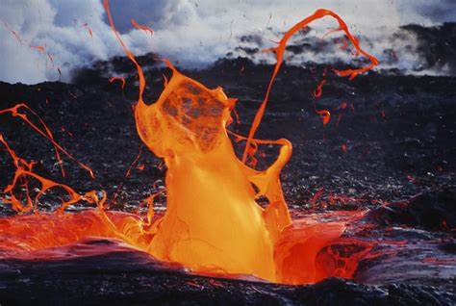

A picture of lava A picture of Aglae