Literacy | Reading Task  With the book that you are currently reading pick two reading tasks from the following website;  https://www.literacyideas.com/reading-activities-for-any-book/  Grammar  This week we are going to revise homophones. Remember homophones are words which sound the same but are spelt differently and have different meaning. Watch the quick video to remind you then complete the worksheet. Please find worksheet on the blog.  https://www.bbc.co.uk/bitesize/topics/zqhpk2p/articles/zc84cwx  Phoneme Task – Revise phoneme Y  Please note I am purposely slowing down the pace and setting the same spelling words and phonemes for both groups, this is due to the holidays.  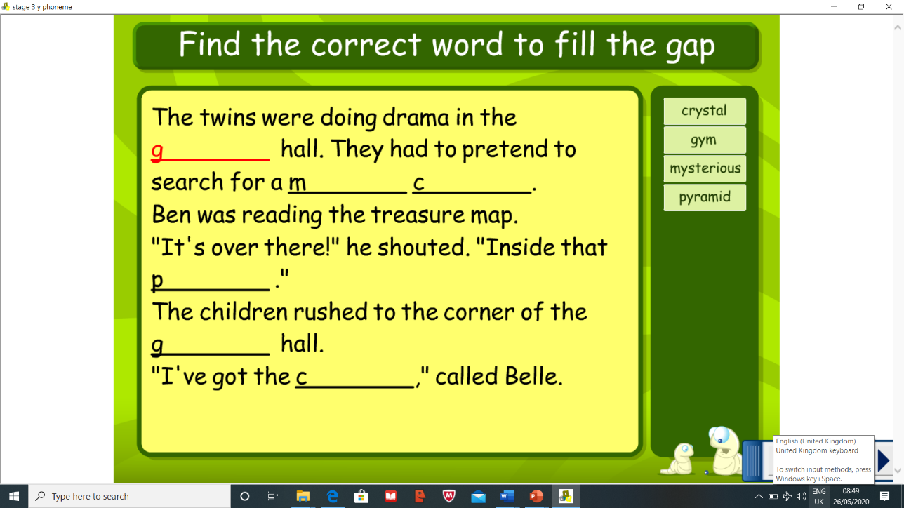  Blue group – gym (y)  Red group – ed (bed, led, red)  Complete the phoneme worksheet found over on the blog  Spelling task – *Please note there will be a spelling test posted on Friday as an audio video so keep practising your words throughout the week. It will be posted on teams for 9am.  Complete the following spelling strategies throughout the week:  Blue group – Backwards spelling and Bubble spelling  Red group – Pyramid spelling and Fancy spelling  Blue Group through, sing, morning, colour, kind Red Group are, dad, not
Numeracy | Mental Maths  Complete some daily mental maths by completing Daily 10. You can choose which area in maths you want to focus on, keep the level low 1,2 or 3 is suitable.  https://www.topmarks.co.uk/maths-games/daily10  Measurement  This week we are going to focus on measuring the capacity or volume of something. Please complete the worksheets on the blog.
HWB  . | The weather has been great make the most of it by getting outside as often as you can! Go for a walk, a run, a jog or a skip!  Give some of these 60 second challenge a go! How many can you do?  https://www.youthsporttrust.org/60-second-physical-activity-challenges
Other | Topic – Scottish Inventors  This week we are going to focus on Alexander Fleming.  Complete the reading task found on the blog as a link.  Invention challenge – Think outside the box  This week I would like to challenge you to think creatively, like an inventor would, and take an old empty cardboard box and I challenge you to make it into something new. Have a think what you would like to create and post your inventions over on the teams. It can be anything you want for example turning it into a jewellery box. (Think outside the box!) Good Luck!  R.M.E  At the weekend it was Eid al-Fitr a Muslim celebration celebrating the end of Ramadan fasting.  Watch the PowerPoint found on the blog explaining Eid and once you have finished make an Eid celebration card. There is a short video to watch too.  https://www.bbc.co.uk/bitesize/clips/zm3b87h

