Literacy | Reading Task  I have set up an Oxford Owl account for you to access online books.  If you look for the “My Class Login” tab and type in for the username: ladywellp34 and for the password p34lw  If your child is onto novels, I would recommend; Roald Dahl, Worst Witch series, David Walliams, Flat Stanley series, Enid Blyon, Judy Moody series, Cathy Cassidy and Horrid Henry series.  If anyone is worried about which books to choose for your child’s ability or struggling on how to use Oxford Owl as a resource, please email me.  https://www.oxfordowl.co.uk/?selLanguage=en&mode=hub  Please encourage your child to read as much as possible throughout the week – both as a private read and partner read, allowing your child to read to you is important too.  Complete some of the following reading tasks:  Dear Diary  Place yourself in the shoes of one of the characters you have just read about and write a diary entry of a key moment from the story.  Express Yourself  Using an iPad or a digital camera make faces of the emotions the main characters would have gone through in your book and take photos of them.  Put them together in a document on your computer or device and explain the emotion below the image and when the character would have felt this way.  Metalinguistics  Find four words you are not quite sure the meaning of, list them and try and guess the meaning using clues from the rest of the sentence. Record your guess. Then check a dictionary and see if you are correct.  Grammar  We are going to revise using speech marks or inverted commas correctly. I have provided a PowerPoint on speech marks over on the blog, you can go through this to familiarise your child with the key learning. There is a web link for BBC bitesize too. Once you have watched the videos complete the grammar sheet.  https://www.bbc.co.uk/bitesize/topics/zmwqtfr/articles/zbkkkmn  Phoneme Task – New phoneme  Blue group – gym (y)  *There will be an audio video introducing the sound on teams on Monday.  Please complete the following sheet by underlining the words that contain your phoneme – challenge yourself by adding 4 more of your own sentences using words containing the ‘y’ phoneme.  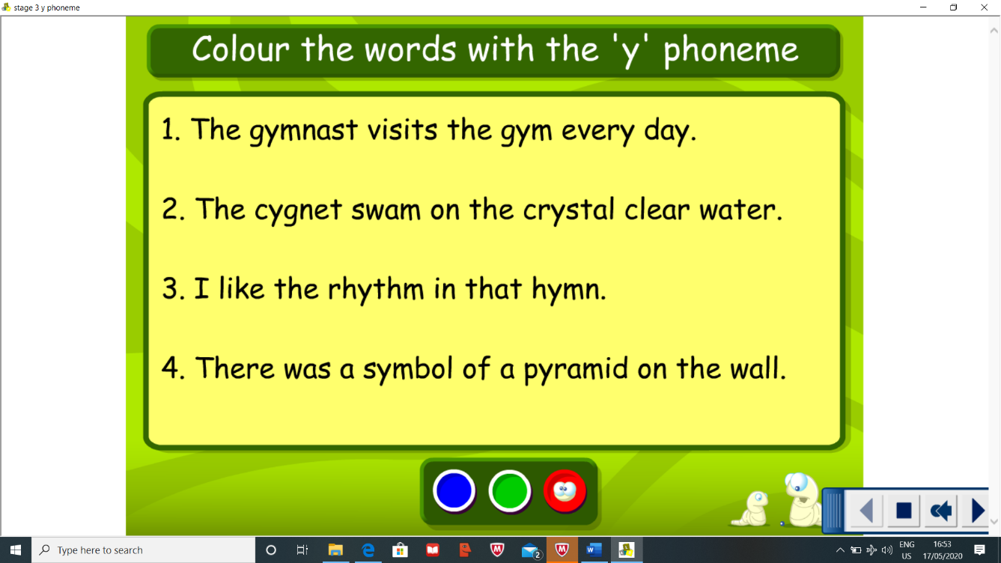  Red group – ed (bed, led, red)  Complete the phoneme worksheet found over on the blog  Spelling task – *Please note there will be a spelling test posted on Friday as an audio video so keep practising your words throughout the week. It will be posted on teams for 9am. There will also be an audio video pointing out the tricky parts of the new spelling words on Monday  Complete the following spelling strategies throughout the week:  Blue group – Bubble spelling and Pyramid spelling  Red group – Rainbow spelling and Bubble spelling  Blue Group through, sing, morning, colour, kind Red Group are, dad, not
Numeracy | Mental Maths  Complete some daily mental maths by completing Daily 10. You can choose which area in maths you want to focus on, keep the level low 1,2 or 3 is suitable.  https://www.topmarks.co.uk/maths-games/daily10  Measurement  This week we are going to focus on measuring the weight of something and reading scales. There is a worksheet to complete for both the red and blue group on weight.  Practical activity- I have left a link to a recipe for salt dough decorations. Something a little bit different and it is simple fun task. Once baked and cooked you can paint and decorate them. You can mould them to any shape – why not make a rainbow.  https://www.bbcgoodfood.com/howto/guide/how-make-salt-dough-recipe
HWB  . | It is Mental Health Awareness week and the theme is kindness. Have a think what kindness means to you. Throughout the week try and complete acts of kindness. It could be drawing a picture for a family member, complimenting someone, or catching up with a relative on zoom. Share your act of kindness on the teams.  Give some of these 60 second challenge a go! How many can you do?  https://www.youthsporttrust.org/60-second-physical-activity-challenges
Other | Topic – Scottish Inventors  This week we are going to focus on Alexander Graham Bell.  Complete the reading task found on the blog as a link.  Practical task: Complete an Alexander Graham Bell inspired experiment. Try to make your own telephone.  https://www.cbc.ca/parents/play/view/three-cool-science-experiments-inspired-by-alexander-graham-bell  Research how the telephone has changed over time. Include dates.  Outdoor Classroom Day – Thursday 21st  It is outdoor classroom day on Thursday and the weather (fingers crossed) is looking to be very nice!  Complete some of the activities;  https://outdoorclassroomday.com/resources/  I will talk about this more over on the teams.  A few Recommendations  - Draw with Rob. I promised to feature this on the blog, a firm favourite how to draw lessons.  https://www.youtube.com/results?search_query=draw+with+rob  - BBC bitesize daily lessons.  https://www.bbc.co.uk/bitesize/dailylessons

