Literacy | Reading Task  *Please see blog post regarding Oxford Owl reading books*  If you choose to read a book from Oxford Owl or if you are currently reading a book at home complete at least three of the reading challenge cards. Cards are found as a link on the blog.  Talking and Listening task  - Draw a picture (adult) and then while you describe what you have drawn your child has to draw what you are describing. Compare your drawings. Swap roles to allow your child to describe the drawing.  Phoneme Task  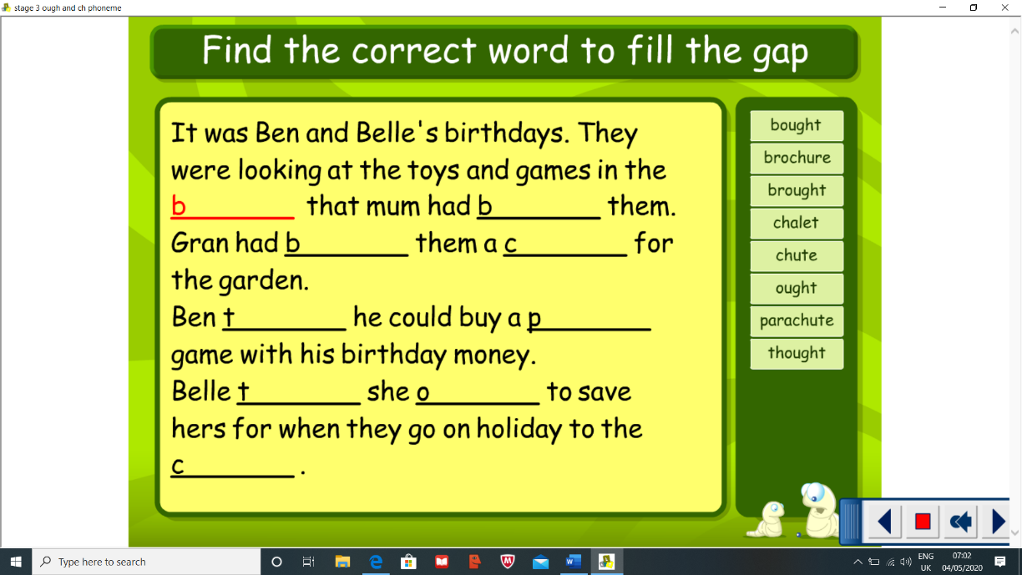  Blue group – complete the sentences below filling the gap with the correct ough word.  Blue group your new phoneme is ough read through the word list and make sure you are pronouncing it correctly. Can you think of any other words?  Red group – Please see ut worksheet on the blog.  Your new sound is ut. Can you say ut? Try and think of words that contain the ut sound.  Spelling task  Blue group – Look for the tricky parts in your new words. For example walk – wa phoneme, it sounds like it should be an o. Write your spelling words out using pyramid spelling  Red group – Write a sentence with each of your spelling words  Blue Group- Phoneme – ough (thought) Common words- walk, water, picture, once, until Red Group- Sound – ut (cut, hut, nut) Common words – your, by, only
Numeracy | This week we are going to focus on measurement. This will be our new topic within term 4. You can use Topmarks and select measurement games throughout the week.  Complete the measure scavenger hunt (see blog)  *If you have an iPhone or iPad there is a measure app. Use this to measure items in your home. Keep a record of the items you choose to measure. Lastly compare the length of the items - which is the longest/shortest item etc. If you do not have the app use another method such as a ruler.  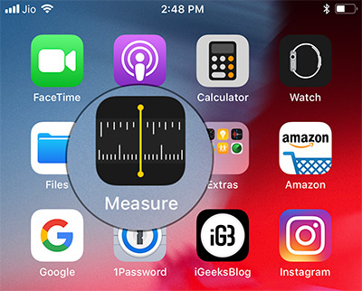
HWB  . | This week for Health and Wellbeing I would like you to think of all the things that make you feel happy. Complete the happy jar and fill it with everything that makes you feel a 5. You can draw a picture or write them inside. Then whenever you are not feeling your best, look at your jar to remind you of the things that make you feel happy!  Please see template of the jar on the blog.  Keep active  If it is nice weather this week (which it looks like it may be – fingers crossed!) go for a walk or jog with your family.  Create an exercise routine and see if you can teach it to a family member.
Other | Topic – Scottish Inventors  If you have not done so already pick an inventor to complete a research task on. Details found on last weeks blog.  Pretend you are an inventor – design your very own invention, remember inventors invent something to fix a problem or make life easier. What are you going to try and fix? What is the name of your invention? Draw and label your invention on a blank piece of paper. Be creative as you like!

